**Let’s Talk: LGBTQIA+**

**Primary**

This resource is part of our self-care suite of resources and has been co-produced with children and young people living in Essex, for children and young people. They have also been developed and quality assured by the following stakeholders:

* Essex Educational Psychology Service
* Health Watch Essex
* Essex Mental Health Support Teams (MHSTs) NELFT NHS Foundation Trust
* Essex Multi-schools Council
* Essex Social, Emotional and Mental Health (SEMH) strategy team
* Essex Child and Family Wellbeing Service, HCRG Care Group in partnership with Barnardos
* NELFT NHS Trust Southend, Essex, and Thurrock (SET) Child, Adolescent and Mental Health Service (CAMHS)
* 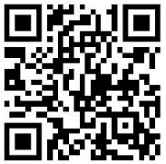Professionals in schools and settings can access all these resources via the [Essex info link SEMH portal](https://schools.essex.gov.uk/pupils/social_emotional_mental_health_portal_for_schools/Pages/Self-care-for-CYP-Library.aspx). Children and young people (CYP), parents/carers and professionals can also access these resources via the SET CAMHS website. Our self-care content can also be accessed via SET CAMHS Instagram account:

The resources are intended to be accessed by CYP independently or trusted adults use these resources with CYP through 1:1 conversation, whole school/group discussion and assemblies.

Please note: some of the content within our self-care resources may be emotive for CYP. We recommend that you make use of the ‘signposting to support’ section of this document should any of the content be triggering.

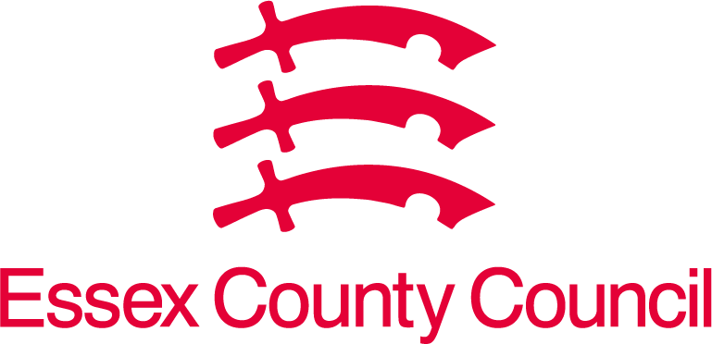   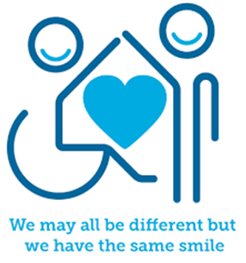

 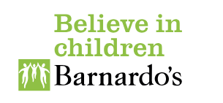

**Introduction (suitable for KS2)**

We are all different and there can be different ways to love someone. We can have different types of families also. Sometimes we can have two mums or two dads and sometimes we can have a mum and a dad.

Some people love someone who is a different sex or ‘gender’ to them (e.g. a women who loves a man, or a man who loves a woman). This is called being ‘heterosexual’, or ‘straight’.

Some people love someone who is the same gender as them (e.g. a women who loves another woman, or a man who loves another man). This can be known as being ‘homosexual’ or ‘gay’. Women who love other women can also be called ‘lesbian’.

People who love both men and women are called ‘bisexual’.

There are many ways that we can be different and this can also include when a someone who is born in a boy’s body wants to be a girl or when someone who is born in a girl’s body wants to be a boy. This can be known as being ‘transgender’.

**Facts**

* Anyone can have thoughts and feelings about themselves which might be confusing and it can be difficult to make sense of this sometimes. We are all different and we can express ourselves in different ways and this is ok.
* It is always good to talk to an adult about your feelings about these things as they can help answer any questions you might have about your family, your friends, or yourself.
* There are a lot of families in the UK which have same sex parents (two mums or two dads) as well as those with a mum and a dad. Growing up in any family type is ok – we can be loved just the same in any type of family.

**Video clips**

Check out these videos

|  |
| --- |
| * <https://www.youtube.com/watch?v=IMCPeFVE3T4>   CBBC – My Life ‘I am Leo’ (Ks2) |
| * <https://www.youtube.com/watch?v=JG0yqhzVuYA>   Having same sex parents. This starts with lots of information about each child and leads into the children talking about having two mums or dads. Celebrating difference. (Ks2) |
| * <https://www.youtube.com/watch?v=Zm9vssgYcHU> PART 1 (Ks2) * <https://www.youtube.com/watch?v=UZ28idcSP9g> PART 2 (Ks2) * <https://www.youtube.com/watch?v=BoTxytQJ3z4> PART 3 (Ks2)   Assigned sex, gender, transgender, non-binary, and gender expression explained. |
| * <https://www.youtube.com/watch?v=tRv57QVem4U>   Heather has two mommies (Ks1) |
| * <https://www.youtube.com/watch?v=hkilGLQHpgA>   Pearl power and the girl with two dads (Ks2) |

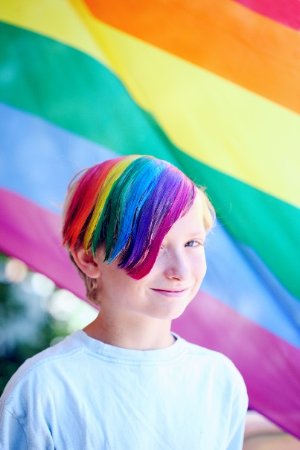**Resources**

|  |
| --- |
| We have indicated whether the resources are accessible for Ks1 or Ks2. Please note that some of the Ks2 content could be adapted and differentiated to support pupils in Ks1. |
| * <https://www.stonewall.org.uk/lgbtq-inclusive-books-children-aged-5-7>   Stonewall LGBTQ+ inclusive books for children aged 5-7 (Ks1)   * Gender: <https://www.youtube.com/shorts/nvMPxuHetvg> (upper Ks2) |

**Reflective questions**

(Try exploring these reflective questions with a CYP) Ks2

* What do you think LGBTQ+ might mean?
* What do you know about this already?
* What kind of thoughts and feelings have you had about this?
* Who have you spoken to?
* Who else can you talk to?
* What would you say to a friend if they were having these thoughts and feelings?

**QUIZ:**

* What does heterosexual mean?
* What does homosexual mean?
* What does lesbian mean?
* What does bisexual mean?
* What does transgender mean?

**Signposting to Support**

For additional support we recommend that trusted adults use these resources to support children and young people access support when required:

* [Getting help for your child: where to start](https://www.youngminds.org.uk/parent/parents-a-z-mental-health-guide/getting-help-for-your-child/)
* [Childline](https://www.childline.org.uk/info-advice/your-feelings/mental-health/?&&&&gclsrc=aw.ds&&gclid=EAIaIQobChMIqryktIeP_wIVicPtCh3QZQs6EAAYASAAEgJr5vD_BwE&gclsrc=aw.ds) 0800 1111 when [contacting ChildLine what to expect](https://www.youtube.com/watch?v=_KNtMOKwTco)?
* [Hopeline 0800 068 41 41](https://www.papyrus-uk.org/papyrus-HOPELINE247/) offering confidential support and practical advice
* [Text ‘SHOUT’ to 85258](https://giveusashout.org/get-help/?gclid=Cj0KCQiA6vaqBhCbARIsACF9M6nG--bxZCnflhd5C3jT-d9dS48o5t6XTTTidI0MLTgwjjRAlxszRT8aAnvvEALw_wcB) for free, confidential, anonymous text support service
* [NHS 111](https://www.nhs.uk/nhs-services/mental-health-services/)
* [Southend, Essex & Thurrock Children and Adolescent Mental Health Service (SET CAMHS)](https://www.nelft.nhs.uk/set-camhs/)
* [Explore counselling/therapy](https://www.nhs.uk/mental-health/talking-therapies-medicine-treatments/talking-therapies-and-counselling/counselling/)
* [Where to get urgent mental health support from: Advice from NHS](https://www.nhs.uk/nhs-services/mental-health-services/where-to-get-urgent-help-for-mental-health/)



* SET CAMHS Instagram account

**How to help a friend**

* Share this resource with them (older KS2)
* Talk to them about the resources, links and apps above
* Listen to them and help them to find positive ways forward
* Show them acceptance for who they are
* Talk about who can help them and who they can talk to (an adult at home or at school) about their feelings
* If you are really concerned about someone, find a trusted adult you can speak to for advice.

**The adult box** (for professionals and parent/carers to read)

|  |
| --- |
| * <https://www.bathnes.gov.uk/sites/default/files/siteimages/allsortsyouthproject_-_trans_inclusion_schools_toolkit_aug_2017.pdf>   Trans Inclusion Schools Toolkit. Supporting trans, non-binary, and gender questioning children and young people |
| * [Stonewall guide (birthto5matters.org.uk)](https://birthto5matters.org.uk/wp-content/uploads/2021/03/getting_started_early_years-1.pdf)   Getting started celebrating difference and challenging gender stereotypes in the early years foundation stage |
| * <https://www.fflag.org.uk/parents-and-teachers/>   FFLAG suggested books for parents and teachers for addressing issues of difference |
| * <https://www.mentallyhealthyschools.org.uk/factors-that-impact-mental-health/vulnerable-children/lgbtqiplus/>   Anna Freud Mentally Healthy Schools LGBTQI+ |
| * <https://uploads-ssl.webflow.com/5888a640d61795123f8192db/5ee0bfaf1afffb0c3dab69f2_AllsortsYouthProject%20-%20A%20Journey%20WIthout%20A%20Map.pdf>   A journey without a map: being a parent of a trans child |
| * <https://cara-friend.org.uk/wp-content/uploads/2018/08/Parents-LGBTQ-v3.2-1.pdf>   A parent and carer’s resource: supporting your LGBTQ+ child |

   

 