**Let’s Talk: Managing Emotions**

**(Co-regulation and Self-regulation)**

**Secondary**

This resource is part of our self-care suite of resources and has been co-produced, with children and young people living in Essex, for children and young people. They have also been developed and quality assured by the following stakeholders:

* Essex Educational Psychology Service
* Health Watch Essex
* Essex Mental Health Support Teams (MHSTs) NELFT NHS Foundation Trust
* Essex Multi-schools Council
* Essex Social, Emotional and Mental Health (SEMH) strategy team
* Essex Child and Family Wellbeing Service, HCRG Care Group in partnership with Barnardos
* NELFT NHS Trust Southend, Essex, and Thurrock (SET) Child, Adolescent and Mental Health Service (CAMHS)
* Professionals in schools and settings can access all these resources via the [Essex info link SEMH portal](https://schools.essex.gov.uk/pupils/social_emotional_mental_health_portal_for_schools/Pages/Self-care-for-CYP-Library.aspx). Children and young people (CYP), parents/carers and professionals can also access these resources via the SET CAMHS website. Our self-care content can also be accessed via SET CAMHS Instagram account:

The resources are intended to be accessed by CYP independently or trusted adults use these resources with CYP through 1:1 conversation, whole school/group discussion and assemblies.

Please note: some of the content within our self-care resources may be emotive for CYP. We recommend that you make use of the ‘signposting to support’ section of this document should any of the content be triggering.

   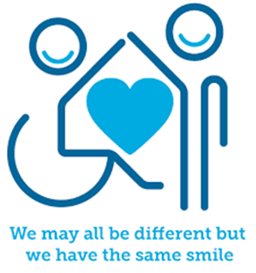

 

**Introduction**

Emotions are a normal part of everyday life. Throughout the day we might at times feel happy, sad, frustrated or angry. We need to be able to understand these feelings and how they affect us so that we are able to manage our own emotions.

**Emotional Regulation** is how we manage and respond to an emotional experience and is also known as **emotional self-regulation**. This may be achieved by processing feelings and perhaps expressing themselves by crying, listening to music, napping, having a break or doing something active like going for a walk.

Children and young people (and adults) who struggle to make sense of and/or manage their emotions on their own, can get help to feel better with the support of another/others (including your pets). We call this **Co-Regulation.** This could be having a cuddle, talking, or kicking a ball with someone.

**Facts**

* We experience emotions in response to our thoughts and feelings and because of what is happening around us.
* People respond differently to different situations, so the same event could leave one person feeling one way (e.g. happy) and another feeling something else (e.g. worried).
* Regulating our emotions is a skill. Some people find it easier than others to regulate their emotions.
* At times everyone struggles to manage their emotions.
* We can learn ways to help us manage our emotions.
* Other people can help us to manage our emotions.





**Myth Buster**

* The older you are, the better you are at managing emotions X
* Having strong emotions means you are out of control X
* Emotions are unhelpful X
* It’s better/easier to just ignore negative emotions X
* Emotion should not be talked about with other people X

**Video clips**

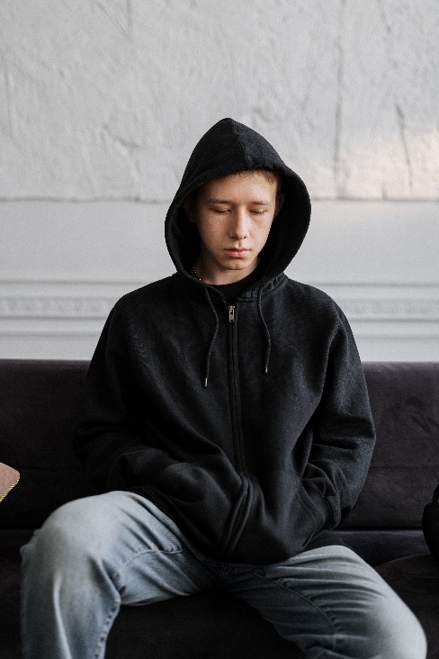Check out these videos about Managing Emotions:

|  |
| --- |
| * [Healthy coping strategies: video for young people : Mentally Healthy Schools](https://mentallyhealthyschools.org.uk/resources/healthy-coping-strategies-video-for-young-people/)   Strategies for young people to try |
| * [Managing Intense Emotions for High School Students (childmind.org)](https://childmind.org/healthyminds/managing-intense-emotions-students-high-school/)   Support for young people to manage intense emotions |
| * [Mindfulness for High School Students (childmind.org)](https://childmind.org/healthyminds/mindfulness-students-high-school/)   Video outlining how young people can use mindfulness |
| * [Managing your emotions – BBC Bitesize Key Stage 3 Learning for Life and Work - YouTube](https://www.youtube.com/watch?v=KGyXe7zcv0M)   Video for KS3+ about managing emotions |
| * [Understanding Feelings](https://www.youtube.com/watch?v=eTeYpQ32JP8)   Video for Ks3+ to explore feelings |
| * [Emotions and the Brain](https://www.youtube.com/watch?v=xNY0AAUtH3g)   The brain and body connection when our emotions get activated |



**Resources**

|  |
| --- |
|  |
| * [Wall of Expression | Childline](https://www.childline.org.uk/toolbox/games/wall-of-expression/)   An online game to support expressing and dealing with emotions (KS3) |
| * [Anger | Childline](https://www.childline.org.uk/info-advice/your-feelings/feelings-emotions/anger/)   Resources to support young people with dealing with anger (all Key Stages) |
| * [Information for 11-18 year olds on understanding your feelings - Mind](https://www.mind.org.uk/for-young-people/introduction-to-mental-health/understanding-my-feelings/)   Resources to support young people with managing their emotions and feelings (all Key Stages) |
| * [Childline | Childline](https://www.childline.org.uk/)   An online resource full of information and details on how to contact their helpline (all Key Stages) |
| * [Relaxation Skills for Teenagers](https://www.youtube.com/watch?v=9lZOond9srU)   How to cope with stress and anxiety |
| * [My Feelings](https://www.youngminds.org.uk/young-person/my-feelings/)   Young Minds have a range of resources that explore and provide advice for the different emotions you may be experiencing. |

**Reflective questions**

(Try exploring these reflective questions with a CYP)

* What feelings might people experience throughout the day?
* Why might someone emotions change throughout the day?
* What factors can impact on people’s changing emotions throughout the day?
* How to recognise that our emotions are managed and we are regulated?

**Quiz**

Once you’ve gone through this resource with a CYP try this quiz questions with them:

* What is emotional regulation?
* How can someone help you to co-regulate?
* Name 3 strategies that can help with self-regulation?
* What is mindfulness?
* How does mindfulness help with emotional regulation?

**Additional ideas**

Other things to try:

|  |
| --- |
| * Keep a feelings diary to reflect on how you’re feeling throughout the day |
| * Try something that is out of your comfort zone. E.g. try something new |
| * Practice some of the regulation strategies when you are feeling ok |

**Signposting to Support**

For additional support we recommend:

* [Anna Freud Centre – On My Mind](https://www.annafreud.org/on-my-mind/)
* [Kooth.com](https://www.kooth.com/) (Age 11-25)
* [Togetherall](https://togetherall.com/en-gb/faqs/becoming-a-member-and-managing-your-profile/#:~:text=Togetherall%20is%20only%20for%20adults,is%20only%20available%20to%2018%2B.) (age 16+)
* [Explore counselling/therapy](https://www.nhs.uk/mental-health/talking-therapies-medicine-treatments/talking-therapies-and-counselling/counselling/)
* [Childline](https://www.childline.org.uk/info-advice/your-feelings/mental-health/?&&&&gclsrc=aw.ds&&gclid=EAIaIQobChMIqryktIeP_wIVicPtCh3QZQs6EAAYASAAEgJr5vD_BwE&gclsrc=aw.ds) 0800 1111 when [contacting ChildLine what to expect](https://www.youtube.com/watch?v=_KNtMOKwTco)?
* [Hopeline 0800 068 41 41](https://www.papyrus-uk.org/papyrus-HOPELINE247/) offering confidential support and practical advice
* [Text ‘SHOUT’ to 85258](https://giveusashout.org/get-help/?gclid=Cj0KCQiA6vaqBhCbARIsACF9M6nG--bxZCnflhd5C3jT-d9dS48o5t6XTTTidI0MLTgwjjRAlxszRT8aAnvvEALw_wcB) for free, confidential, anonymous text support service.
* [Share any concerns about your mental health with your GP](https://www.mind.org.uk/information-support/guides-to-support-and-services/seeking-help-for-a-mental-health-problem/talking-to-your-gp/) and [Understanding Confidentiality](https://www.mind.org.uk/for-young-people/your-rights/understanding-confidentiality/)
* [NHS 111](https://www.nhs.uk/nhs-services/mental-health-services/)
* [Southend, Essex & Thurrock Children and Adolescent Mental Health Service (SET CAMHS)](https://www.nelft.nhs.uk/set-camhs/)
* [Where to get urgent mental health support from: Advice from NHS](https://www.nhs.uk/nhs-services/mental-health-services/where-to-get-urgent-help-for-mental-health/)



* SET CAMHS Instagram account 
* [Big White Wall 16+](https://togetherall.com/en-gb/big-white-wall/)

**How to help a friend**

* Share this resource with them
* Tell them about the SET CAMHS Instagram account
* Suggest they talk to a trusted adult
* Share ideas about how they can access support outside of school (e.g. charities or helplines)

**The adult box** (for professionals and parent/carers to read)

|  |
| --- |
| * [Anna Freud | Anna Freud](https://www.annafreud.org/)   World-leading mental health charity for children and families |
| * [Setting boundaries for teenagers | Relate](https://www.relate.org.uk/get-help/setting-boundaries-teenagers?gclid=EAIaIQobChMI5-2oxeHIggMV9z0GAB12UAyBEAAYAiAAEgLExPD_BwE)   This resource provides advice and suggestions on how to implement rules and boundaries with your teenager |
| * [Help Teens Cope with Thier Emotions | Connections Academy®](https://www.connectionsacademy.com/support/resources/article/9-tips-for-dealing-with-teen-emotions/)   9 Tips for deal with teen emotions |
| * [How can I help my child deal with their emotions](https://parents.actionforchildren.org.uk/feelings-behaviour/talking-about-feelings/dealing-with-emotions/#:~:text=Help%20them%20manage%20difficult%20feelings&text=Prompt%20them%20to%20find%20the,them%20when%20they%20feel%20bad.)   This resource provides advice and suggestions to help a CYP manage their emotions. |
| * [Help your children control their emotions](https://www.google.co.uk/search?q=helping+your+children+manage+emotions&sourceid=ie7&rls=com.microsoft:en-GB:%7breferrer:source%7d&ie=UTF-8&oe=&safe=active&ssui=on#fpstate=ive&vld=cid:81659867,vid:J4n2MiGgDUI,st:0)   UCLA offer 6 tips for parents/carers to help them control their emotions |
| * [Family Lives](https://www.familylives.org.uk/)   This service offers a range of support parents/carers who are managing a range of family dynamics and stressors. This service also includes a free and confidential helpline, online chat and email services. |

   

 