**Let’s Talk: Confidence**

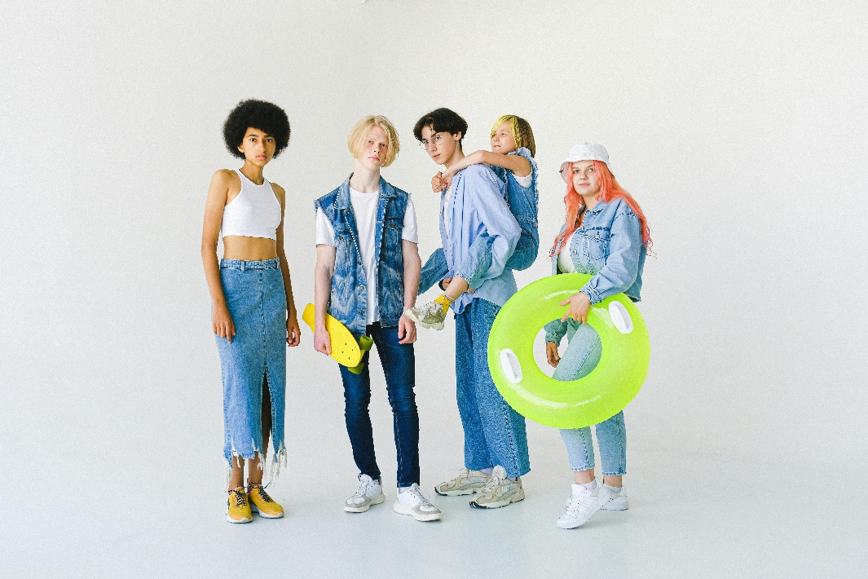**Primary**

This resource is part of our self-care suite of resources and has been co-produced with children and young people living in Essex, for children and young people. They have also been developed and quality assured by the following stakeholders:

* Essex Educational Psychology Service
* Health Watch Essex
* Essex Mental Health Support Teams (MHSTs) NELFT NHS Foundation Trust
* Essex Multi-schools Council
* Essex Social, Emotional and Mental Health (SEMH) strategy team
* Essex Child and Family Wellbeing Service, HCRG Care Group in partnership with Barnardos
* NELFT NHS Trust Southend, Essex, and Thurrock (SET) Child, Adolescent and Mental Health Service (CAMHS)
* Professionals in schools and settings can access all these resources via the [Essex info link SEMH portal](https://schools.essex.gov.uk/pupils/social_emotional_mental_health_portal_for_schools/Pages/Self-care-for-CYP-Library.aspx). Children and young people (CYP), parents/carers and professionals can also access these resources via the SET CAMHS website. Our self-care content can also be accessed via SET CAMHS Instagram account:

The resources are intended to be accessed by CYP independently or trusted adults use these resources with CYP through 1:1 conversation, whole school/group discussion and assemblies.

Please note: some of the content within our self-care resources may be emotive for CYP. We recommend that you make use of the ‘signposting to support’ section of this document should any of the content be triggering.

   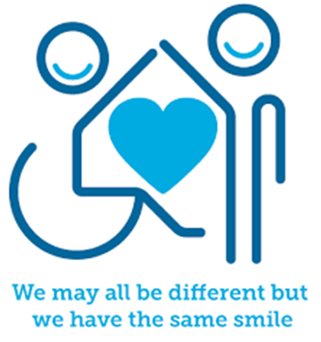

 

**Introduction**

Confidence is about believing in ourselves, our abilities, and ideas.

This could be:

* Feeling proud of your strengths
* Feeling positive about how you look
* Being okay with not being great at sports
* Not wanting to change yourself to fit in with others
* Belief in your own ideas

Sometimes, negative experiences knock our confidence, and it can take time to build it back up. If we don’t build our confidence it could affect our mental health overtime. You may be more likely to experience anxiety, sadness, and frustration.

Whatever affects your confidence, it's important to remember that you have the right to feel good about yourself and believe in your capabilities.

**Facts**

* Positive experiences can boost our confidence.
* Negative experiences can lower our confidence.
* What effects confidence can be different for different people.
* The people we surround ourselves with can really affect our confidence.
* Building your confidence can take time and practice, but there are lots of things you can do to improve your confidence and the way you feel about yourself and your abilities.

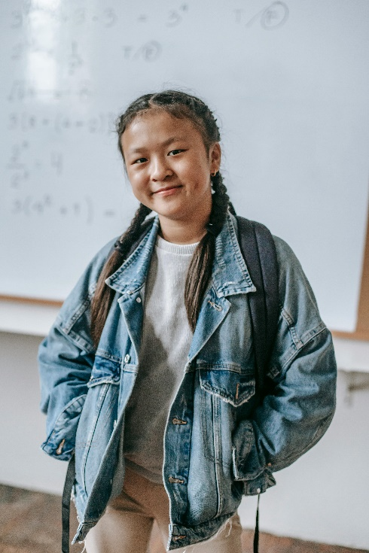

**Myth Buster**

* You have to be good at everything to be confident X
* Self-confidence depends on your looks, money or upbringing X
* Confidence involves being pushy, loud and aggressive X
* Self-confidence is static X
* Someone must be outgoing to have confidence X

**Video clips**

Check out these videos about confidence:

|  |
| --- |
| * [What is confidence - YouTube](https://youtu.be/pdjaxS4ME2A?si=9Y407gWu-trLPIAh)   Wellbeing for children: confidence and self-esteem (Ks2) |
| * [Building self -esteem and self- confidence](https://youtu.be/5BuHC8wBdBU?si=djB8gajZhV1Dg9Yq)   10 ways to build self-esteem and self-confidence (Ks2) |
| * [READ ALOUD: Confidence Is My Superpower By: Alicia Ortego (youtube.com)](https://www.youtube.com/watch?v=7bLRZe4krNI)   Story promoting confidence as a superpower (KS1) |



**Resources**

|  |
| --- |
| We have indicated whether the resources are accessible for Ks1 or Ks2. Please note that some of the Ks2 content could be adapted and differentiated to support pupils in Ks1. |
| * [How to boost your confidence, combat imposter syndrome and stop comparing yourself to others - BBC Bitesize](https://www.bbc.co.uk/bitesize/articles/z2y2h4j#z4pwmbk)   Exploring confidence (KS2) |
| * [Positive mindset | Building confidence | Tools and resources | Help for young people | The Prince's Trust (princes-trust.org.uk)](https://www.princes-trust.org.uk/how-we-can-help/tools-resources/building-confidence/positive-mindset)   Being aware of your negative inner voice so it doesn’t knock your confidence (KS2) |
| * [Document_Resource-Centre_AllWorthIt_Positivity_PDF.pdf (princes-trust.org.uk)](https://documents.princes-trust.org.uk/Document_Resource-Centre_AllWorthIt_Positivity_PDF.pdf)   Self-worth confidence and positivity activity (Ks2)   * [PowerPoint Presentation (princes-trust.org.uk)](https://documents.princes-trust.org.uk/Document_Resource-Centre_AllWorthIt_Confidence_Affirmations_PDF.pdf)   Supporting document to write your own positive affirmation (KS2)   * [PowerPoint Presentation (princes-trust.org.uk)](https://documents.princes-trust.org.uk/Document_Resource-Centre_AllWorthIt_Relationships_Balloon_PDF.pdf)   Hot air balloon activity (Ks2) |

**Reflective questions**

(Try exploring these reflective questions with a CYP)

* How would you describe self-confidence?
* What can affect our confidence?
* How might you help a friend who has low confidence?
* Give 3 examples of things that you are proud of.

**Quiz**

Once you have gone through this resource with a CYP try these quiz questions with them:

* Can you remember one myth about confidence?
* Is confidence affected by the same things for everybody?
* Give 3 examples of things you can do to help build confidence.
* Give 3 ideas on what someone with low self-confidence might do to get support
* What can help build our confidence?

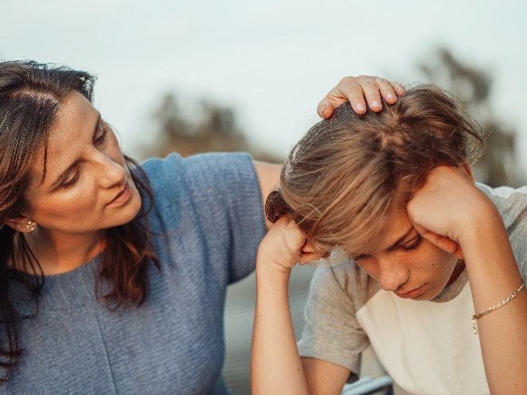



**Signposting to Support**

For additional support we recommend that trusted adults use these resources to support children and young people access support when required:

* [Getting help for your child: where to start](https://www.youngminds.org.uk/parent/parents-a-z-mental-health-guide/getting-help-for-your-child/)
* [Childline](https://www.childline.org.uk/info-advice/your-feelings/mental-health/?&&&&gclsrc=aw.ds&&gclid=EAIaIQobChMIqryktIeP_wIVicPtCh3QZQs6EAAYASAAEgJr5vD_BwE&gclsrc=aw.ds) - 0800 1111 – [when contacting ChildLine what to expect](https://www.youtube.com/watch?v=_KNtMOKwTco)
* [Text ‘SHOUT’ to 85258](https://giveusashout.org/get-help/?gclid=Cj0KCQiA6vaqBhCbARIsACF9M6nG--bxZCnflhd5C3jT-d9dS48o5t6XTTTidI0MLTgwjjRAlxszRT8aAnvvEALw_wcB) for free, confidential, anonymous text support service
* [NHS 111](https://www.nhs.uk/nhs-services/mental-health-services/)
* [Southend, Essex & Thurrock Children and Adolescent Mental Health Service (SET CAMHS)](https://www.nelft.nhs.uk/set-camhs/)
* [Explore counselling/therapy](https://www.nhs.uk/mental-health/talking-therapies-medicine-treatments/talking-therapies-and-counselling/counselling/)
* [Where to get urgent mental health support from: Advice from NHS](https://www.nhs.uk/nhs-services/mental-health-services/where-to-get-urgent-help-for-mental-health/)

**How to help a friend**

* Start a conversation about self-confidence. Describe to them what it is and why it’s important for your mental health.
* Ask a friend to name some things they are good at.
* Share with your friend the things you think they are good at.
* Share this resource with them.
* Help them to relax.
* Listen to them and reassure them.

**The adult box** (for professionals and parent/carers to read)

|  |
| --- |
| * [5 ways you can help boost your child’s confidence this summer - BBC Bitesize](https://www.bbc.co.uk/bitesize/articles/z4dfn9q)   5 tips to helping you boost your child’s confidence |
| * [14 Strategies for Building Confidence in Your Children | Psychology Today](https://www.psychologytoday.com/us/blog/being-your-best-self/202103/14-strategies-building-confidence-in-your-children)   Strategies to support boost your child’s confidence |
| * [12 Tips to Raise Confident Children | Building Self-Esteem | Child Mind Institute](https://childmind.org/article/12-tips-raising-confident-kids/)   Top tips to support develop your child’s confidence and self-esteem |
| * [Building confidence in girls | Spotlight stories | YoungMinds](https://www.youngminds.org.uk/professional/spotlight-stories/how-i-help-build-confidence-and-resilience-in-young-girls/)   Raising confidence in young girls |

