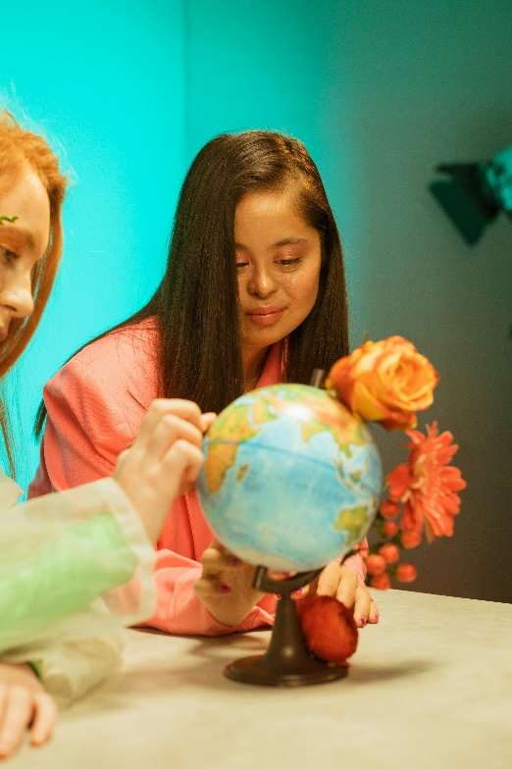**Let’s Talk: Disability**

**Secondary**

This resource is part of our self-care suite of resources and has been co-produced, with children and young people living in Essex, for children and young people. They have also been developed and quality assured by the following stakeholders:

* Essex Educational Psychology Service
* Health Watch Essex
* Essex Mental Health Support Teams (MHSTs) NELFT NHS Foundation Trust
* Essex Multi-schools Council
* Essex Social, Emotional and Mental Health (SEMH) strategy team
* Essex Child and Family Wellbeing Service, HCRG Care Group in partnership with Barnardos
* NELFT NHS Trust Southend, Essex, and Thurrock (SET) Child, Adolescent and Mental Health Service (CAMHS)
* Professionals in schools and settings can access all these resources via the [Essex info link SEMH portal](https://schools.essex.gov.uk/pupils/social_emotional_mental_health_portal_for_schools/Pages/Self-care-for-CYP-Library.aspx). Children and young people (CYP), parents/carers and professionals can also access these resources via the SET CAMHS website. Our self-care content can also be accessed via SET CAMHS Instagram account:

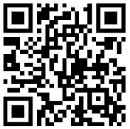

The resources are intended to be accessed by CYP independently or trusted adults use these resources with CYP through 1:1 conversation, whole school/group discussion and assemblies.

Please note: some of the content within our self-care resources may be emotive for CYP. We recommend that you make use of the ‘signposting to support’ section of this document should any of the content be triggering.

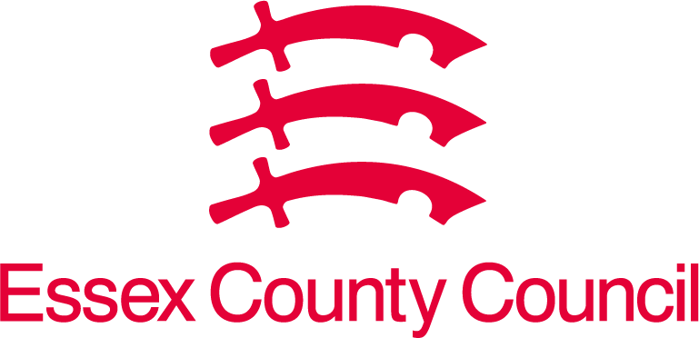   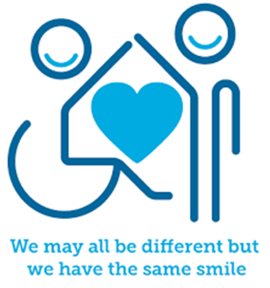

 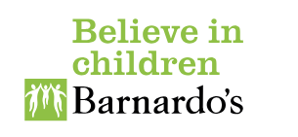

**Introduction**

A disability is any condition of the body or mind (neurodiversity) that makes it more difficult for the person with the condition to do certain activities and interact with the world around them. But disabilities can also be a strengths and someone’s superpower, and these capabilities are something to be celebrated and fostered. Think about how many people with disabilities partake in the Paralympics or how many famous people in history have a disability such as Albert Einstein, Stephen Hawking, Bill Gates, and Sir Isaac Newton.

The word disability is a term that encompasses a wide range of conditions and experiences including being paralysed, having a hearing impairment, and/or having different neurobiological diagnosable conditions such as Autism, Attention Deficit Hyperactivity Disorder (ADHD), epilepsy and Dyslexia. Some disabilities are more common than others, whilst some are more visible than others. We should all make every effort to try and understand our own and other’s disabilities, be accepting and supportive of these differences and celebrate them.

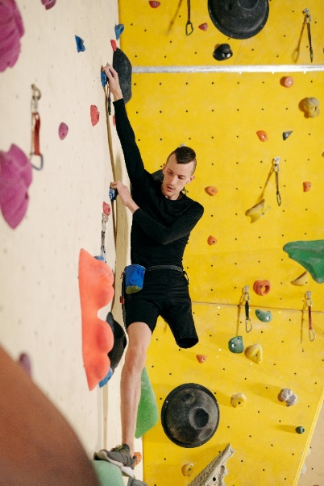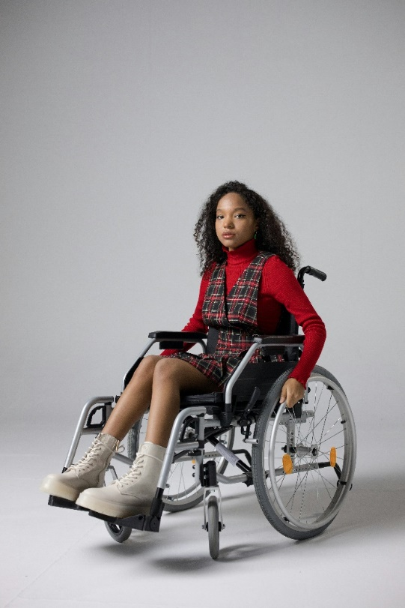

**Facts**

Disability facts:

* A physical disability is a limitation on a person’s physical functioning, mobility, dexterity, or stamina that has a ‘substantial’ and ‘long-term’ negative effect on their ability to perform normal daily activities.
* Neurobiological conditions describe conditions that affect the brain and nervous system.
* Neurodiversity describes differences in brain function from person to person that affect daily mental functions.
* Managing the challenges of a disability can impact of someone’s emotional wellbeing and mental health.

**Myth Buster**

Disability myths:

* Disabilities can’t be supported, reduced or improved. X
* People use their disability as an excuse. X
* You can’t have a disability if you can’t see it. X
* You can always see someone’s disability. X

**Video clips**

Check out these videos about disability:

## [Disability and Child Protection | UNICEF (youtube.com)](https://www.youtube.com/watch?v=3SzazN2OrsQ)

## UNICEF’s video about disability and child protection

* [Understanding Disabilities (for students) (youtube.com)](https://www.youtube.com/watch?v=r9Y6XMko9Jc)

Oasis Mental Health Applications video about understanding disabilities (for students)

* [What is an Intellectual Disability? Lesson for Kids (youtube.com)](https://www.youtube.com/watch?v=3Hqws_ON3rY)

Transition Abilities describes what an intellectual disability is

* [DISABILITY | How You See Me (youtube.com)](https://www.youtube.com/watch?v=bwW6mYdJ7Xc)

Participant video exploring people’s experiences of disability

* [Hidden Disabilities (youtube.com)](https://www.youtube.com/watch?v=ENzHs8yjtg4)

University of Southampton students union film of student’s lived experiences of hidden disabilities

* [Student Voice and Disability Inclusion (youtube.com)](https://www.youtube.com/watch?v=QNwVhATA3ic)

Department for Education Victoria promotes student voice to advocate disability and inclusion in school

* [Disabilities: How to Cope With Them & Support Others (youtube.com)](https://www.youtube.com/watch?v=hjvmAUbfXdw)

Oasis Mental Health video promoting how to cope with a disability and how to support others with a disability

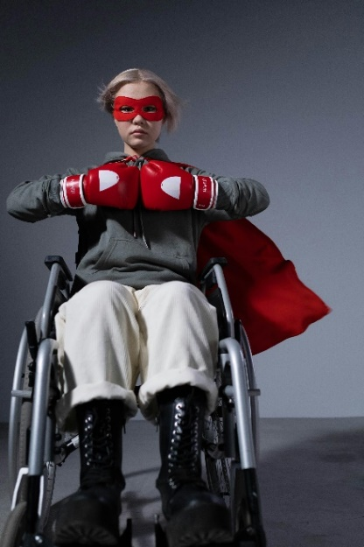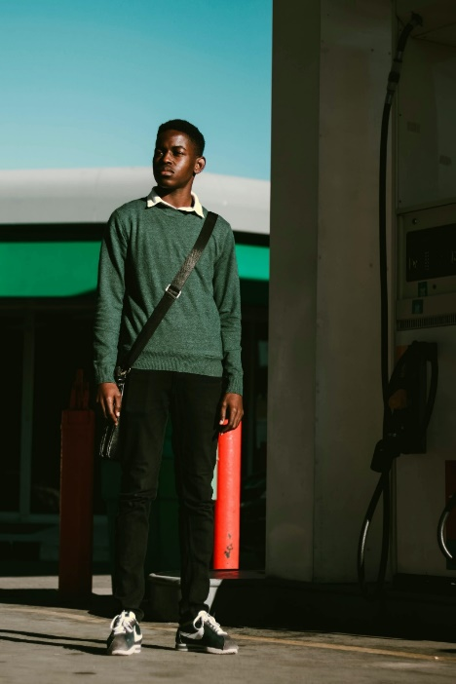

**Resources**

* [What is the Hidden Disabilities Sunflower? (youtube.com)](https://www.youtube.com/watch?v=qWPqg3PJ0D4)

Hidden Disability Sunflower

**Reflective questions**

(Try exploring these reflective questions with a CYP)

* What have you learnt about disability from this resource?

**Quiz**

Once you have gone through this resource with a CYP try this quiz questions with them:

* What is a physical disability?
* What does a neurobiological condition affect?
* What is neurodiversity?
* What is a hidden disability?
* What is the hidden disability sunflower?

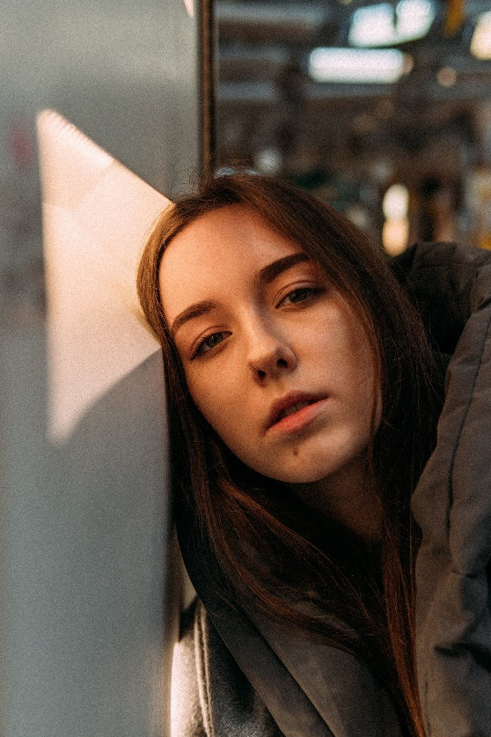

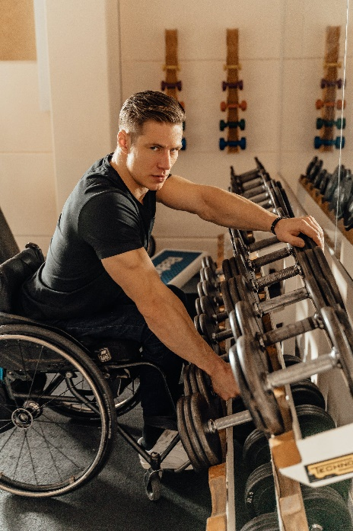

**Signposting to Support**

For additional support we recommend you take a look at the following links:

* [Anna Freud Centre – On My Mind](https://www.annafreud.org/on-my-mind/)
* [Kooth.com](https://www.kooth.com/) (Age 11-25)
* [Togetherall](https://togetherall.com/en-gb/faqs/becoming-a-member-and-managing-your-profile/#:~:text=Togetherall%20is%20only%20for%20adults,is%20only%20available%20to%2018%2B.) (age 16+)
* [Explore counselling/therapy](https://www.nhs.uk/mental-health/talking-therapies-medicine-treatments/talking-therapies-and-counselling/counselling/)
* [Childline](https://www.childline.org.uk/info-advice/your-feelings/mental-health/?&&&&gclsrc=aw.ds&&gclid=EAIaIQobChMIqryktIeP_wIVicPtCh3QZQs6EAAYASAAEgJr5vD_BwE&gclsrc=aw.ds) 0800 1111 when [contacting ChildLine what to expect](https://www.youtube.com/watch?v=_KNtMOKwTco)?
* [Hopeline 0800 068 41 41](https://www.papyrus-uk.org/papyrus-HOPELINE247/) offering confidential support and practical advice
* [Text ‘SHOUT’ to 85258](https://giveusashout.org/get-help/?gclid=Cj0KCQiA6vaqBhCbARIsACF9M6nG--bxZCnflhd5C3jT-d9dS48o5t6XTTTidI0MLTgwjjRAlxszRT8aAnvvEALw_wcB) for free, confidential, anonymous text support service.
* [Share any concerns about your mental health with your GP](https://www.mind.org.uk/information-support/guides-to-support-and-services/seeking-help-for-a-mental-health-problem/talking-to-your-gp/) and [Understanding Confidentiality](https://www.mind.org.uk/for-young-people/your-rights/understanding-confidentiality/)
* [NHS 111](https://www.nhs.uk/nhs-services/mental-health-services/)
* [Southend, Essex & Thurrock Children and Adolescent Mental Health Service (SET CAMHS)](https://www.nelft.nhs.uk/set-camhs/)
* [Where to get urgent mental health support from: Advice from NHS](https://www.nhs.uk/nhs-services/mental-health-services/where-to-get-urgent-help-for-mental-health/)
* 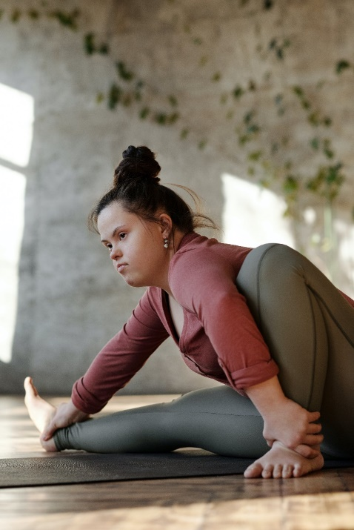SET CAMHS Instagram account 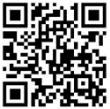

**How to help a friend**

* Start a conversation about disability.
* Explore how aware your friendship group is about disability (visual and hidden disabilities) and how they support and understand those that may experience challenges.
* 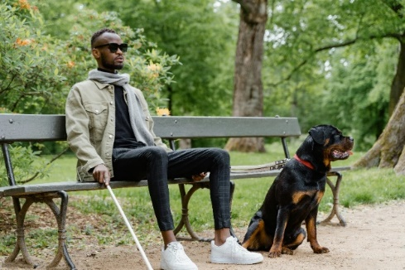Share this resource with your friend.

**The adult box** (for professionals and parent/carers to read)

* [We need to talk about disability (youtube.com)](https://www.youtube.com/watch?v=Z3faUGgMsNI)

Australian Greens film to discuss supporting people with disability.

* [Inclusion and Education: #AllmeansALL​ (youtube.com)](https://www.youtube.com/watch?v=kEyjlqixq9c)

GEM report UNESCO describe the need to promote inclusion for children and young people who have a disability

* [Teach pupils with special educational needs and disabilities | Get Into Teaching GOV.UK](https://getintoteaching.education.gov.uk/is-teaching-right-for-me/teach-disabled-pupils-and-pupils-with-special-educational-needs)

Advice for teachers to help support them to develop the skills to support teach students with special educational needs and disabilities

* [SEND code of practice: 0 to 25 years - GOV.UK (www.gov.uk)](https://www.gov.uk/government/publications/send-code-of-practice-0-to-25)

DfE SEND code of practice

* [Essex County Council: Special Educational Needs and Disabilities (SEND) | Essex Local Offer](https://send.essex.gov.uk/)

Essex SEND local offer

* [KS3 Assembly PowerPoint for UK Disability History Month (twinkl.co.uk)](https://www.twinkl.co.uk/resource/ks3-assembly-powerpoint-for-uk-disability-history-month-t-s-1665573201)

Twinkl resources for disability history month

* [Embracing Disability: 'Not Every Disability Is Visible' Discussion Teaching (twinkl.co.uk)](https://www.twinkl.co.uk/resource/t3-p-157-embracing-disability-not-every-disability-is-visible-discussion-teaching-ideas)

Twinkl teaching ideas for embracing disability

* [Disability and barriers in sports - Social groupings and participation in sport - OCR - GCSE Physical Education Revision - OCR - BBC Bitesize](https://www.bbc.co.uk/bitesize/guides/zy62hv4/revision/4)

BBC Bitesize GCSE topic disability and barriers in sports

   

 