**Let’s Talk: Healthy Boundaries**

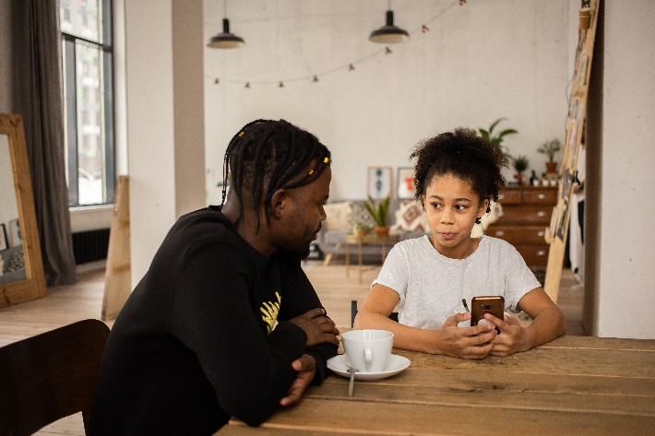**Primary**

This resource is part of our self-care suite of resources and has been co-produced with children and young people living in Essex, for children and young people. They have also been developed and quality assured by the following stakeholders:

* Essex Educational Psychology Service
* Health Watch Essex
* Essex Mental Health Support Teams (MHSTs) NELFT NHS Foundation Trust
* Essex Multi-schools Council
* Essex Social, Emotional and Mental Health (SEMH) strategy team
* Essex Child and Family Wellbeing Service, HCRG Care Group in partnership with Barnardo’s
* NELFT NHS Trust Southend, Essex, and Thurrock (SET) Child, Adolescent and Mental Health Service (CAMHS)
* 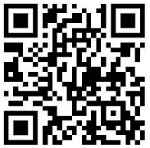Professionals in schools and settings can access all these resources via the [Essex info link SEMH portal](https://schools.essex.gov.uk/pupils/social_emotional_mental_health_portal_for_schools/Pages/Self-care-for-CYP-Library.aspx). Children and young people (CYP), parents/carers and professionals can also access these resources via the SET CAMHS website. Our self-care content can also be accessed via SET CAMHS Instagram account:

The resources are intended to be accessed by CYP independently or trusted adults use these resources with CYP through 1:1 conversation, whole school/group discussion and assemblies.

Please note: some of the content within our self-care resources may be emotive for CYP. We recommend that you make use of the ‘signposting to support’ section of this document should any of the content be triggering.

   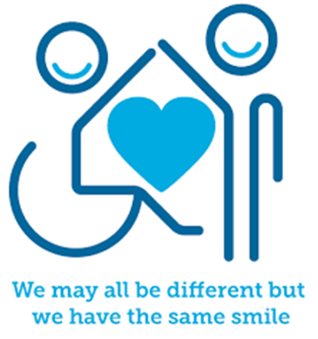

 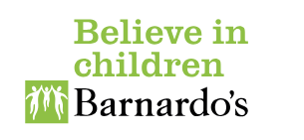

**Introduction**

Healthy boundaries are limits and rules we set for ourselves and others within relationships. Setting boundaries can be helpful to let others know what we feel comfortable with and what we do not feel comfortable with. They can be thought of as lines that separate us from others, in terms of our physical space and our emotions and feelings. Boundaries can be personal to us, or we can share agreed boundaries with others which we all follow. A personal boundary might be saying ‘no thank you’ when someone wants us to do something we do not want to do, whilst a shared boundary would be something we agree to do/not do such as being a good friend. Boundaries are important to help keep ourselves and others safe. They affect how we treat ourselves and others as well as how others treat us. We can set boundaries with a range of things including our things (possessions), bodies, feelings, time, thoughts, and beliefs.

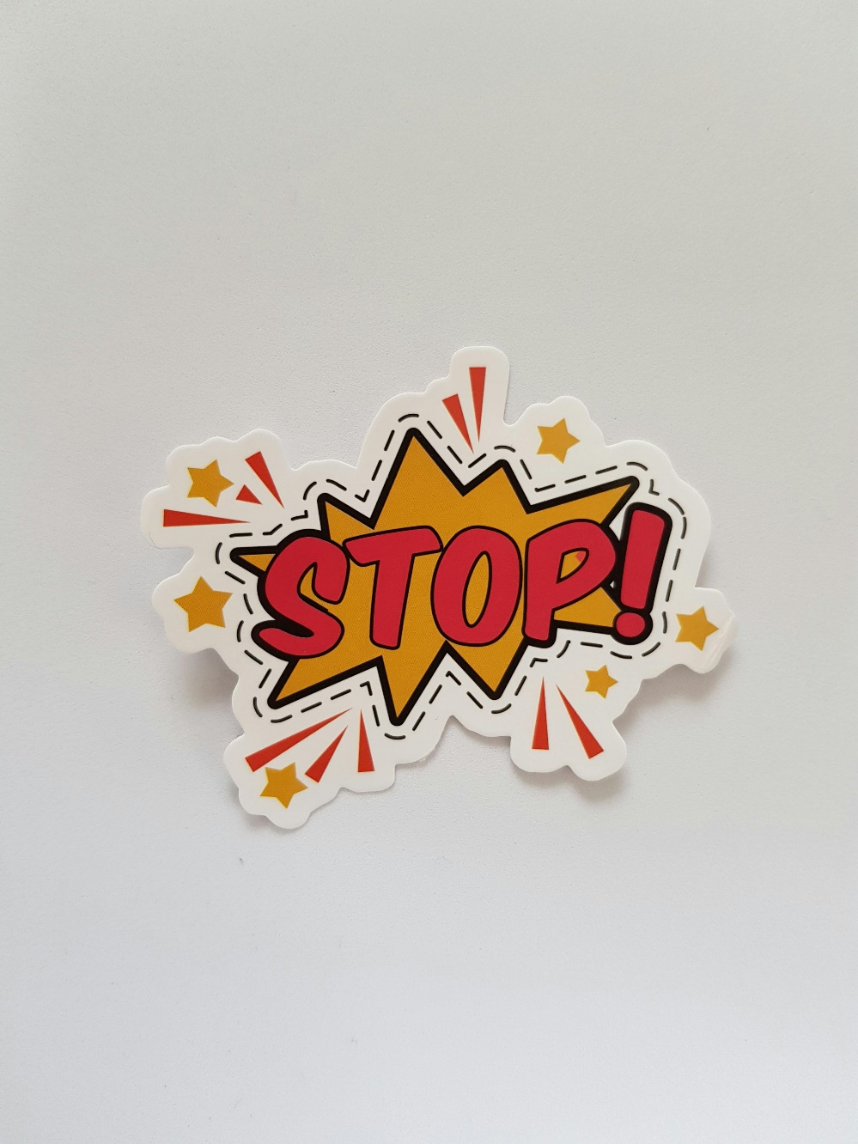

**Facts**

Boundaries:

* are a form of self-care.
* help create a clear guideline/rule/limit of how you would like to be treated.
* let others know what is and what is not okay/acceptable.
* honour our needs and wants so that we feel respected and safe.
* also help to avoid burnout, stress, and anxiety.

**Myth Buster**

Here are some of the myths about self-care.

* Setting boundaries is selfish X
* Boundaries push people away X
* Putting boundaries in place is rude X
* Having boundaries is saying no to everything all the time X
* Putting in boundaries will upset others X
* Boundaries you set can never change X
* Setting boundaries is telling someone what to do X
* You must have the same boundaries for everyone X

**Video clips**

Check out these videos about boundaries:

|  |
| --- |
| * [The Boundaries Song](https://www.youtube.com/watch?v=aSFvJbSQdA4)   A song that explains and provides examples of boundaries (Ks1) |
| * [Body boundaries make me stronger by Elizabeth Cole](https://www.youtube.com/watch?v=O_vIcy6ngJo)   A children’s story book about body boundaries (Ks1) |
| * [[Rethink SEL - Boundaries](https://www.youtube.com/watch?v=STP6KTKArPc)](https://www.youtube.com/watch?v=_s20iNLTRwo)   Video describing boundaries (Ks1 & Ks2) |
| * [How to Set Healthy Personal Boundaries](https://www.youtube.com/watch?v=pC5FtPX6Ngg)   Video to explain how to set healthy boundaries (Ks2) |
| * [Setting Healthy Boundaries](https://www.youtube.com/watch?v=XFAEeOd3H9k)   The Prevention Connection have created a video about boundaries (Ks2) |
| * [Setting Boundaries - Mental Health Lessons](https://www.youtube.com/watch?v=Gf4FIt5DG4g)   Irelands National Public Service Media’s setting boundaries video (Ks2) |

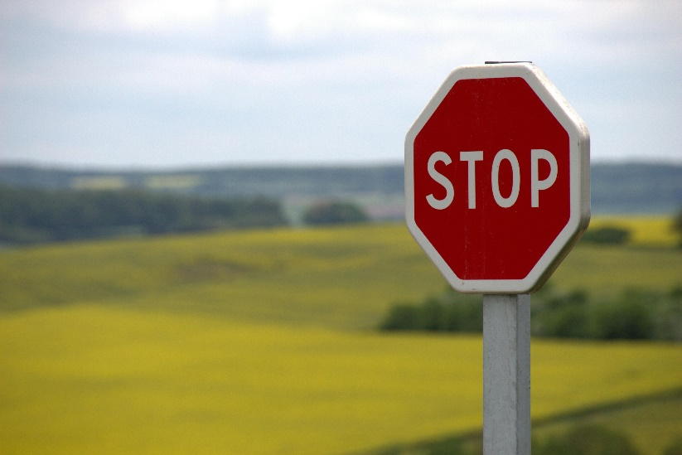

**Resources**

|  |
| --- |
| We have indicated whether the resources are accessible for Ks1 or Ks2. Please note that some of the Ks2 content could be adapted and differentiated to support pupils in Ks1. |
| * [255 Top "Boundaries" Teaching Resources curated for you](https://www.twinkl.co.uk/search?q=boundaries)   Twinkl resources for teaching pupils about boundaries (Ks1 & Ks2) |

**Reflective questions**

(Try exploring these reflective questions with a CYP)

* What are boundaries?
* Who needs boundaries?
* Why are boundaries so important?
* Can you name three of your own boundaries?

**Quiz**

Once you have gone through this resource with a CYP try these quiz questions with them:

* Name three boundaries that school set for their pupils?
* Why are boundaries important?
* Describe two personal boundaries.
* Describe two shared boundaries.
* Who needs boundaries?

**Signposting to Support**

For additional support we recommend you access the following:

* [Getting help for your child: where to start](https://www.youngminds.org.uk/parent/parents-a-z-mental-health-guide/getting-help-for-your-child/)
* [Childline](https://www.childline.org.uk/info-advice/your-feelings/mental-health/?&&&&gclsrc=aw.ds&&gclid=EAIaIQobChMIqryktIeP_wIVicPtCh3QZQs6EAAYASAAEgJr5vD_BwE&gclsrc=aw.ds) - 0800 1111 – [when contacting ChildLine what to expect](https://www.youtube.com/watch?v=_KNtMOKwTco)
* [Hopeline 0800 068 41 41](https://www.papyrus-uk.org/papyrus-HOPELINE247/) offering confidential support and practical advice
* [Text ‘SHOUT’ to 85258](https://giveusashout.org/get-help/?gclid=Cj0KCQiA6vaqBhCbARIsACF9M6nG--bxZCnflhd5C3jT-d9dS48o5t6XTTTidI0MLTgwjjRAlxszRT8aAnvvEALw_wcB) for free, confidential, anonymous text support service
* [NHS 111](https://www.nhs.uk/nhs-services/mental-health-services/)
* [Southend, Essex & Thurrock Children and Adolescent Mental Health Service (SET CAMHS)](https://www.nelft.nhs.uk/set-camhs/)
* [Explore counselling/therapy](https://www.nhs.uk/mental-health/talking-therapies-medicine-treatments/talking-therapies-and-counselling/counselling/)
* [Where to get urgent mental health support from: Advice from NHS](https://www.nhs.uk/nhs-services/mental-health-services/where-to-get-urgent-help-for-mental-health/)



* SET CAMHS Instagram account

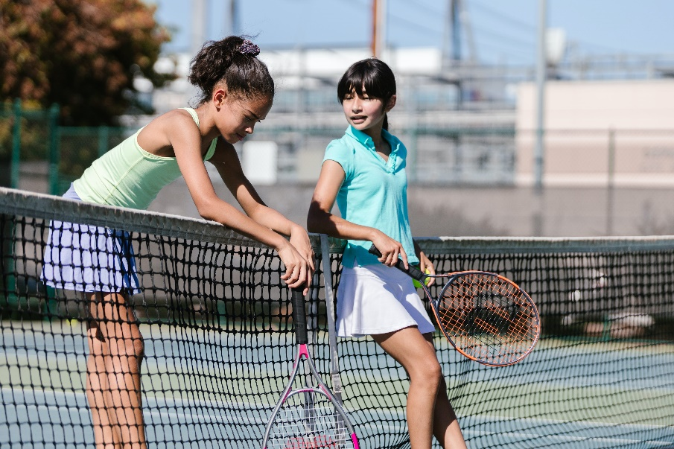

**How to help a friend**

* Start a conversation about boundaries. Describe to them what boundaries are and why they are important.
* Review your boundaries with your friends. Tell them what you like and what you do not like, describe what makes you feel comfortable and uncomfortable.
* Ask your friends about their boundaries. What are the things they like or do not like and let them describe the things they are comfortable and uncomfortable with.

**The adult box** (for professionals and parent/carers to read)

|  |
| --- |
| * [How to Teach Children to Set Boundaries](https://www.twinkl.co.uk/blog/how-to-teach-children-to-set-boundaries#:~:text=You%20can%20discuss%20what%20boundaries,inclined%20to%20push%20their%20boundaries.)   Twinkl’s teaching resources to support you teach pupils about boundaries |
| * [Teaching Kids About Boundaries](https://childmind.org/article/teaching-kids-boundaries-empathy/)   Child Mind Institute article on teaching kids about boundaries |
| * [Teaching Kids About Healthy Boundaries](https://www.ourfamilywizard.co.uk/blog/teaching-kids-about-healthy-boundaries)   Our Family Wizard article teaching kids about healthy boundaries |
| * [Setting boundaries](https://familytoolbox.co.uk/resource-list/setting-boundaries/)   Family toolbox video for parents about setting boundaries |
| * [Teaching About Consent and Healthy Boundaries with Learners with SEND](https://www.twinkl.co.uk/blog/teaching-about-consent-and-healthy-boundaries-with-learners-with-send)   Twinkl describe the importance of teaching about boundaries to those learners with SEND |

