**Let’s Talk: Belonging & being a part of a healthy group**

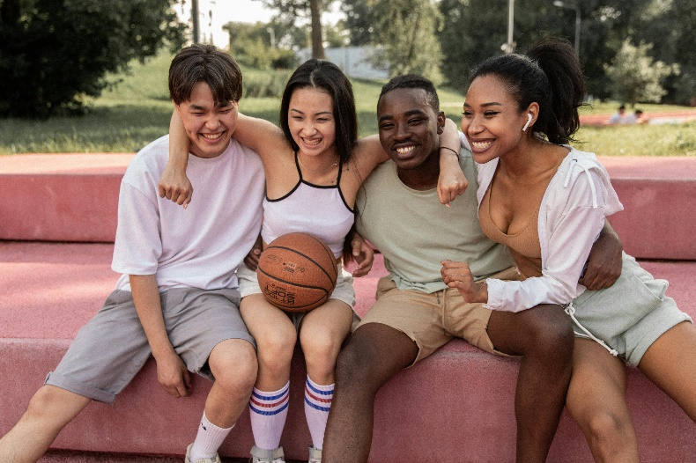**Secondary**

This resource is part of our self-care suite of resources and has been co-produced with children and young people living in Essex, for children and young people. They have also been developed and quality assured by the following stakeholders:

* Essex Educational Psychology Service
* Health Watch Essex
* Essex Mental Health Support Teams (MHSTs) NELFT NHS Foundation Trust
* Essex Multi-schools Council
* Essex Social, Emotional and Mental Health (SEMH) strategy team
* Essex Child and Family Wellbeing Service, HCRG Care Group in partnership with Barnardos
* NELFT NHS Trust Southend, Essex, and Thurrock (SET) Child, Adolescent and Mental Health Service (CAMHS)
* Professionals in schools and settings can access all these resources via the [Essex info link SEMH portal](https://schools.essex.gov.uk/pupils/social_emotional_mental_health_portal_for_schools/Pages/Self-care-for-CYP-Library.aspx). Children and young people (CYP), parents/carers and professionals can also access these resources via the SET CAMHS website. Our self-care content can also be accessed via SET CAMHS Instagram account:

The resources are intended to be accessed by CYP independently or trusted adults use these resources with CYP through 1:1 conversation, whole school/group discussion and assemblies.

Please note: some of the content within our self-care resources may be emotive for CYP. We recommend that you make use of the ‘signposting to support’ section of this document should any of the content be triggering.

   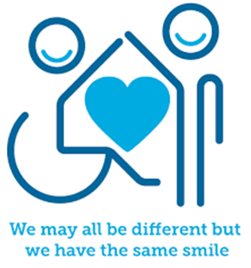

 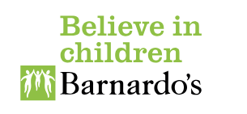

**Introduction**

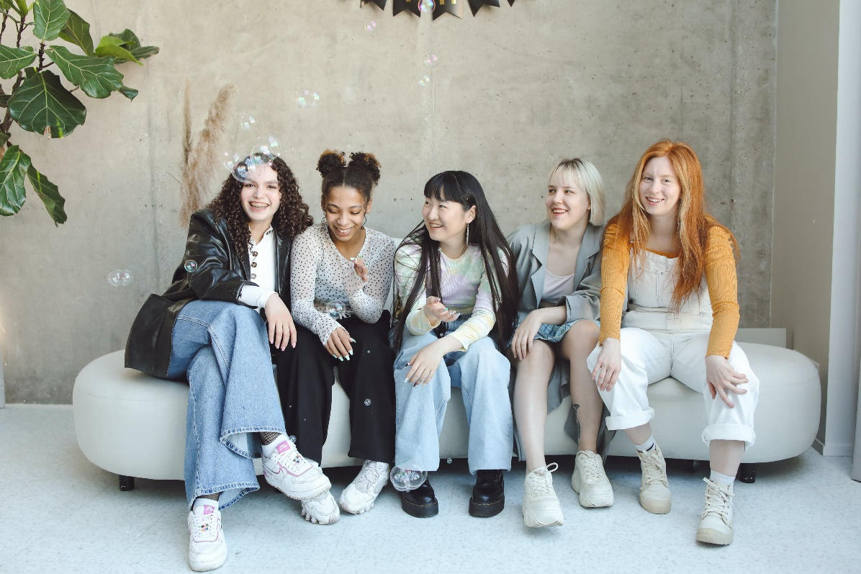Feeling a sense of belonging and being a part of a healthy group of people is essential for our wellbeing. Surrounding yourself with people that are like minded and who share common interests is considered one of the most important things you can do to look after your mental health. Healthy relationships in a child or young person’s life are important to their development, with research suggesting that those who have difficult or unhealthy peer relationships are more vulnerable to social and emotional problems as they grow up. Many children and young people agree that activities and hobbies are more enjoyable when they are shared with other people – enriching that sense of belonging.

**Facts**

Belonging is:

* One of humanities most basic needs
* Feeling happy or comfortable as part of a healthy group
* Having a positive relationship with other members of the group​
* Feeling welcomed and accepted by the whole group or community

Being a part of a healthy group means:

* Group members are willing to get to know one another, particularly those with different interests and backgrounds.
* Group members trust one another enough to share their own ideas and feelings.
* All members of the group feel safe, equal and respected.
* Group members demonstrate support for each other in times of need and emotional difficulty.



**Myth Buster**

Belonging and being a part of a healthy group:

* Can only be achieved in school X
* Is only important for girls X
* Others in the group always have to come first X
* Everyone in the group must like me X
* Group members must have the same interests and hobbies X
* You must agree with the views and opinions of others X
* You cannot be your true self X
* Belonging to an unhealthy group, such as a gang, is better than not belonging to any group X
* Online groups and communities and always safer X



**Video clips**

Check out these videos about belonging and being a part of a healthy group:

* [Spending time with friends | Anna Freud](https://www.annafreud.org/resources/children-and-young-peoples-wellbeing/self-care/spending-time-with-friends/)

Information for young people on why spending time with friends can have a positive impact on our mental health and emotional wellbeing.

* [Making new friends - BBC Bitesize](https://www.bbc.co.uk/bitesize/articles/znhf7nb)

For those worried about the transition to secondary school and making new friends.

* [Scouts made me - YouTube](https://www.youtube.com/watch?v=Jlrimx5fjTQ)

Feel a sense of belonging through joining your local scout group.

* <https://youtu.be/YmVpwXH4jhA>

How friendship affects your brain and why friendship is important.

**Resources**

* [Anna Freud – Mentally Healthy Schools](https://mentallyhealthyschools.org.uk/factors-that-impact-mental-health/school-based-risk-factors/relationships-and-belonging/" \t "_blank)

Importance of maintaining relationships

* [How sport can create a sense of belonging and inclusion - Youth Sport Trust](https://www.youthsporttrust.org/news-insight/blogs/how-sport-can-create-a-sense-of-belonging-and-inclusion)

Read about the importance of sport for building a sense of belonging

* [Friends | Tips and Advice about Friendships | YoungMinds](https://www.youngminds.org.uk/young-person/coping-with-life/friends/)

Understanding the importance of friendships for your mental health. How to recognise an unhealthy friendship

* [Faith and religion | Anna Freud](https://www.annafreud.org/resources/children-and-young-peoples-wellbeing/self-care/faith-and-religion/)

Read about how some young people find a sense of belonging in their faith communities

* [Online chat or peer group support | Anna Freud](https://www.annafreud.org/resources/children-and-young-peoples-wellbeing/self-care/online-chat-or-peer-group-support/)

Advice on how to communicate safely online with peers and chat communities

**Local groups and communities**

* [Essex Youth Service](https://youth.essex.gov.uk/)

Essex Youth Service helps young people in Essex to get the most out of school, work and life through community groups.

* [Essex Outdoors](https://www.essexoutdoors.com/groups/youth-groups/)

Bringing out the best in young people through the great outdoors through a number of community groups

* [Scouts](https://www.scouts.org.uk/)

Why not take a look at the Scouts Association and join one of their local groups?

* [Youth Sport Trust - Youth Sport Trust](https://www.youthsporttrust.org/)

The Youth Sport Trust Sport gives young people a platform to have their voice heard and a place to feel they belong.

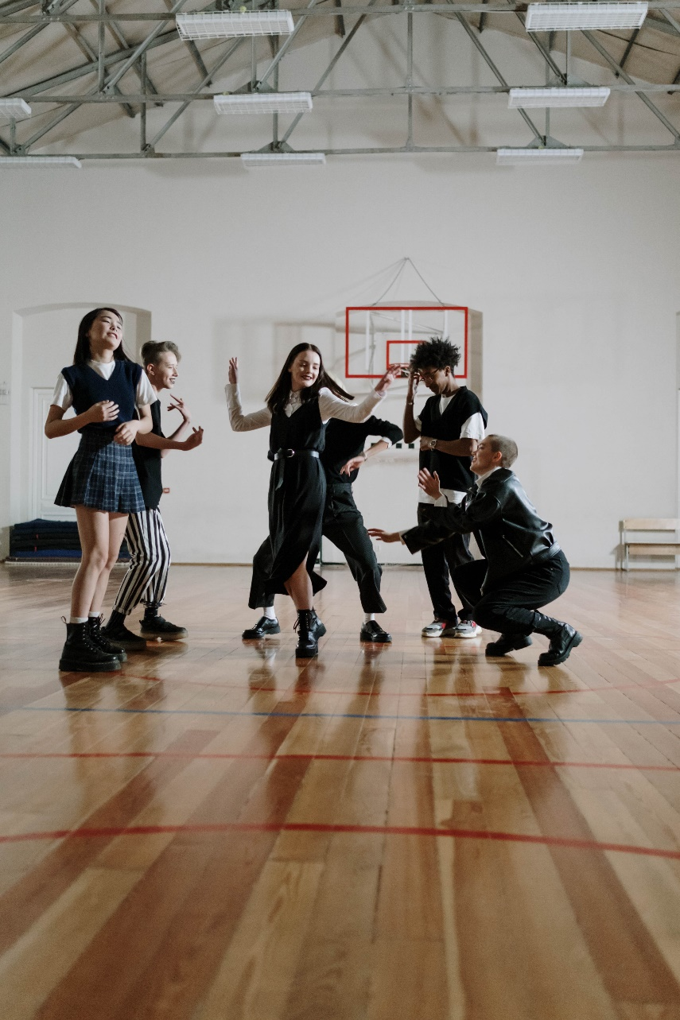

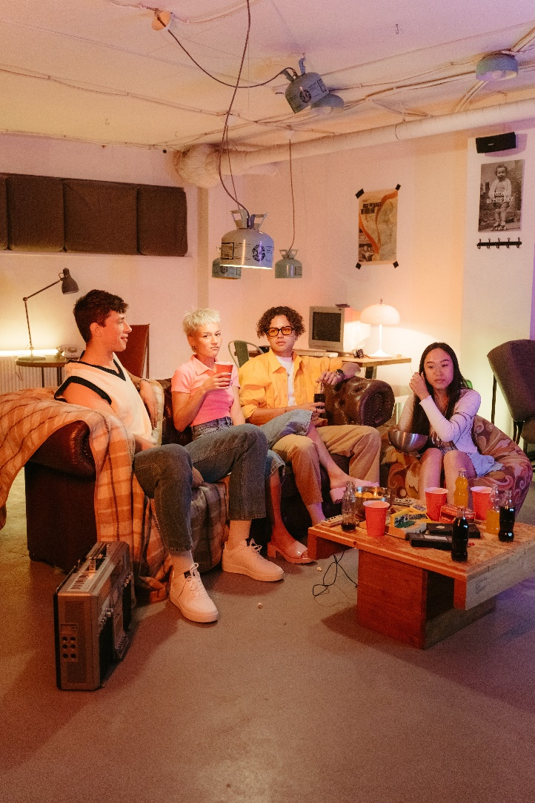

**Reflective Questions**

(Try exploring these reflective questions with a CYP)

1. What does belonging mean to you?
2. What groups do you belong to?
3. Where do you feel like you belong?
4. Are there any parts of your identity you wish you could know more about?
5. Do you ever feel lonely? If so, when?

**Quiz**

Once you’ve gone through this resource with a CYP try these quiz questions with them:

1. What does belonging mean?
2. Why is it important to feel a sense of belonging?
3. With whom can you feel like you belong?
4. Can everyone belong?
5. What could you do to feel connected?

**Additional Ideas**

Other things to try:

* [The Duke of Edinburgh's Award (essex.gov.uk)](https://youth.essex.gov.uk/young-people/the-duke-of-edinburghs-award/)

Have you thought about taking part in the Duke of Edinburgh Award?

**Signposting to Support**

For additional support we recommend you take a look at the following links:

* [Anna Freud Centre – On My Mind](https://www.annafreud.org/on-my-mind/)
* [Kooth.com](https://www.kooth.com/) (Age 11-25)
* [Togetherall](https://togetherall.com/en-gb/faqs/becoming-a-member-and-managing-your-profile/#:~:text=Togetherall%20is%20only%20for%20adults,is%20only%20available%20to%2018%2B.) (age 16+)
* [Explore counselling/therapy](https://www.nhs.uk/mental-health/talking-therapies-medicine-treatments/talking-therapies-and-counselling/counselling/)
* [Childline](https://www.childline.org.uk/info-advice/your-feelings/mental-health/?&&&&gclsrc=aw.ds&&gclid=EAIaIQobChMIqryktIeP_wIVicPtCh3QZQs6EAAYASAAEgJr5vD_BwE&gclsrc=aw.ds) 0800 1111
* [Text ‘SHOUT’ to 85258 for access to their 24/7 textline](https://giveusashout.org/)
* [Share any concerns about your mental health with your GP](https://www.mind.org.uk/information-support/guides-to-support-and-services/seeking-help-for-a-mental-health-problem/talking-to-your-gp/) and [Understanding Confidentiality](https://www.mind.org.uk/for-young-people/your-rights/understanding-confidentiality/)
* [NHS 111](https://www.nhs.uk/nhs-services/mental-health-services/)
* [Southend, Essex & Thurrock Children and Adolescent Mental Health Service (SET CAMHS)](https://www.nelft.nhs.uk/set-camhs/)
* [Where to get urgent mental health support from: Advice from NHS](https://www.nhs.uk/nhs-services/mental-health-services/where-to-get-urgent-help-for-mental-health/)
* [SouthEast and East Asian Centre](https://www.seeac.org.uk/mental-health-support) A community group for migrants, refugees and anyone of southeast and east Asian heritage in the UK.
* [African families in the UK](https://africanfamiliesuk.wixsite.com/afiuk) A community interest charity for British African children and their families.
* [The Outhouse](https://theouthouse.org.uk/)  A place for the Essex LGBTQ+ community to find support and friendship.
* SET CAMHS Instagram account 

**The adult box** (for professionals and parent/carers to read)

* [Research shows 'a sense of belonging' is important for pupils’ learning and behaviour | IOE - Faculty of Education and Society - UCL – University College London](https://www.ucl.ac.uk/ioe/news/2020/nov/research-shows-sense-belonging-important-pupils-learning-and-behaviour)

How research shows the importance of pupil’s sense of belonging

* [Parents' Guide to Looking After Your Mental Health | YoungMinds](https://www.youngminds.org.uk/parent/parents-guide-to-looking-after-yourself/)

A-Z mental health guide for parents: how to talk to your child about mental health, getting help for your child, parent support groups, parent helplines, webchats and blogs.

* [What do Scouts do? | Scouts](https://www.scouts.org.uk/information-for-parents/what-do-scouts-do/)

A guide for parents of the various groups the scouting association offer to children and young people, including Scouts (10-14 years) and Explorers (14-18 years)

* [How sport can create a sense of belonging and inclusion - Youth Sport Trust](https://www.youthsporttrust.org/news-listings/blogs/how-sport-can-create-a-sense-of-belonging-and-inclusion)

Youth sport trust explain how sport can create a sense of belonging and inclusion

* [Supporting others - Every Mind Matters - NHS (www.nhs.uk)](https://www.nhs.uk/every-mind-matters/supporting-others/)

Advice on how best to support children and young people with their mental health

* [Positive friendships](https://campaignresources.phe.gov.uk/schools/resources/positive-friendships)

Public Health England resources for Ks3 and Ks4 about positive friendships

* [National education union](https://neu.org.uk/advice/classroom/behaviour/creating-sense-place-and-belonging-schools)

How to create a sense of space and belonging in schools – teaching staff resources

* [UNICEF – How to connect with your child](https://www.unicef.org/parenting/child-care/9-tips-for-better-communication)

Parenting advice on how to listen, connect and bond with your child.

* [On our sleeves – how to boost belonging](https://www.onoursleeves.org/mental-wellness-tools-guides/belonging/belonging-boosts-kids-mental-health)

Guidance on how to help children and young people feel a sense of belonging to boost their mental health.

* [Sport England](https://www.sportengland.org/research-and-data/research/children-and-young-people" \t "_blank)

An article on how sports can help children and young people to feel a sense of belonging.

   

 