**Running Reports Step-by-step**

Please note that once you submit your data in COLLECT, you must wait 24 hours until you can run the reports as the system updates overnight.

This is also the case if you edit your data and then submit your return. You will only be able to run the reports 24 hours after you have submitted the data.

Before launching any reports, you need to know where to find the specific reports that your school needs to run as this will differ depending on your data. To find what reports you need to run you will firstly:

1. Go into COLLECT onto your source page (where it tells you what status your data is at), and then click on the ‘Open Return’ button.
2. 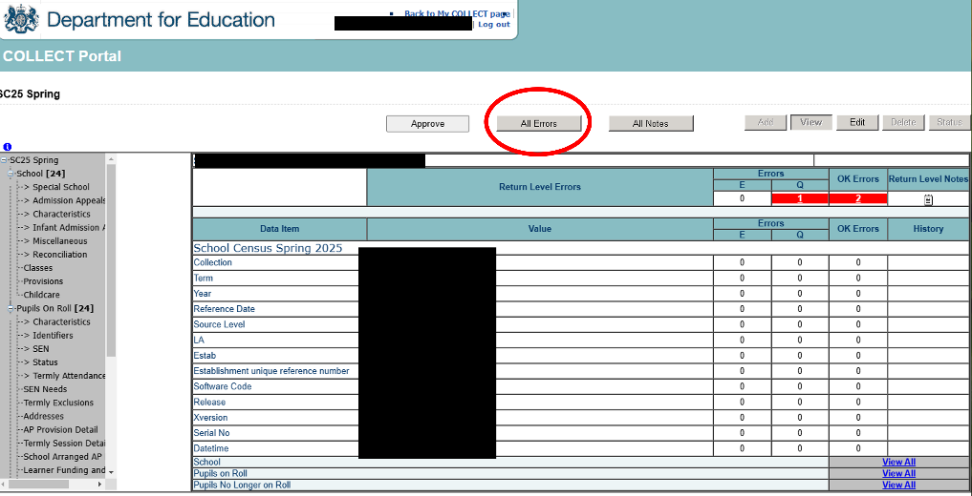Once you have opened the return, you will then need to click on the ‘ALL Errors’ button at the top as this will allow you to view any and all errors including the running reports query.
3. Once you have opened this you will be able to see the run reports query (usually the last query in your list).

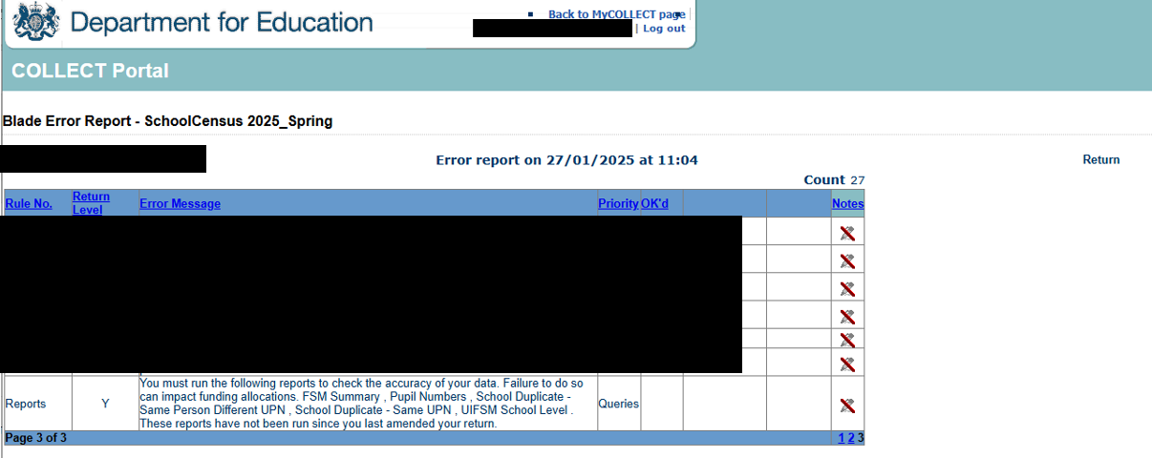

1. This will give you a list of the different reports you will need to run. We recommend that you make note of the different reports so you don’t have to keep going back and forth.
2. Once you have your list, you will then click the ‘Return to My COLLECT Page’ button which will take you back to your main COLLECT page.

This can be done following these steps which can be found [here](https://assets.publishing.service.gov.uk/media/5d3ade7aed915d0d0446889e/Collect_guide_for_schools_July-2019.pdf) on page 20:

1. Once you are back to your COLLECT page, you will then need to click the button that says “Launch Report”.

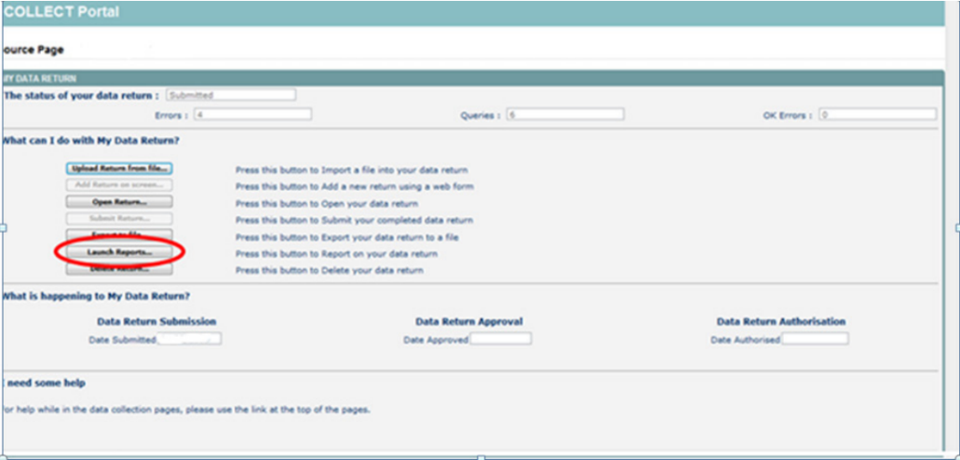

1. Once you click on “Launch Report”, you will be given a drop-down list of reports you can run.
2. Select the relevant report and launch report, you will then have to click launch report again on a separate page.
3. Once you have the information about the relevant report, you can choose to print or save this for your own file.
4. Then you will need to go all the way back to the main portal page, then click onto ‘Launch Report’.
5. You will then repeat steps 5-9 for each report needed. If you have any issues with any of the reports, you need to let us know so that we can help resolve these issues.

School Data Team

[Schooldata@essex.gov.uk](mailto:Schooldata@essex.gov.uk)