Unauthorised leave (term time holidays) - Essex Fixed Penalty Notice Portal – Guidance for Schools
September 2024

SCHOOL - Adding a New Fixed Penalty Notice (FPN) Request

Using the FPN Portal
 | Activity | Screen
 | Select the school the FPN request is being submitted from | 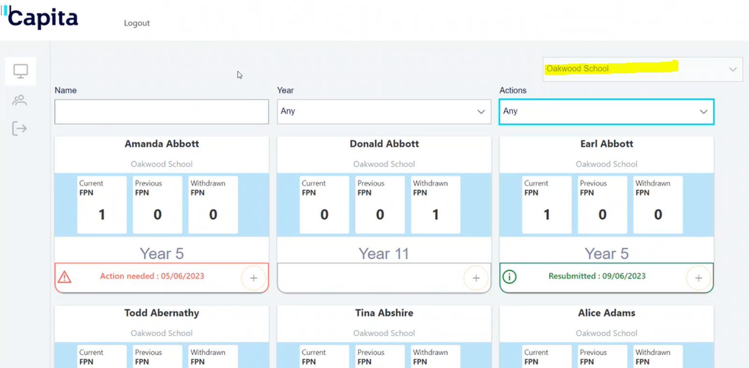
 | Search for the student the FPN request is for | 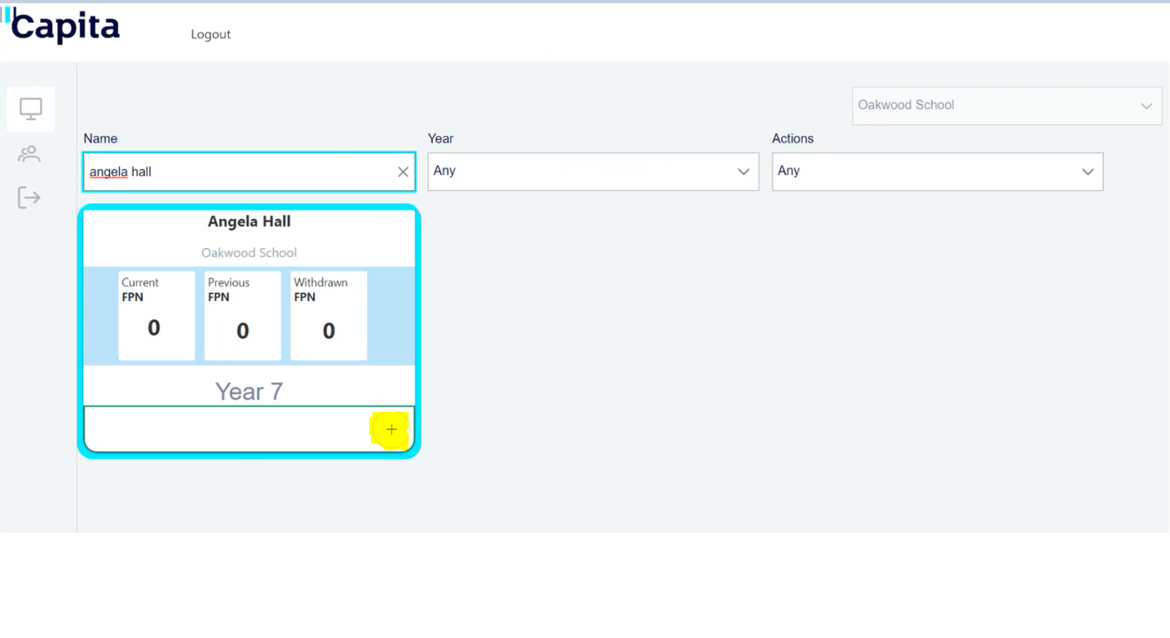
 | Click on the “Start new request” icon in the bottom right of the card – select a reason for the request.  N.B. Holiday absences is the only reason which should be selected here – requests for penalty notices for other absence reasons must be submitted via the alternative referral pathways, available via Essex Schools Infolink, | 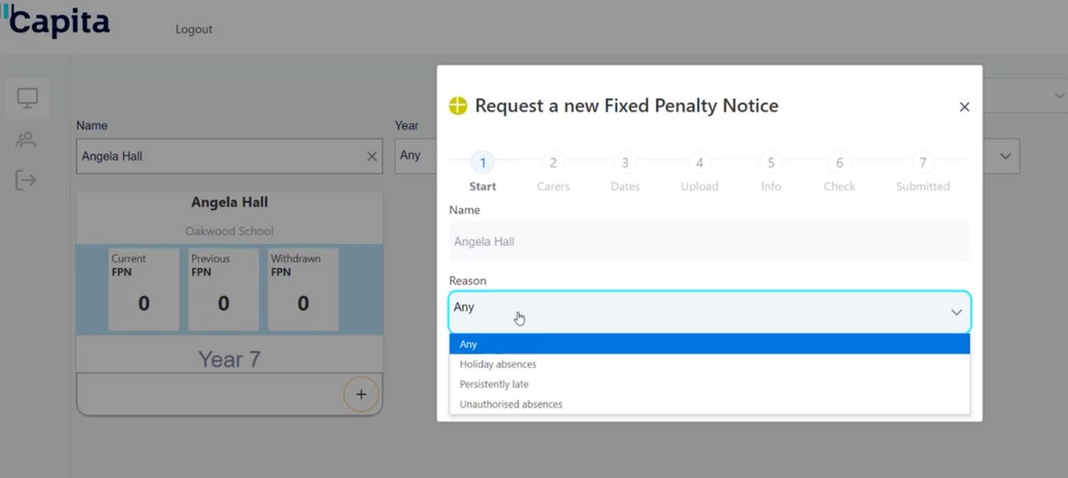
 | Click Next to take you to the Carers step – add one or more parents and carers | 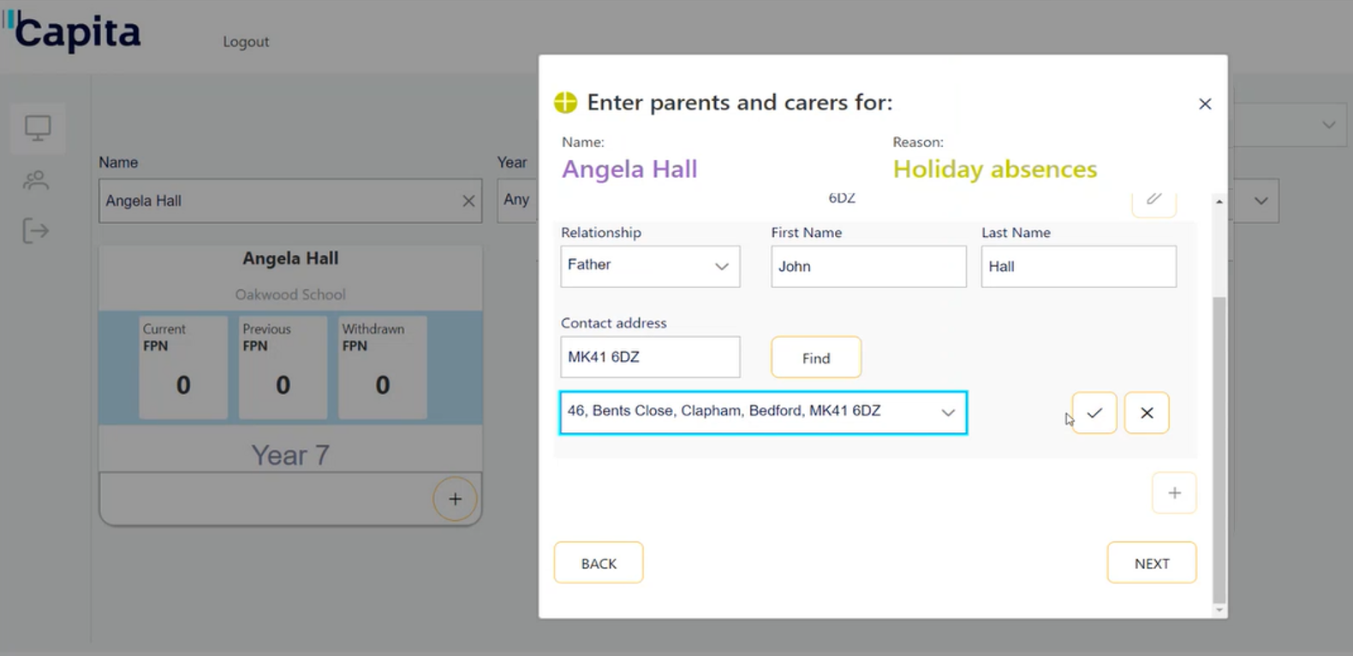  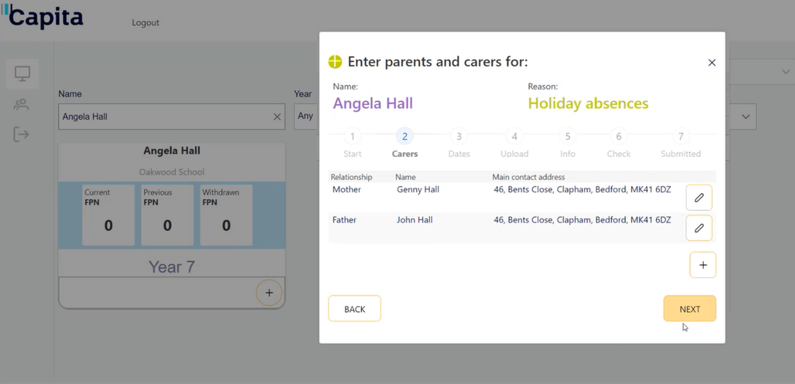
 | Click Next to take you to Dates step – add one or more dates or date ranges | 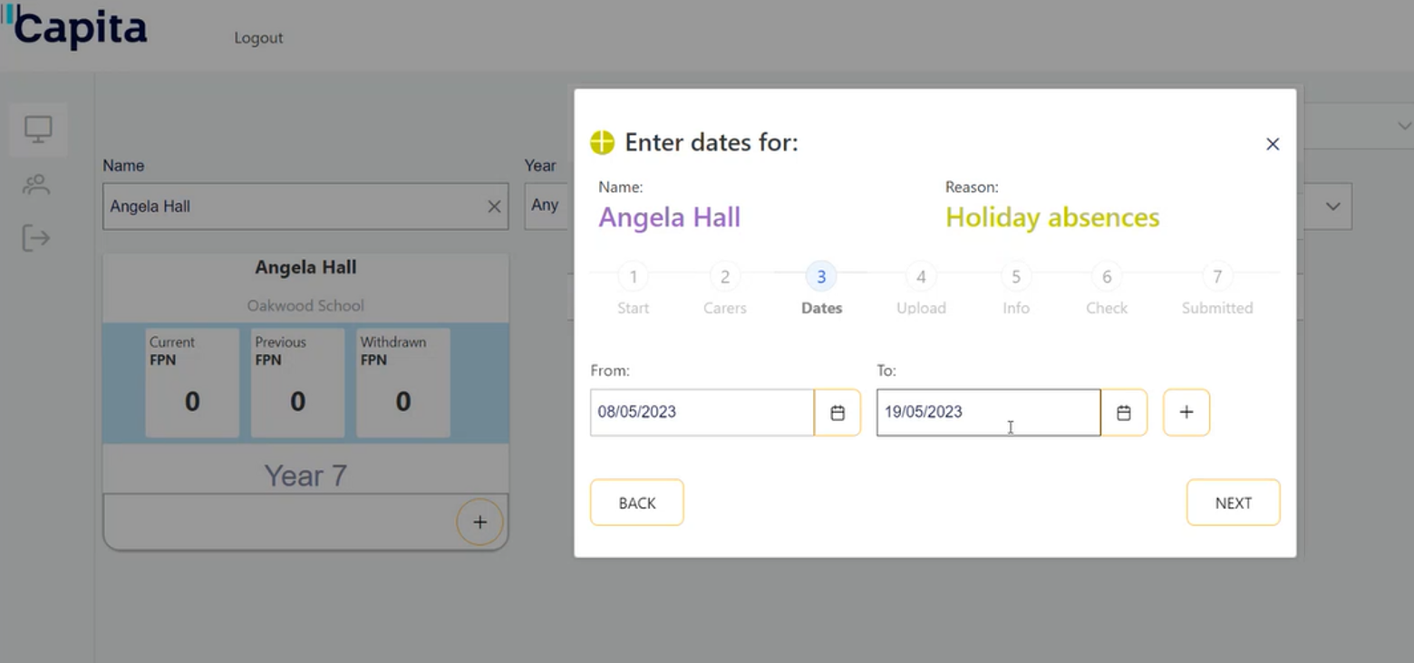
 | Click Next to take you to Evidence step – select one or more files – ensure that all evidence listed within the guidance provided is uploaded to your FPN request | 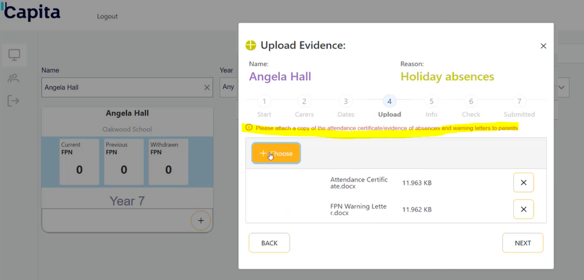
 | Click Next to take you to Further Information step – it is optional to record text here | 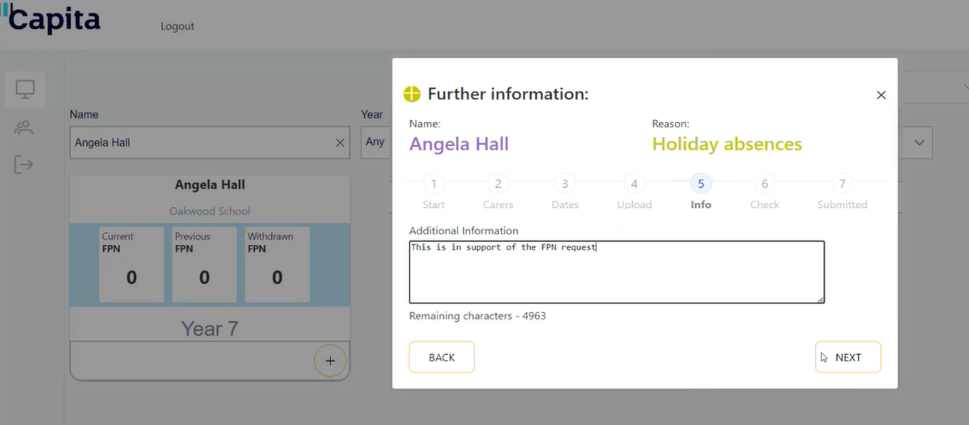
 | Click Next to take you to Submission next – you must agree to the Terms & Conditions to click Submit | 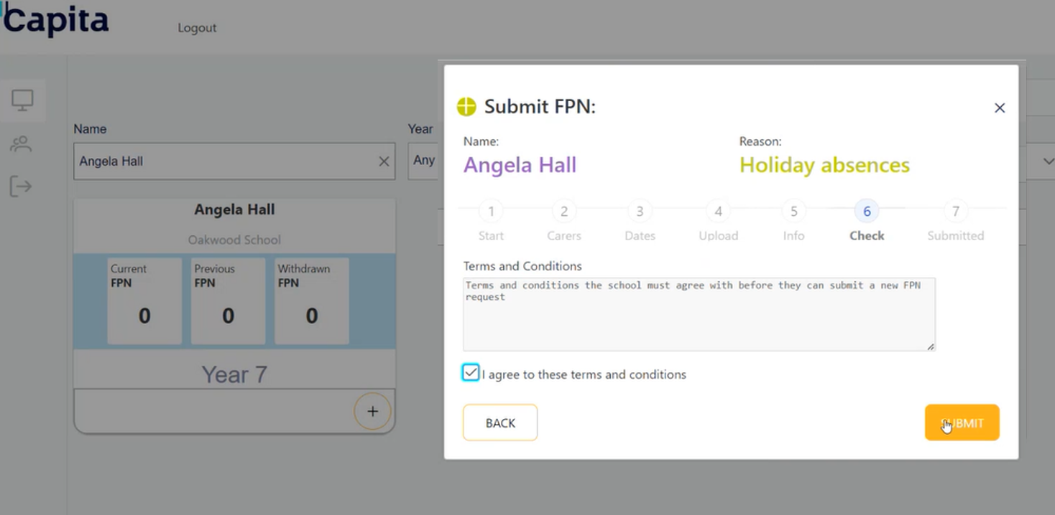
 | Click Submit displays a confirmation window | 