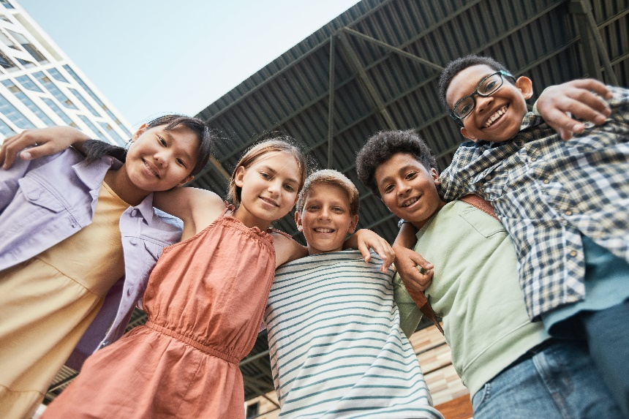**Let’s Talk: kindness, compassion, and gratitude**

**Primary**

This resource is part of our self-care suite of resources and has been co-produced with children and young people living in Essex, for children and young people. They have also been developed and quality assured by the following stakeholders:

* Essex Educational Psychology Service
* Health Watch Essex
* Essex Mental Health Support Teams (MHSTs) NELFT NHS Foundation Trust
* Essex Multi-schools Council
* Essex Social, Emotional and Mental Health (SEMH) strategy team
* Essex Child and Family Wellbeing Service, HCRG Care Group in partnership with Barnardo’s
* NELFT NHS Trust Southend, Essex, and Thurrock (SET) Child, Adolescent and Mental Health Service (CAMHS)
* Professionals in schools and settings can access all these resources via the [Essex info link SEMH portal](https://schools.essex.gov.uk/pupils/social_emotional_mental_health_portal_for_schools/Pages/Self-care-for-CYP-Library.aspx). Children and young people (CYP), parents/carers and professionals can also access these resources via the SET CAMHS website. Our self-care content can also be accessed via SET CAMHS Instagram account:

The resources are intended to be accessed by CYP independently or trusted adults use these resources with CYP through 1:1 conversation, whole school/group discussion and assemblies.

Please note: some of the content within our self-care resources may be emotive for CYP. We recommend that you make use of the ‘signposting to support’ section of this document should any of the content be triggering.

   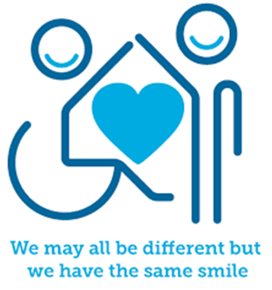

 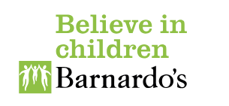

**Introduction**

Kindness, compassion, and gratitude are three separate skills, that together are very powerful in supporting our mental health and wellbeing. Being kind is a way of being nice, generous, helpful, and caring to not only others, but ourselves too. Being kind feels good to both the person who is receiving it and the person offering it. Compassion is understanding what someone else is feeling and experiencing and wanting to help and support them. It is a very helpful skill and enables us to be a good friend. Gratitude is the positive feeling of being grateful, appreciative, and thankful for what you have, what you experience and what you receive from others. These three qualities all contribute to a positive mindset which helps us to feel confident, happy, and motivated in our lives.

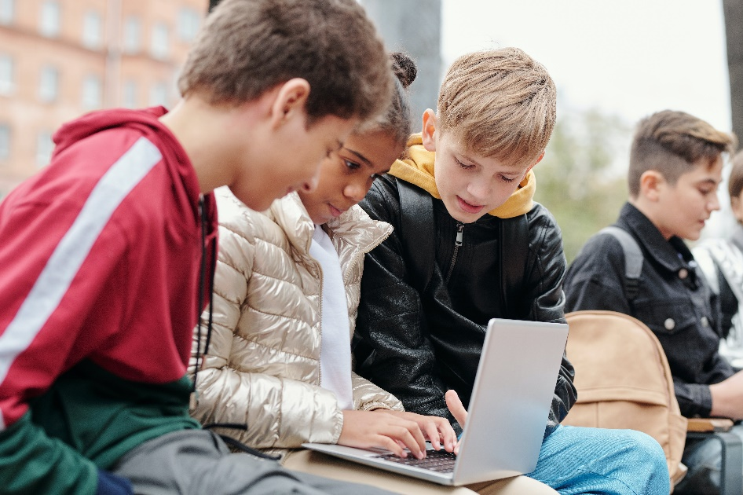

**Facts**

Kindness, compassion, and gratitude:

* are skills that need to be learnt and practiced
* are things you can show both others and yourself
* are qualities that help us be a good friend

**Myth Buster**

Here are some of the myths about kindness, compassion, and gratitude.

* If you do not show these qualities all the time you are a bad person X
* Being kind to yourself is selfish X
* It is not okay to find these skills difficult to do X
* You should not expect other people to show you these qualities X

**Video clips**

Check out these videos about kindness, compassion and gratitude:

|  |
| --- |
| * [The Science of Kindness](https://www.youtube.com/watch?v=O9UByLyOjBM)   This video describes the benefits of being kind (Ks2) |
| * [Kindness Makes Me Stronger](https://www.youtube.com/watch?v=m7R1sucXRFk)   A children’s story book about kindness read by StoryTimeFamily (Ks1) |
| * [Compassion in Action](https://www.youtube.com/watch?v=cAFq6PcFYgI)   Video describing compassion and how to show it to others (Ks1) |
| * [Character education: Compassion](https://www.youtube.com/watch?v=9ylsG5zx6Mo)   Video to describe what compassion means (Ks2) |
|  |
| * [Thankful by The Juicebox Jukebox | Gratitude Appreciation Kids Songs](https://www.youtube.com/watch?v=YeSdQmO51Ps)   A song about being grateful (Ks1 & Ks2) |
| * [Podcast: The Power of Gratitude](https://www.youtube.com/watch?v=7zym8dalGUw)   Headspace describes the benefits of gratitude (Ks2) |
|  |

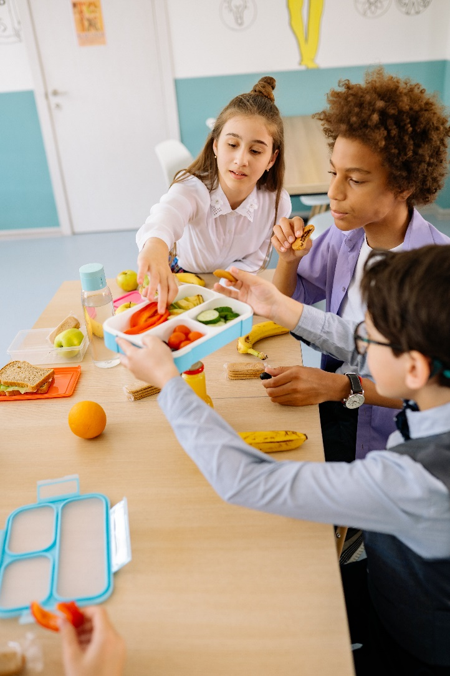

**Resources**

|  |
| --- |
| We have indicated whether the resources are accessible for Ks1 or Ks2. Please note that some of the Ks2 content could be adapted and differentiated to support pupils in Ks1. |
| * [School of Kindness | Encouraging Kindness in Schools](https://schoolofkindness.org/resources-for-schools/games-and-circle-time?gad_source=1&gclid=EAIaIQobChMIiLPfkI7ChgMV1ZJQBh1gXS8AEAAYASAAEgJ4RfD_BwE)   Kindness resources and activities for primary age children (Ks1 & Ks2) |
| * [Kindness activities that help improve wellbeing in your school](https://www.worthit.org.uk/blog/kindness-activities-school)   Ten practical kindness activity ideas (Ks1 & Ks2) |
| * [Free children's kindness activities pack](https://www.redcross.org.uk/get-involved/teaching-resources/kindness-activity-pack)   British Red Cross free kindness activity pack (Ks2) |

**Reflective questions**

(Try exploring these reflective questions with a CYP)

* Name three kind things you have done today.
* What was the last compassionate thing you did?
* What three things are you most grateful for?
* How has someone shown you kindness and compassion?
* What do you think your friend might be most grateful for?

**Quiz**

Once you have gone through this resource with a CYP try these quiz questions with them:

* What does it mean to be kind?
* What is compassion?
* What is gratitude?
* How can you be kind and compassionate to someone else?
* How can you show gratitude?

**Signposting to Support**

For additional support we recommend you:

* [Getting help for your child: where to start](https://www.youngminds.org.uk/parent/parents-a-z-mental-health-guide/getting-help-for-your-child/)
* [Childline](https://www.childline.org.uk/info-advice/your-feelings/mental-health/?&&&&gclsrc=aw.ds&&gclid=EAIaIQobChMIqryktIeP_wIVicPtCh3QZQs6EAAYASAAEgJr5vD_BwE&gclsrc=aw.ds) - 0800 1111 – [when contacting ChildLine what to expect](https://www.youtube.com/watch?v=_KNtMOKwTco)
* [Hopeline 0800 068 41 41](https://www.papyrus-uk.org/papyrus-HOPELINE247/) offering confidential support and practical advice
* [Text ‘SHOUT’ to 85258](https://giveusashout.org/get-help/?gclid=Cj0KCQiA6vaqBhCbARIsACF9M6nG--bxZCnflhd5C3jT-d9dS48o5t6XTTTidI0MLTgwjjRAlxszRT8aAnvvEALw_wcB) for free, confidential, anonymous text support service
* [NHS 111](https://www.nhs.uk/nhs-services/mental-health-services/)
* [Southend, Essex & Thurrock Children and Adolescent Mental Health Service (SET CAMHS)](https://www.nelft.nhs.uk/set-camhs/)
* [Explore counselling/therapy](https://www.nhs.uk/mental-health/talking-therapies-medicine-treatments/talking-therapies-and-counselling/counselling/)
* [Where to get urgent mental health support from: Advice from NHS](https://www.nhs.uk/nhs-services/mental-health-services/where-to-get-urgent-help-for-mental-health/)



* 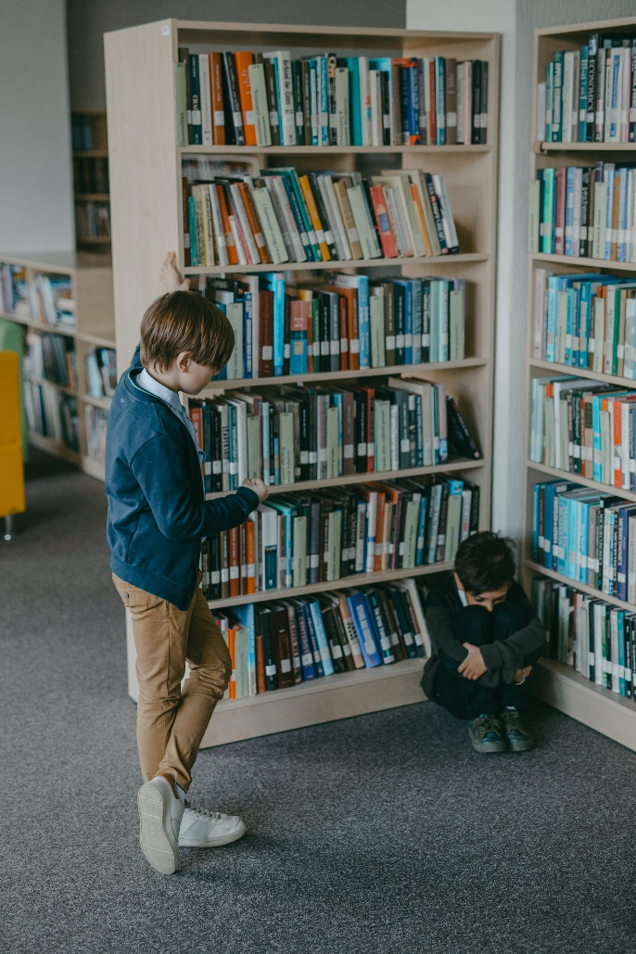SET CAMHS Instagram account

**How to help a friend**

* Start a conversation with a friend about kindness, compassion, and gratitude.
* Tell a friend what you are grateful for in your friendship with them.
* Ask a friend to think of a time they felt you had been kind and compassionate towards them.

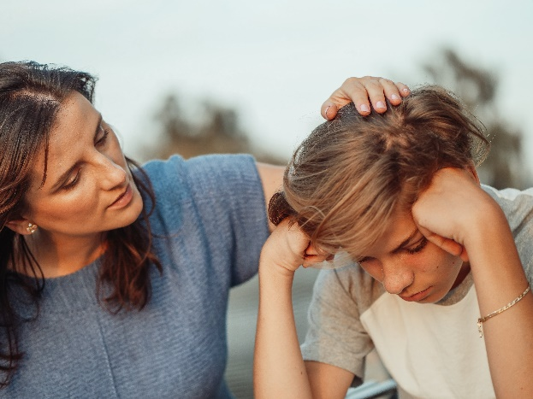**The adult box** (for professionals and parent/carers to read)

|  |
| --- |
| * [What is Kindness? How to Teach Kindness for Kids](https://www.twinkl.co.uk/teaching-wiki/kindness)   Twinkl’s teaching resources to support you teach pupils about kindness |
| * [Activities for teaching kindness to toddlers and children](https://parents.actionforchildren.org.uk/feelings-behaviour/wellbeing-activities/activities-teaching-kindness/)   Action for Children offer activities for parents/carers to do at home to teach their child about kindness. |
| * [How Can You Teach Your Children to Be Kind?](https://www.compassfostering.com/advice/teaching-children-kindness)   Compass fostering offers tips of helping to develop children’s kindness skills |
| * [Compassion Sorting Activity](https://www.twinkl.co.uk/resource/compassion-sorting-activity-t-tp-6932)   Twinkl’s teaching resources to support you teacher compassion |
| * [How to Teach Gratitude to Children](https://www.twinkl.co.uk/blog/how-to-teach-gratitude-to-children-10-top-tips)   Twinkl offer ten top tips on how to teach gratitude to children |
| * [10 Tips for Raising Grateful Kids](https://childmind.org/article/10-tips-raising-grateful-kids/)   Child Mind Institute provide ten tips for raising grateful children |
| * [Kindness and wellbeing teaching resources to develop resilience](https://www.redcross.org.uk/get-involved/teaching-resources/kindness-and-wellbeing-teaching-resources)   Red cross Kindness resources for Ks1 and Ks2 |

