**Let’s Talk: Unhealthy Relationships**

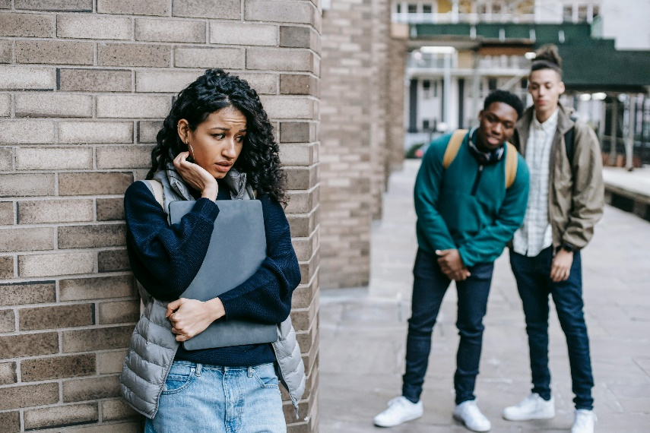**Secondary**

This resource is part of our self-care suite of resources and has been co-produced with children and young people living in Essex, for children and young people. They have also been developed and quality assured by the following stakeholders:

* Essex Educational Psychology Service
* Health Watch Essex
* Essex Mental Health Support Teams (MHSTs) NELFT NHS Foundation Trust
* Essex Multi-schools Council
* Essex Social, Emotional and Mental Health (SEMH) strategy team
* Essex Child and Family Wellbeing Service, HCRG Care Group in partnership with Barnardo’s
* NELFT NHS Trust Southend, Essex, and Thurrock (SET) Child, Adolescent and Mental Health Service (CAMHS)
* Professionals in schools and settings can access all these resources via the [Essex info link SEMH portal](https://schools.essex.gov.uk/pupils/social_emotional_mental_health_portal_for_schools/Pages/Self-care-for-CYP-Library.aspx). Children and young people (CYP), parents/carers and professionals can also access these resources via the SET CAMHS website. Our self-care content can also be accessed via SET CAMHS Instagram account:

The resources are intended to be accessed by CYP independently or trusted adults use these resources with CYP through 1:1 conversation, whole school/group discussion and assemblies.

Please note: some of the content within our self-care resources may be emotive for CYP. We recommend that you make use of the ‘signposting to support’ section of this document should any of the content be triggering.

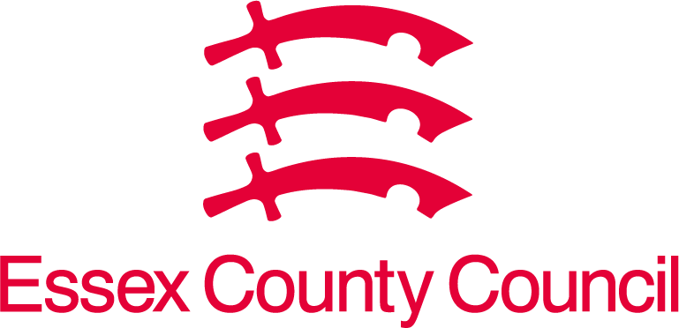  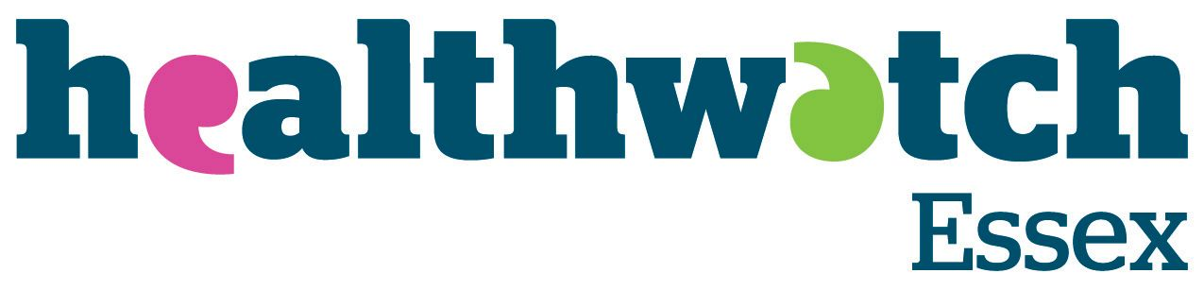 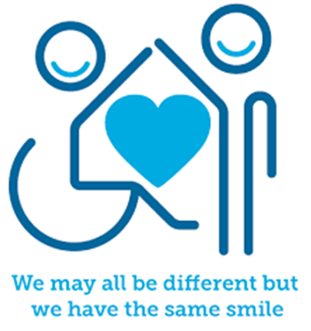

 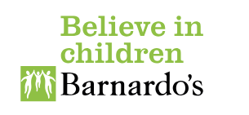

**Introduction**

In life we all need to feel that we belong and matter to others. This is why relationships are so important. These relationships can include our families, trusted adults, friends at school, different social groups outside of school, romantic relationships and even friends we make online. Knowing what makes a healthy relationship is important and you can find out more in our ‘Let’s Talk: Healthy Relationships’ self-care resource. It can also be just as important to know what the warning signs are of unhealthy relationships. This helps us to decide if the friendship/relationship is right for us and if we need help from others to support us with the relationship(s). An unhealthy relationship is one that has negative patterns of communication that cause unhappiness, power imbalances, lack of mutual respect and support, emotional, verbal and even physical abuse.



**Facts**

Some unhealthy relationship qualities include:

* Being pressured into doing things that you do not want to do such as being unkind to others or engaging in activities you know, or think are not right.
* When others say comments that are hurtful, unkind, and disrespectful towards you.
* You are constantly arguing and falling out.
* You are being left out regularly.
* Others make you feel guilty all the time.
* Others make you feel like you are always in the wrong.
* They put you down and make you feel bad about yourself.
* The person/people make you feel bad about being with other people, makes you choose between spending time with them and someone else/others, or doesn’t let you spend time with others.
* A relationship that is ‘one sided’ where you give them a lot of support, but you don’t get much in return.
* Being bullied, hurt, or hit.

**Myth Buster**

Here are some of the myths about unhealthy relationships:

* You must stay in a friendship group even if it is making you unhappy X
* We can’t ask for help to manage unhealthy relationships X
* Unhealthy relationships are okay if it is with family members X
* Unhealthy relationships only happen to younger/older people X
* If you love someone you do what they ask you to do because you want them to be happy X
* It’s just friends bantering with me so it’s okay X
* The language and way we communicate online is not as important as the way we speak to family, friends, and teachers in our everyday lives X
* An unhealthy relationship can’t turn into a healthy relationship with the right support X

**Video clips**

Check out these videos about boundaries:

|  |
| --- |
| * [Tricky Friends | Norfolk Safeguarding Children Partnership | C&YP (norfolklscp.org.uk)](https://norfolklscp.org.uk/children-young-people/tricky-friends)   Video talking about tricky friendships (Ks3)   * [Healthy vs Unhealthy Relationships (youtube.com)](https://www.youtube.com/watch?v=Gn7ZQ2x0cOE)   Video describing healthy and unhealthy relationships   * [Is My Relationship Healthy or Abusive? And What To Do (youtube.com)](https://www.youtube.com/watch?v=kPnbNQDkJWw)   A video to explore if a relationship is healthy or abusive and what to do   * [Official film | Disrespect NoBody (youtube.com)](https://www.youtube.com/watch?v=ObvC12uJa6A&t=13s)   Disrespect Nobody video about romantic relationships and sex |
| * [The Group Chat | Bullying | I Got You | Childline (youtube.com)](https://www.youtube.com/watch?v=iY5vtS5OtFY)   Childline ‘the group chat’ illustrates being a friend and not going along with the group ‘banter’ (Upper Ks2)   * [What Teens Think About: Healthy Relationships (youtube.com)](https://www.youtube.com/watch?v=DPb_B0pTBoQ)   myHealth for teens and young adults video describing what teens think about healthy relationships |
|  |
| * [Unhealthy Relationships (youtube.com)](https://www.youtube.com/watch?v=y-d3pa_wv1c&t=66s)   Somerset County Council video exploring unhealthy relationships   * [Healthy Relationships (youtube.com)](https://www.youtube.com/watch?v=9T3skk3pnu4)   Fixers UK video describes different unhealthy relationships |
| * [Teen Voices: Sexting, Relationships, and Risks (youtube.com)](https://www.youtube.com/watch?v=IZwVT6WnPQY)   Common sense education video about sexting, relationships, and risks   * [What Happens When You Contact Childline? | Childline (youtube.com)](https://www.youtube.com/watch?v=fCA6EhBhiC8)   Childline explaining what happens when you call them   * [What makes Childline so different? | NSPCC Learning (youtube.com)](https://www.youtube.com/watch?v=3vO7CPNnG4E)   Childline describe their service’s support for children and young people |
| * [The Walk Home From School | Bullying | I Got You | Childline (youtube.com)](https://www.youtube.com/watch?v=JKOa86HXyY0)   Childline bullying video |
|  |

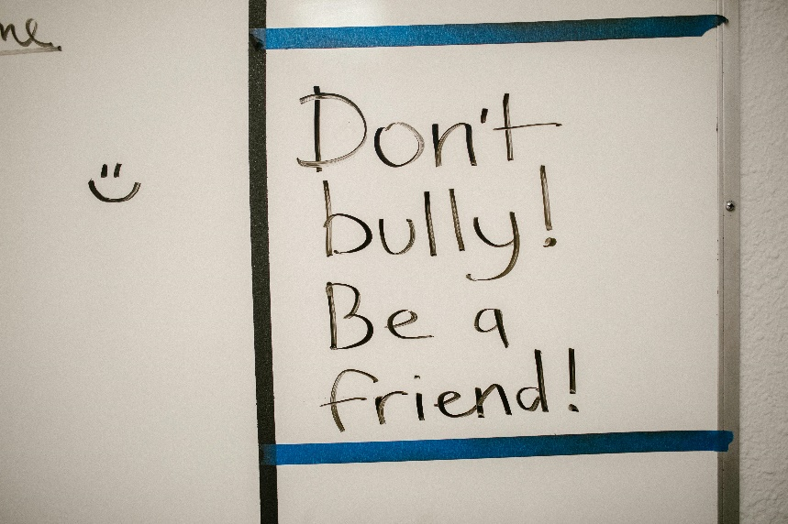

**Resources**

* [Healthy and unhealthy relationships | Childline](https://www.childline.org.uk/info-advice/friends-relationships-sex/sex-relationships/healthy-unhealthy-relationships/)

Childline article exploring healthy and unhealthy relationships

* [Friends | Tips and Advice about Friendships | YoungMinds](https://www.youngminds.org.uk/young-person/coping-with-life/friends/)

Young minds information about friends

* [What is a healthy relationship? - BBC Bitesize](https://www.bbc.co.uk/bitesize/articles/zfn7vk7)

BBC Bitesize What is a healthy relationship (Ks3)

* [Unhealthy Relationships – LMK (lmkletmeknow.org)](https://lmkletmeknow.org/unhealthy-relationships/?gad_source=1&gclid=EAIaIQobChMIl9iu5djYhgMV5o9QBh3eYwJ5EAAYAyAAEgK_tfD_BwE)

LMK Let me know – 10 unhealthy signs in a relationship explored

* [Characteristics of Healthy & Unhealthy Relationships | Youth.gov](https://youth.gov/youth-topics/teen-dating-violence/characteristics)

Youth.gov provide information about characteristics of healthy and unhealthy relationships

* [Am I in a Healthy Relationship? (for Teens) | Nemours KidsHealth](https://kidshealth.org/en/teens/healthy-relationship.html)

Nemours TeensHealth article – am I in a healthy relationship?

**Reflective questions**

(Try exploring these reflective questions with a CYP)

* What is an unhealthy relationship?
* Name three warning signs that a relationship may be unhealthy?
* Why might someone stay in an unhealthy relationship?
* Who could you go to for support to manage unhealthy relationships?
* What types of relationships can be unhealthy?

**Quiz**

Once you have gone through this resource with a CYP try these quiz questions with them:

* What is an unhealthy relationship?
* What are some of the signs of an unhealthy relationship?
* What are three myths about unhealthy relationships?
* Name different relationships that could be unhealthy.
* What service can you call to get help in managing unhealthy relationships?

**Signposting to Support**

For additional support we recommend you:

* [Getting help for your child: where to start](https://www.youngminds.org.uk/parent/parents-a-z-mental-health-guide/getting-help-for-your-child/)
* [Childline](https://www.childline.org.uk/info-advice/your-feelings/mental-health/?&&&&gclsrc=aw.ds&&gclid=EAIaIQobChMIqryktIeP_wIVicPtCh3QZQs6EAAYASAAEgJr5vD_BwE&gclsrc=aw.ds) - 0800 1111 – [when contacting ChildLine what to expect](https://www.youtube.com/watch?v=_KNtMOKwTco)
* [Hopeline 0800 068 41 41](https://www.papyrus-uk.org/papyrus-HOPELINE247/) offering confidential support and practical advice
* [Text ‘SHOUT’ to 85258](https://giveusashout.org/get-help/?gclid=Cj0KCQiA6vaqBhCbARIsACF9M6nG--bxZCnflhd5C3jT-d9dS48o5t6XTTTidI0MLTgwjjRAlxszRT8aAnvvEALw_wcB) for free, confidential, anonymous text support service
* [NHS 111](https://www.nhs.uk/nhs-services/mental-health-services/)
* [Southend, Essex & Thurrock Children and Adolescent Mental Health Service (SET CAMHS)](https://www.nelft.nhs.uk/set-camhs/)
* [Explore counselling/therapy](https://www.nhs.uk/mental-health/talking-therapies-medicine-treatments/talking-therapies-and-counselling/counselling/)
* [Where to get urgent mental health support from: Advice from NHS](https://www.nhs.uk/nhs-services/mental-health-services/where-to-get-urgent-help-for-mental-health/)



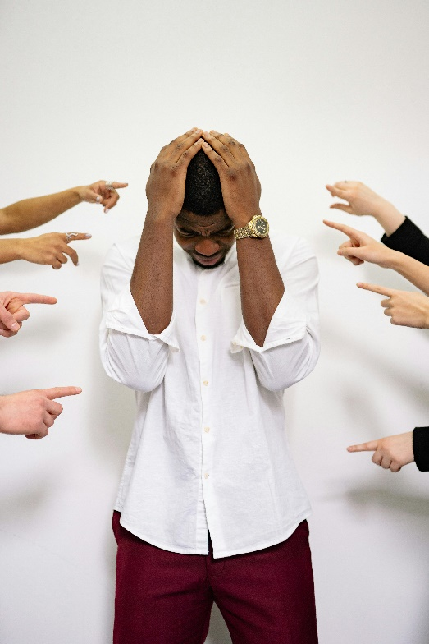

* SET CAMHS Instagram account

**How to help a friend**

* Start a conversation with a friend about healthy and unhealthy relationships.
* Suggest a friend seeks help from a trusted adult if they are experiencing one or more unhealthy relationships.
* Speak to a trusted adult if you are concerned a friend managing an unhealthy relationship.

**The adult box** (for professionals and parent/carers to read)

|  |
| --- |
| * [It's Not OK: online teaching resources | NSPCC Learning](https://learning.nspcc.org.uk/research-resources/schools/its-not-ok)   NSPCC learning resource It’s not ok - positive relationships resources (age 11+) |
| * [teaching-resource-guide.pdf (justonenorfolk.nhs.uk)](https://www.justonenorfolk.nhs.uk/media/p4ze40vs/teaching-resource-guide.pdf)   NSPCC and PSHE Association – making sense of relationships (Ks3 & Ks4) |
| * [How Can I Support My Friend in an Unhealthy Relationship? Worksheet (twinkl.com.se)](https://www.twinkl.com.se/resource/t3-p-186-how-can-i-support-my-friend-in-an-unhealthy-relationship-activity-sheet)   Twinkl – how can I support a friend in an unhealthy relationship worksheet along with a range of other secondary based resources to explore healthy and unhealthy relationships |
| * [7 Signs Your Teen Is in an Unhealthy Relationship (verywellfamily.com)](https://www.verywellfamily.com/unhealthy-relationship-signs-in-teens-4065362)   Verywellfamily provide 7 signs that your teen’s relationship is unhealthy |
| * [Healthy and unhealthy relationships | NSPCC Learning](https://learning.nspcc.org.uk/safeguarding-child-protection/healthy-and-unhealthy-relationships)   NSPCC Learning – healthy and unhealthy relationships |
| * [A Relationship Health Check A4 Display Poster (teacher made) (twinkl.co.uk)](https://www.twinkl.co.uk/resource/t3-p-195-a-relationship-health-check-a4-display-poster)   Twinkl relationship health check poster for CYP |
| * [Signs of an Unhealthy Relationship Poster (teacher made) (twinkl.co.uk)](https://www.twinkl.co.uk/resource/signs-of-an-unhealthy-relationship-poster-t-lf-1634216104)   Twinkl signs of an unhealthy relationship poster for CYP |

   

 