**Let’s Talk: Worrying about tests**

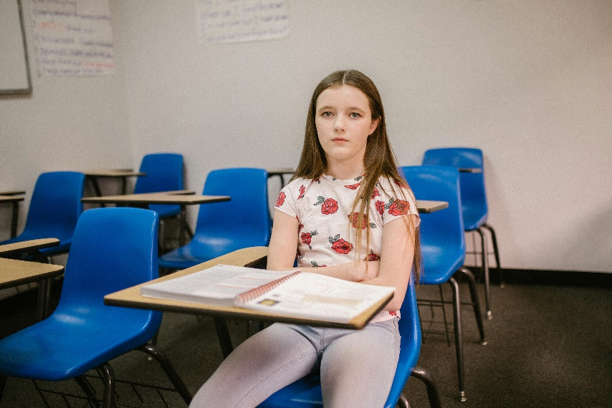**Primary**

This resource is part of our self-care suite of resources and has been co-produced with children and young people living in Essex, for children and young people. They have also been developed and quality assured by the following stakeholders:

* Essex Educational Psychology Service
* Health Watch Essex
* Essex Mental Health Support Teams (MHSTs) NELFT NHS Foundation Trust
* Essex Multi-schools Council
* Essex Social, Emotional and Mental Health (SEMH) strategy team
* Essex Child and Family Wellbeing Service, HCRG Care Group in partnership with Barnardos
* NELFT NHS Trust Southend, Essex, and Thurrock (SET) Child, Adolescent and Mental Health Service (CAMHS)
* Professionals in schools and settings can access all these resources via the [Essex info link SEMH portal](https://schools.essex.gov.uk/pupils/social_emotional_mental_health_portal_for_schools/Pages/Self-care-for-CYP-Library.aspx). Children and young people (CYP), parents/carers and professionals can also access these resources via the SET CAMHS website. Our self-care content can also be accessed via SET CAMHS Instagram account:

The resources are intended to be accessed by CYP independently or trusted adults use these resources with CYP through 1:1 conversation, whole school/group discussion and assemblies.

Please note: some of the content within our self-care resources may be emotive for CYP. We recommend that you make use of the ‘signposting to support’ section of this document should any of the content be triggering.

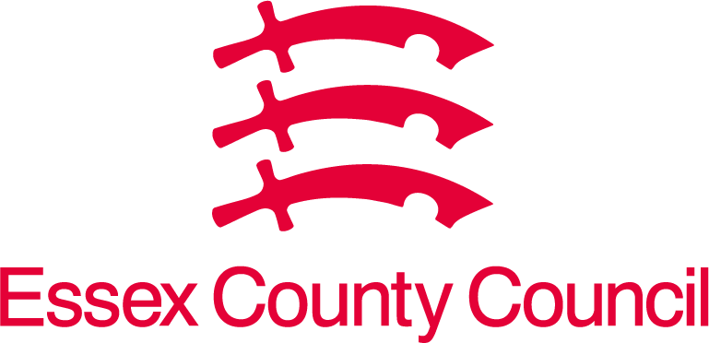  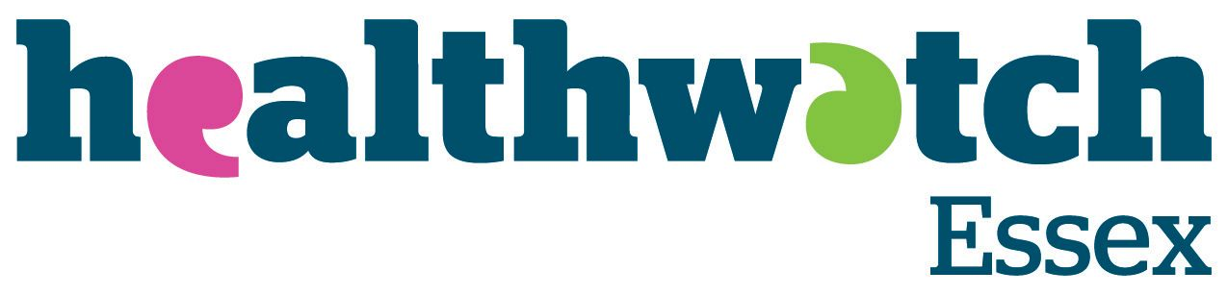 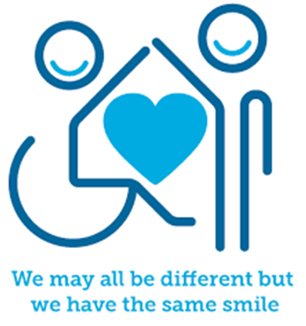

 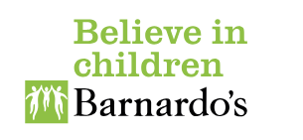

**Introduction**

It is normal to feel worried about doing tests. If you are worried about taking tests, this shows you care and want to do well. Tests do matter, but not in the way you think they do. Tests allow teachers to find out what you need help with, and when you get answers wrong it helps teachers know what to teach you. It is amazing if you get everything right, however most people do not.

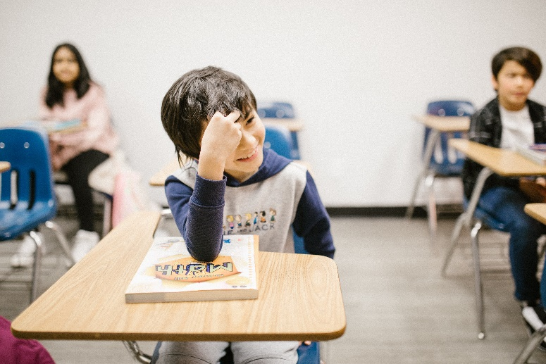

**Facts**

* **Most tests in school do not tell teachers how clever you are.** Tests are there to let teachers know what you need more help with. We all need help, children and adults, so tests help teachers know what you need help with the most.
* **The thing that matters more than anything is trying your best.** If you have tried your best, then it makes it easier for teachers to know how to help you, like it says above.
* **If you are worried about a test, it is best to talk to an adult in school.** They will have seen lots of other children take tests and will have some ideas on how to help you.
* **There can be some side effects that stress about tests can cause.** It is helpful to look out for these in yourself and your friends. They include: becoming upset, angry or withdrawn, not wanting to go to school, funny feelings in the tummy or head, not wanting to talk about school or exams, being more tired, calling themselves names such as stupid or rubbish, reacting badly to mistakes in their work.

**Myth Buster**

* **If you fail a test, you are stupid** X

If you fail a test, you have found something difficult, and your teachers need to find a new way of teaching it to you. We all learn things at different speeds and in different ways and when a teacher knows you do not know something they can make sure you get time to practice it.

* **You can fail your SATs** X

If you’re in year 2 or year 6 you may be taking these tests called SATs. These help teachers see how you are doing in your learning and helps check how good teachers are. You cannot fail these tests, and as long as you try your best that’s all anyone can ask for.

* **You must work all the time to get the best test results** X

This is not true, but you do have to practice and learn as best you can. This might mean doing extra bits at home; however, you must also keep doing things you love and need. This means you must still eat at dinner time; you must engage in your hobbies and spend time outside. This is particularly important at weekends, adults need time away from work, children need time away from school!

* **Tests are the only way to measure how clever you are** X

There are so many things that tests, particularly SATs, cannot measure. You may have amazing skills in other things, such as social skills, understanding emotions, running and sports, drama….

**Video clips**

Check out these videos about self-care:

|  |
| --- |
| [Real kids talk about coping with anxiety (American)](https://www.youtube.com/watch?v=f3_Ew7ejOo4)  Kids Help Phone asked real kids about their experiences with anxiety to learn how they cope and how to get support |
| [Stress Relief for Kids - Stress Management Techniques - 9 Daily Habits to Reduce Stress](https://www.youtube.com/watch?v=h2zWopNUUJE)  Stress can be very uncomfortable, and sometimes overwhelming. Fortunately, stress is manageable with the right tips and coping skills. |
| [How to Cope with Anxiety – Childline](https://www.youtube.com/watch?v=pvM_TtQi9DU&t=4s)  Worried about exams? Get information on the symptoms of anxiety, why you feel nervous and what you can do. Contact Childline online or call free on 0800 1111. |
| The following are videos that can support self-esteem:  [The Power of Yet – Sesame Street with Janelle Monae](https://www.youtube.com/watch?v=XLeUvZvuvAs)  When something doesn't work out right now, follow Janelle Monae's advice and don't give up because you'll learn how! Keep trying and you'll reach your goal because that's the Power of Yet  [Don’t Give Up – Sesame Street with Bruno Mars](https://www.youtube.com/watch?v=pWp6kkz-pnQ)  When you want to do something new that seems hard to do, listen to Bruno Mars and don't give up! |

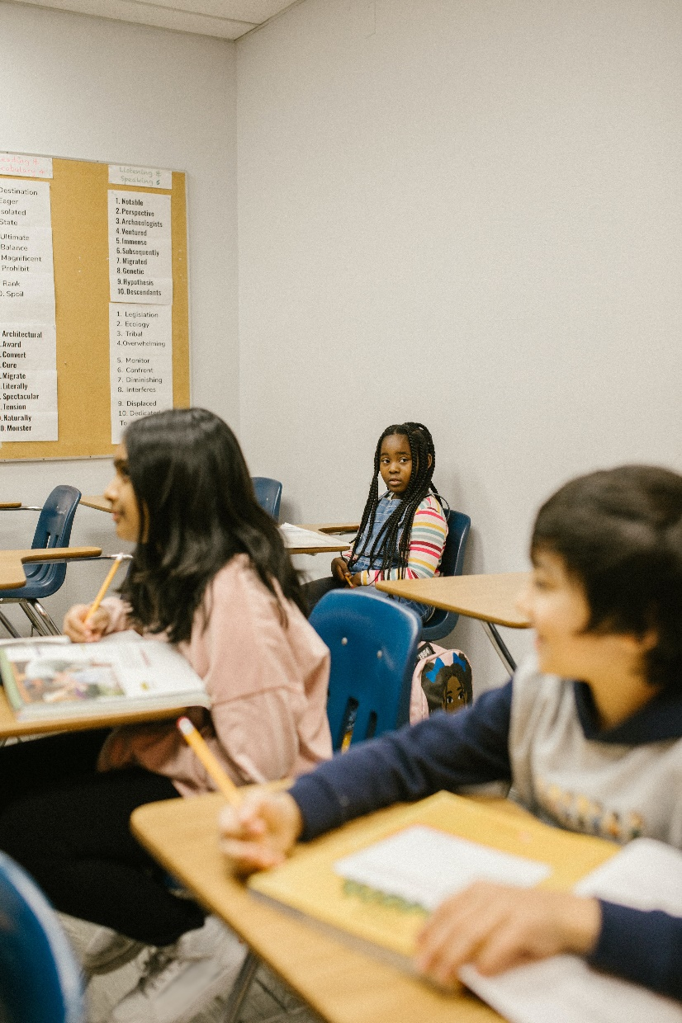

**Resources**

|  |
| --- |
| We have indicated whether the resources are accessible for KS1 or KS2. Please note that some of the KS2 content could be adapted and differentiated to support pupils in KS1. |
| [Staying Calm Checklist – KS1 and KS2](https://www.twinkl.co.uk/resource/sats-staying-calm-checklist-t-lf-1645103481)  Helping pupils prepare for their SATs isn’t just about revision technique and learning. It’s also about helping to maintain their mental health and overall wellbeing. When they’re preparing for an important exam like SATs, staying calm can be tricky - they might experience many uncomfortable emotions, such as stress, anxiety, frustration and disappointment. |

**Reflective questions**

(Try exploring these reflective questions with a CYP)

* What advice would you give a friend doing a test?
* What helps people be good at doing tests?
* What things are you good at?
* What makes you good at these things?
* How can these skills help you with tests?
* When was the last time you did well on a test?
* Why did you do well on a test?

**Quiz**

Once you’ve gone through this resource with a CYP try this quiz questions with them:

* For a year 6: Why do you do SATs?
* For a year 6: Can you fail a SATs test?
* What is a test? Are there different types of tests?
* Why do you do tests?
* What will help you stay calm during a test?

**How to help a friend**

* Share these resources and videos with them.
* You should play with them and help each other forget about the exams. Play is really important!
* You could test each other but remember you must be supportive if either of you get something wrong.

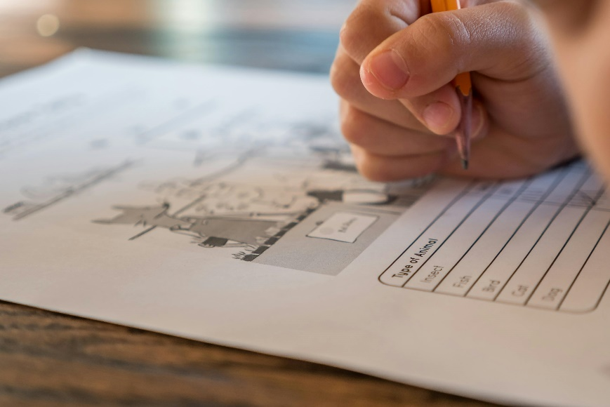**The adult box** (for professionals and parent/carers to read)

|  |
| --- |
| [How to prepare a child for exams](https://cpdonline.co.uk/knowledge-base/safeguarding/preparing-a-child-for-exams/)  This includes guidance for KS1, KS2, KS3, and KS4, and explains why exams can be stressful and what children need academically and emotionally. |
| [Exam Time & Exam Stress | Parents Guide to Support | YoungMinds](https://www.youngminds.org.uk/parent/parents-a-z-mental-health-guide/exam-time/)  YoungMinds provide some guidance for parents on how to best support their children through this stressful period.  [A Guide to Year 6 SATs for Parents and Carers - Twinkl](https://www.twinkl.co.uk/blog/a-guide-to-year-6-sats-for-parents-and-carers)  There is a Twinkl blog that provides a guide to Year 6 SATs for Parents and Carers. It offers guidance as to what SATs are and details on the SATs exams.    [Exam Stress - Roundup | YoungMinds Parents Lounge (youtube.com)](https://www.youtube.com/watch?v=6_BCnGhZiAg)  Young minds parent lounge talking about exam stress |
| [Navigate exam season](https://www.place2be.org.uk/exams?gclid=EAIaIQobChMIqoqDkev4gwMVO5RQBh1VTgQSEAAYAiAAEgI4UvD_BwE)  Place2Be are a great organisation who provide support up and down the country to young people and have developed a resource page for all sorts of exam-related topics that can be found here: |
| [SATs 2024: Top tips and advice for taking your exams - BBC Newsround](https://www.bbc.co.uk/newsround/69001386)  [Free interactive KS1 and KS2 SATs revision resources - BBC Bitesize](https://www.bbc.co.uk/bitesize/articles/zrybvk7#zs82p9q)  There are lots of resources for supporting children through SATs |
| [Supporting Children with SEND through SATs week](https://www.twinkl.co.uk/news/supporting-pupils-with-send-through-sats-week-2023) – KS1 and KS2  While the resources highlighted above will support children with SEND, they may need differentiation. Here is some information for supporting children with SEND. |

   

 