Information and Resources for Helping to Cope with Bereavement and Loss

Guidance for Essex schools and Education Settings

Most grieving children do not need a ‘bereavement expert’ they need people who care. Child Bereavement UK explain that, just by carrying on with their usual day-to-day activities while being aware of the bereavement, schools can do a huge amount to support a grieving pupil.
The following videos and resources provide support and guidance for those who have been affected by loss and bereavement, and for those supporting them.

Essex Educational Psychology

September 2024

Contents
The Grief Cycle 3
Feelings and emotions of grief 3
How you can help with emotions and feelings of grief 5
How to talk to children and young people about bereavement 5
Children and young people’s reactions to death 6
How the school can help 7
RESOURCES
Resources for children (EYFS & primary phase)...................................................................................................8
Resources for young people (secondary phase+) 9
Resources for all adults supporting children/young people 9
Resources for parent/carers 10
Resources for schools 10

Please note: Essex County Council does not manage the content nor does it own these resources. It does not hold clinical risk for those using them. Please check the suitability of the resources based on your knowledge of the individual.

3

The Grief Cycle

People who are grieving do not necessarily go through the stages in the same order or experience all of them.

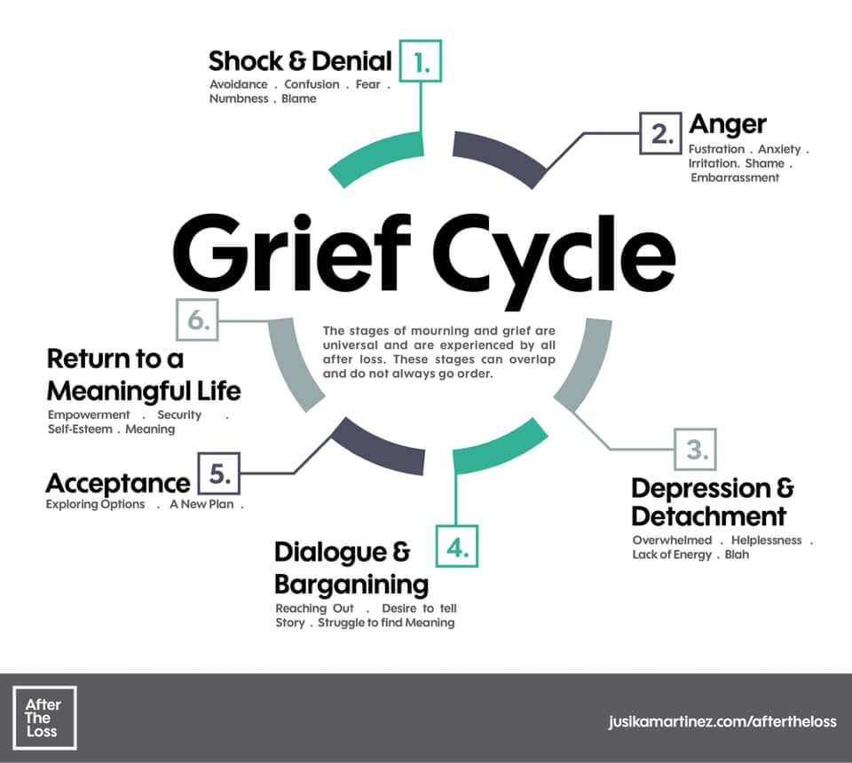

Feelings and emotions of grief
Grief is a normal, essential response to the death of a loved one, and can be short lived or last a lifetime depending on the personality involved, the closeness of the relationship, the circumstances of the death and previous losses suffered.

Shock and Disbelief

This happens when the model of our world is upset. One not only loses the person, but life can feel as though it has no meaning. Shock can take the form or physical pain or numbness, but more often consists of complete apathy or withdrawal or abnormal calm, in some cases anger. Numbness can act as a defence, so we are able to cope with immediate jobs and needs. A child’s reaction may range from silent withdrawal to a wild outburst of screaming. Often young children are unable to understand what is going on, but they are sensitive to a disturbed and sad atmosphere and of the disruption of all that is usually familiar to them.

Denial

This generally occurs within the first fourteen days and can last minutes, hours or weeks; behaving as though the dead person is still there, no loss is acknowledged. For example a husband may make arrangements for he and his wife to go somewhere together. Young children may talk in terms of the dead person returning for significant events e.g. “I expect Mummy will come back when it’s my birthday.”

Growing Awareness

Many at this stage feel abnormal because they have never before experienced the waves of savage feelings that surge through them and over which they temporarily have no control such as tears, anger, guilt, sadness and loneliness. Some or all of the following emotions may be experienced:

- Yearning and pining - the urge to search, go over the death, trying to find a reason for the death, visiting where it happened. For children this is probably the most logical part of their grieving. They have lost something, so they set out to find it. The fact that they never do may build up into tremendous anguish and fear of losing other people.

- Anger against any or all of the following: the medical services, the person who caused the death, in case of accident, God for letting it happen, the deceased for leaving them. Even very small children can feel anger towards a parent who has ‘left’. Real fury may show itself not in words but in fits of temper. In adolescents the anger may be shown in different ways such as lying or stealing.

- Depression – the bereaved person begins to feel despair, the emptiness, the pain of the loss. It is often felt alongside feelings of redundancy, lack of self-worth, and no point to anything. If the person can cry, it usually helps to relieve the stress.

- Guilt – this emotion is felt for the real or imagined feelings of negligence or harm inflicted on the person who has just died. People might say “if only I’d called the Doctor / not gone out” etc. Children may dwell on things they think could have done to prevent the death. There is the tendency to idolise the person who died and feel that they should have loved them better. The bereaved can also guilty about the feelings of the person who died and their inability to enjoy life.

- Anxiety – in extreme cases anxiety can become panic, as the full realisation of the loss begins to come through. There are anxieties about changes taking place and new responsibilities and the loneliness looming ahead. There may even be thoughts of suicide. There may be practical anxieties, adolescents for example may worry about who will pay pocket money, pay University fees, take them on holiday etc.

5

How you can help with emotions and feelings of grief
When someone dies the natural order of things is upturned. The following advice forms a set of principles for responding to an individual who has suffered loss through bereavement.

  - DO let your genuine concern and caring show

  - DO say you are sorry about what happened and their pain

  - DO allow them to express as much grief as they are feeling at the moment and are willing to share

  - DO encourage them to be patient with themselves, not to expect too much of themselves and not to impose any ‘should’ on themselves

  - DO talk about the special endearing qualities of the person they have lost

  - DON’T let your own sense of helplessness keep you from reaching out to a bereaved person.

  - DON’T avoid them because you are uncomfortable (being avoided by friends adds pain to an already intolerable painful experience).

  - DON’T change the subject when they mention the person’s name or avoid mentioning the person’s name out of fear of reminding them of their pain (they have not forgotten it).

How to talk to children and young people about bereavement

  - Be honest - Children need to know what happened to the person that died. Try to explain in clear, simple language that’s right for their age and level of experience. You might also try giving them information in small amounts at a time, especially to young children, as this can help them understand. Once you’ve explained that someone has died, the details can follow.

  - Use plain language - It is clearer to say someone has died than to use euphemisms. Avoid explanations such as the person has ‘gone to sleep’ or ‘gone away’. They may make the child frightened to go to sleep or worry when you leave the house you might not come back.

  - Encourage questions - Be prepared for a child to be curious and to ask the same questions again and again. This can be distressing but remember it’s a part of their need for reassurance and helps them process the information.

  - Reassure them - It’s common for children to feel that the person has died as a result of something they may have said or done. Explain simply how and why they’re not to blame. It might be helpful to give an example, like saying the person died because their heart stopped working. Reassure them that nothing that anyone said or did caused this to happen.

  - Ask them to tell their story - To protect children, adults sometimes try to avoid talking about the person who’s died. But the child may want to talk about the person. They need to tell their story and it might help them remember the person who’s died. They had a relationship with the person who died and it was important to them.

Listening to them can help you understand what they know about what happened. You can also correct anything that’s not quite accurate. Listening will also help you understand how the child’s feeling. Avoid telling them what you think they should feel. Let them know that the feelings they may be having are OK, including ones that they may feel bad about, such as relief that the person has died.

Reference: Marie Curie
For more information, follow this link: https://www.mariecurie.org.uk/help/support/bereaved-family- friends/supporting-grieving-child/talking-to-children-about-death

Children and young people’s reactions to death

REGRESSIONAL BEHAVIOUR
Some children and young people may seem to change their personality in several different ways. These include:

  - Isolating themselves and want to be alone
  - Becoming ‘grown-up’, mature and overly serious
  - Beginning to feel that ‘life isn’t worth it’ and there is ‘no point in thinking about the future’
  - Retreating into a fantasy world and withdrawing from adults and friends
SCHOOL PROBLEMS - Many children and young people begin to have temporary problems with their school work. It is common to have difficulty concentrating on what teachers say, or on the work in hand. They may find school work unimportant, or begin to show behaviour problems, or in keeping friends in class. As behaviour changes, other children and young people may find it difficult to understand why their friend is behaving differently.

What might help Teachers/Form Tutors if a student has died:
  - Consider talking with the class about decisions regarding the place where the student sat and to acknowledge when it feels ok to move things around or for others to use the chair.
  - Acknowledge no longer calling out their name in the register
  - Be flexible with initial lessons soon after the event has occurred – some students will feel ok to continue with usual lessons and structure can be very helpful. Other students will appreciate space and time to talk about the student who has died and their memories of them or the last times they saw or spoke with them.

7

How the school can help

SUPPORTING THE SCHOOL COMMUNITY

  - Recognise the need for the whole school community to have clear, concise and up to date information at all stages, taking into account the needs and feelings of those directly involved

  - Recognise the need for formal grieving, rituals and commemoration

  - Recognise the needs of staff for support as well as pupils

  - Encourage all the continuation of normal activities while remaining sensitive to individual needs

  - Respect difference in terms of culture, religious beliefs etc.

  - Reassure pupils of the acceptability of their feelings and that there is no ‘right’ was of grieving and reacting to loss
Schools facing a traumatic incident should already have the School Incident Management Plan in place, written perhaps with support from the School Service and with reference to the Schools Incident Management Plan – Essex LA Guidance for schools.

Betinna Devou and Marie-Ange Widershoven-Zervikis ‘Effects of Mourning on cognitive processes’ in Educational and Child Psychology vol. 21, No. 3, 2004. BPS

Adam Abedelnoor and Sheila Hollins ‘How children cope at school after family bereavement’ in Educational and Child Psychology Vol. 21, No 3, 2004. BPS

Information Sheet on The Needs of Bereaved Children – see Appendix 1 below.

8

RESOURCES

Resources for children (EYFS & primary phase)

  - The Small Creature, an animated story to help bereaved children by the British Heart Foundation https://www.youtube.com/watch?v=Ks2DOoZtZ4A
When young children lose someone close to them, it can be so difficult to tell how they are
dealing with that loss, and help them through any feelings they might be having. This is where Small Creature can help. He loses his best friend, Bird, and finds himself experiencing all sorts of feelings as he tries to deal with her loss. The friends he encounters along the way give him little ways to deal with those feelings and let him know that help is at hand.

  - Howard B. Wigglebottom Listens to a Friend, book link: https://wedolisten.org/books-and-lessons/book/Howard+B.+Wigglebottom+Listens+to+a+Friend%3A+A+Fable+About+Loss+and+Healing. This helps young children be better listeners, learn important life lessons and feel good about themselves. It is about being a good friend when someone we know experiences loss.
  - The Invisible String, book read aloud. https://www.youtube.com/watch?v=_cO2LBBBtAI
A bestseller that has helped countless readers of all ages across the world cope with
separation anxiety, loss, loneliness and grief.

  - The Dragonfly Story, book read aloud. https://www.youtube.com/watch?v=LFrOMCdZynY
This story is an adaptation of the fable of the transformation of the dragonfly. This fable has
been long used to explain death and the hope of heaven. Using the experience of the death of her eldest child, the author, Kelly Owen, has retold the fable in simple terms to encourage children and families to talk about death and what happens when we die. The book does not shy away from the subject of death but aims to explain it in a real and loving way. The story starts in the family home as the siblings feel sad and confused about their sister's death, so the parents take them to the park where they discover a dragonfly. The fable of the dragonfly is then told, and they reflect on how that might explain their loss. The book is ideal for people of all beliefs and none. The Dragonfly Story offers hope and comfort to the bereaved.

Resources for young people (secondary phase+) 9

  - The Grieving Process: Coping with Death, video. https://www.youtube.com/watch?v=gsYL4PC0hyk
There is no right or wrong way to deal with the loss of a loved one. The grieving process is rough—and it's different for everyone. It's not just a matter of coping with a loss, but coping with change—and that takes time. This video deals with a very difficult subject. How do you deal with the death of a loved one? How do you live your life in the face of a life-changing event? We don't have all the answers. Honestly, you'll need to work through your through the stages of grieving in a way that works for you. But we do have some advice to help you heal.
  - Hope Again, website for young people.
https://www.hopeagain.org.uk/ Hope Again is the youth website of Cruse Bereavement Care. It is a safe place where you can learn from other young people, how to cope with grief, and feel less alone. Here you will find information about our services, a listening ear from other young people and advice for any young person dealing with the loss of a loved one. Hope Again provides somewhere to turn to when someone dies. Get involved and join the conversation.

  - Talk Grief: website for young people.
https://www.talkgrief.org/ An online tool to help young people who have experienced the death of a loved one come to terms with their loss.

Resources for all adults supporting children/young people

Winston’s Wish: Supporting a bereaved child
https://www.winstonswish.org/supporting-you/supporting-a-bereaved-child/

Cruse Bereavement Support
Home - Cruse Bereavement Support

Resources for parent/carers

  - Cruse Bereavement Care, website with advice, guidance and support. https://www.cruse.org.uk/get-help/for-parents
In these pages we have information on; what you can do to help a child or young person who is grieving; how to understand the concept of loss in children and young people of different ages and; how to recognise potential complicated grief.
Helpline: 0808 808 1677, open Monday-Friday 9.30-5pm (excluding bank holidays), with extended hours on Tuesday, Wednesday and Thursday evenings, when we’re open until 8pm.
Email: helpline@cruse.org.uk

  - Mind Ed for Families, advice relating to death and loss.
https://mindedforfamilies.org.uk/

Resources for schools

Cruse Bereavement Care
https://www.cruse.org.uk/get-help/for-schools
These pages are for personnel working in schools and colleges, particularly headteachers, pastoral staff, tutors and other members of senior management teams. Cruse also have extensive information on children, young people and bereavement. A Schools Pack is available from their online shop.

  - Child Bereavement UK, website for Primary schools. https://www.childbereavementuk.org/pages/category/primary-schools
Information for teachers, teaching assistants, learning support assistants, headteachers, education welfare officers and other adults working in schools

  - Mentally Healthy Schools by Heads Together https://www.mentallyhealthyschools.org.uk/mental-health-needs/bereavement-and-grief/
An important foundation for helping children deal with and bounce back from adversity is the development of social and emotional skills. Many universal and targeted school-based programmes are proven to help children adjust and develop resilience. This website offers top tips and advice for supporting pupils in school.

  - The Little Book of Bereavement for Schools by Ian Gilbert, Oliver Gilbert and William Gilbert 2010 ISBN 1845904648

  - Winstons Wish: Teaching about loss and bereavement in schools

On average, 1 in every 29 children will be bereaved of a parent, that’s the equivalent of one in every class, and many more children will experience the death of another family member or friend. It is something that impacts us all, yet for many people, death is not something that is often talked about. Therefore, it is important to provide the opportunity to learn about bereavement in PSHE lessons and to support children and young people to develop the skills and understanding they need to deal with this particular life event. The resources for lessons on loss (created for Key Stages 1-4) have been developed by teachers and bereavement experts and awarded the Quality Mark by the PSHE Association.

PSHE lessons on loss and bereavement
Winston’s Wish provide free PSHE lessons on loss for Key Stages 1-4 which have been developed by teachers and bereavement experts and awarded the Quality Mark by the PSHE Association

- Free PSHE lessons on loss and bereavement | School resources | Winston's Wish (winstonswish.org)

- Activities for bereaved children and young people | Download for free | Winston's Wish (winstonswish.org)

Where to get support

The Winston’s Wish Freephone National Helpline is available if you need advice on supporting a child bereaved by murder, you can call on 08088 020 021 (9.00am-5.00pm, Monday-Friday)

Email: ask@winstonswish.org or use the online chat.

The Winston’s Wish Crisis Messenger is available 24/7 for urgent support in a crisis. Text WW to 85258.

For full details of the latest advice from Winston’s Wish can be found via the following link: Explaining murder to children and young people | Winston's Wish (winstonswish.org) (Advice July 2020)

Author: Senior Specialist EPS (SEMH)
Essex Educational Psychology- September 2024

Copyright © Essex County Council 2024
No part of this publication may be reproduced, stored in a retrieval system of any nature, downloaded, transmitted or distributed in any form or by any means including photocopying and recording, without the prior written permission of Essex County Council, the copyright owner.

