**Questionnaires, Surveys and Other Tools – Adaptive Guidance**

Questionnaire and surveys can be helpful tools in gaining the views of adults, children and young people. However, they can pose a barrier which means that the information you’re seeking is corrupted by the process itself.

Below you will find top tips for using these tools effectively as well as ideas on how to adapt questions, ratings and scales to be more inclusive. Whilst it would be useful to have tools adapted to differing needs, it is impossible to do this as each need is so individual. As the key person using the tool, you are best placed to adapt it to suit the specific need of that child.

There are many reasons why a resource may need to be adapted. The tools need to accessible by everyone regardless of the age/key stage, SEND including autism, communication and cognition difficulties and language spoken.

If you can’t find the answers here, please do seek support from specialist teaching teams. They may be able to provide direct support or signpost you to resources. If you have adapted a tool or resource for a particular need, please do share it with them afterwards so we can build a bank of ‘good practice’ and give ideas to others.

**Top Tips for Tools:**

* Consider WHO is asking the questions – try to ensure they are a trusted adult, even if they are not responsible for the outcomes of the tool itself
* Consider WHERE the tool is used – if the child is uncomfortable in school, do it somewhere they feel comfortable such as in their home
* Consider HOW the tool is used – can you sit side by side to avoid uncomfortable eye contact?
* Consider whether the tool be used whilst the CYP is working on a self-regulating task such as colouring, stroking a pet, sewing etc
* Give time for the CYP to think before they response – this is their processing or ‘take up’ time
* If there are a large number of questions, think about how to manage that without creating brain fatigue. Can you complete them with the CYP over the course of a day, a couple of days or the week?
* If the CYP finds a questionnaire or survey anxiety-provoking, work through the questions in a conversational way, rather than as a list
* If possible, give examples to aid understanding, but avoid this if it is likely to cause more confusion. Ask follow-up questions if required in order to ensure the CYP has understood
* If using rating scales, use ones that are meaningful to the CYP (see examples below) or make your own that is personal to them (eg using photos of their face to show emotion)
* Ensure the questions re accessible. If you’re not reading them, adapt them to aid the reader for example, using braille (via the Visual Impairment team), larger print, widgets/symbols, breaking up the questions, overlays etc
* If the tool or questionnaire uses a 7-point scale (for example) then assist the CYP by making it a 5 or 3 point scale if they find it too difficult
* Use talking mats, feelings mats or monster moods as a different way of representing a scaled response
* Use maps or photos of the school, photos of the staff and visual timetables when talking about school issues as this will support the CYP in identifying areas, people and subjects more readily
* Open a dialogue by using comic strip conversations
* Keep the CYP engaged by turning it into a game – eg if they the rating how they feel on a 5 point scale, have five buckets and a ball and ask them to throw the ball into the bucket that corresponds to the number on the scale

**Examples of scales:**

Scales can be many points – usually 3, 5 or 10. You can adapt these by using colour, faces, symbols etc. You can change the words to fit the scale on your tool



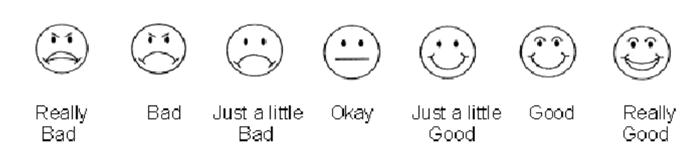

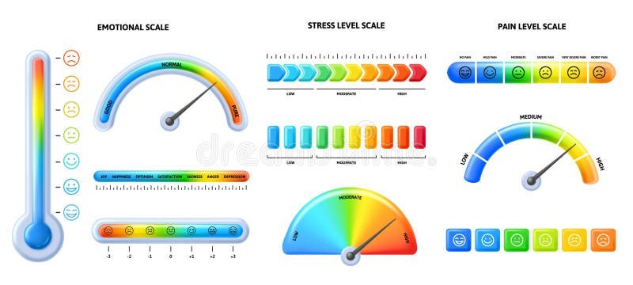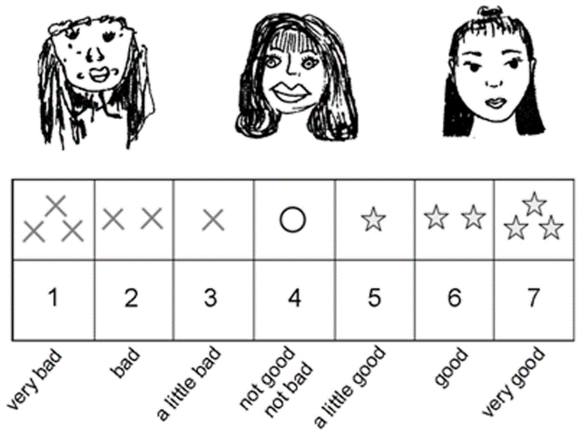

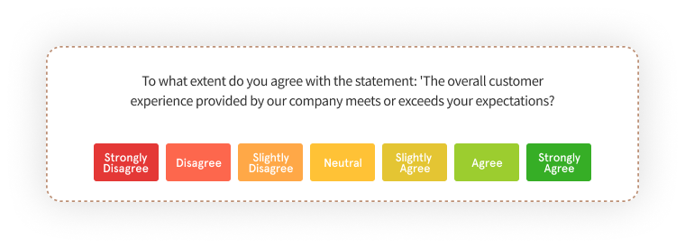



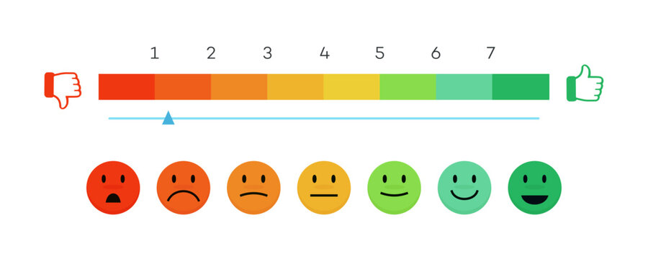

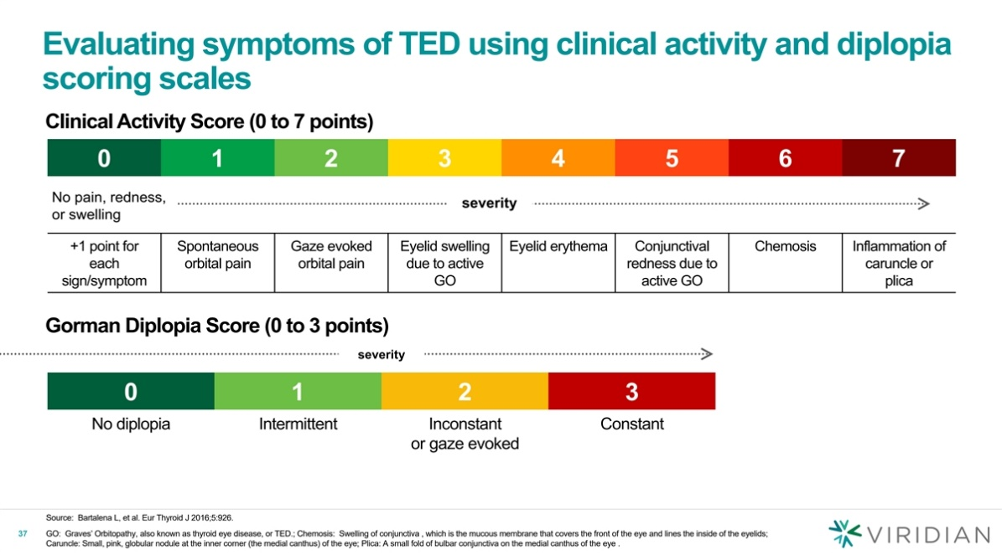

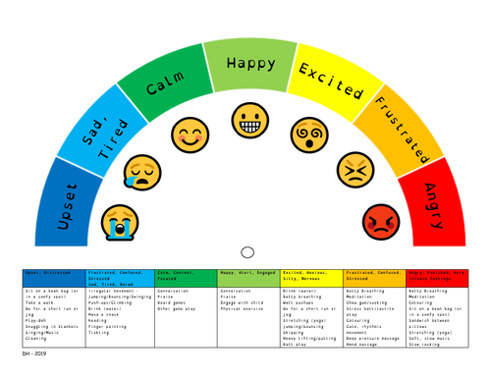

**Adaptive Questions:**

You can adapt questions for visual impairment using Braille, larger/different fonts and colours. You can also use Widgets/Symbols as below. See the Specialist Teams for support with this,

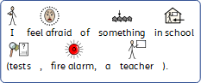 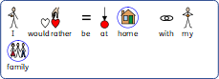

**The 10 Second Rule**



1..2..3..4..5..6..7..8..9..10..

***What*?**  After asking the pupil a question give him/her time to answer. Count to ten slowly in your head.

***Why?*** We get uncomfortable if we do not get an answer after 3 seconds but pupils with language difficulties need at least 6 or 7 seconds to process what we have said.

***How?***  During the waiting time, try not to look impatient, think about how you have asked the question. Was the language right for the pupil, could you have made it easier to understand? Was the question too long or were there multiple questions? Was it about something that happened a while ago or in a different place?

If you do not get a reply after counting to ten, try one of the following:

* Repeat the question again in exactly the same way if you think you used the right language the first time
* Cue the pupil by “setting the scene”, then ask the question
* Rephrase the question using simpler language
* Shorten the question or break it down into one question at a time

**Talking Mats:**

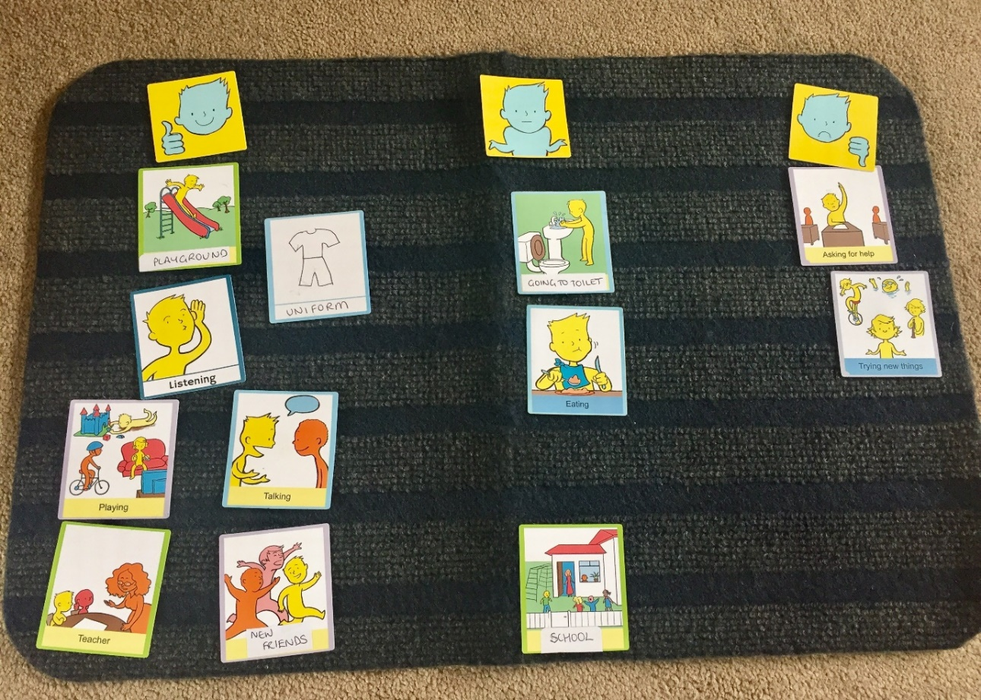

**Talking Mats support comprehension by:**

**–**Helping children process concepts by breaking information down into small, manageable chunks

**–**Allowing the child time to process information and respond in their own time

**–**Reducing memory demands

**Talking Mats improve the quality of the conversations by:**

**–**Handing over control to the thinker

**–**Providing a structured framework for open questions

**–**Reducing anxiety

**–** Supporting children to express how they really feel

**Using symbols or Mood Monsters to support understanding:**

