**Let’s Talk: Diversity, Equity & Inclusion**

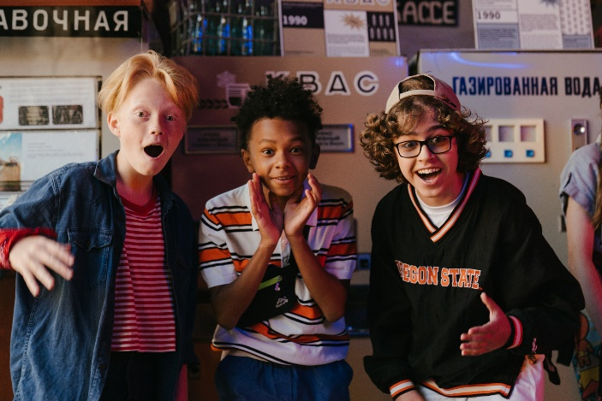**Primary**

This resource is part of our self-care suite of resources and has been co-produced, with children and young people living in Essex, for children and young people. They have also been developed and quality assured by the following stakeholders:

* Essex Educational Psychology Service
* Health Watch Essex
* Essex Mental Health Support Teams (MHSTs) NELFT NHS Foundation Trust
* Essex Multi-schools Council
* Essex Social, Emotional and Mental Health (SEMH) strategy team
* Essex Child and Family Wellbeing Service, HCRG Care Group in partnership with Barnardos
* NELFT NHS Trust Southend, Essex, and Thurrock (SET) Child, Adolescent and Mental Health Service (CAMHS)
* Professionals in schools and settings can access all these resources via the [Essex info link SEMH portal](https://schools.essex.gov.uk/pupils/social_emotional_mental_health_portal_for_schools/Pages/Self-care-for-CYP-Library.aspx). Children and young people (CYP), parents/carers and professionals can also access these resources via the SET CAMHS website. Our self-care content can also be accessed via SET CAMHS Instagram account:

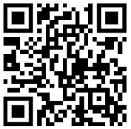

The resources are intended to be accessed by CYP independently or trusted adults use these resources with CYP through 1:1 conversation, whole school/group discussion and assemblies.

Please note: some of the content within our self-care resources may be emotive for CYP. We recommend that you make use of the ‘signposting to support’ section of this document should any of the content be triggering.

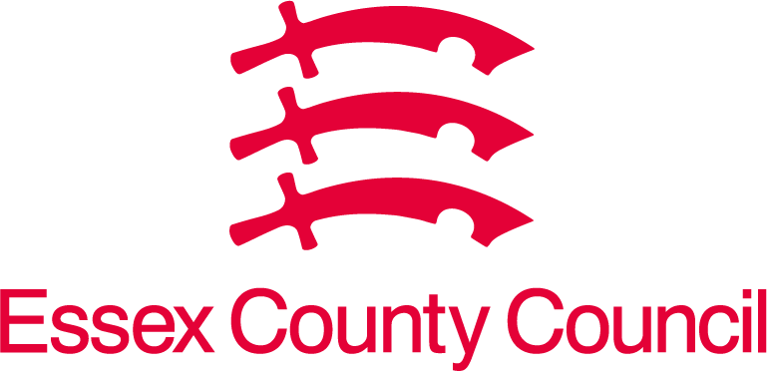   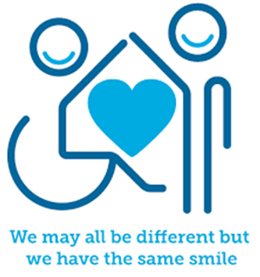

 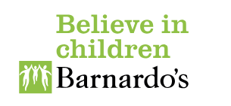

**Introduction**

Diversity simply means differences between people. This includes our skin colour, our heritage, gender, age, physical abilities, religious beliefs, our values, likes and interests. Our diversity can make us feel the same as others or different from others, which affects how we see and feel about ourselves, and how we see and feel about the world around us. Being different from others can feel difficult sometimes but it is important that our differences are understood, accepted, and celebrated by others. Every person has the right to be their true self, included, and to live a full life without experiencing bullying, unfairness, fear, or barriers.

Equality is where everyone in a group has the same opportunities and rights as each other, and inclusion is when people feel valued and included in a group or situation. At school for instance, an example of inclusion would be that everyone is able to fully participate in all lessons and are offered the same opportunities. This includes people with disabilities for instance or those who experience other disadvantages.

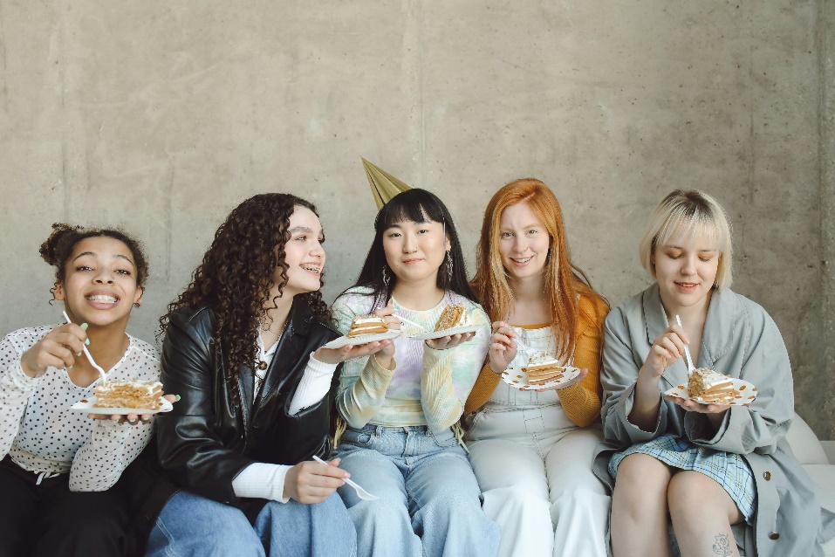

**Facts**

Diversity, equality, and inclusion:

* We are all diverse.
* Everyone has the right to experience equality.
* Everyone has the right to feel included in different aspects of their life e.g. education, friendships, and family.

**Myth Buster**

Diversity, equality, and inclusion:

* Diversity is just about gender and race. X
* Diversity, equality, and inclusion describe the same things. X
* You have to treat everyone the same all of the time. X Sometimes we may need to make changes so everyone is included and gets an equal opportunity.
* Inclusion is something that only adults are responsible for. X

**Video clips**

Check out these videos about diversity, equality, and inclusion:

* [What is diversity? [Diversity for kids] (youtube.com)](https://www.youtube.com/watch?v=SyaLcfMeeEM)

Muse wellbeing explains what Diversity means. (Upper KS2)

* [Is there a lack diversity in books for young people? - BBC Young Reporter (youtube.com)](https://www.youtube.com/watch?v=E7fg8nAin90)

BBC young reporter discussing the lack of diverse books for children and young people to read. (Upper KS2)

* [Who We Are Music Video (youtube.com)](https://www.youtube.com/watch?v=x5BxqkoSBoY)

The Diversity Movement song about diversity, equality, and inclusion.

* [WHAT IS DIVERSITY? EDUCATE KIDS - AWESOME (youtube.com)](https://www.youtube.com/watch?v=P6mXWXVTIiU)

Natasha Lamb explores what diversity is (KS1)

* [Respecting the differences between people | Mariana Chartier | TEDxYouth@BSCR (youtube.com)](https://www.youtube.com/watch?v=_qtpmi4yzSs)

TedX Talks – Mariana Chartier talks about respecting the differences between people (KS2)

* [We're all amazing! by London Rhymes | Diversity and Equality | Songs for Babies and children (youtube.com)](https://www.youtube.com/watch?v=vbHQ-OS9_G0)

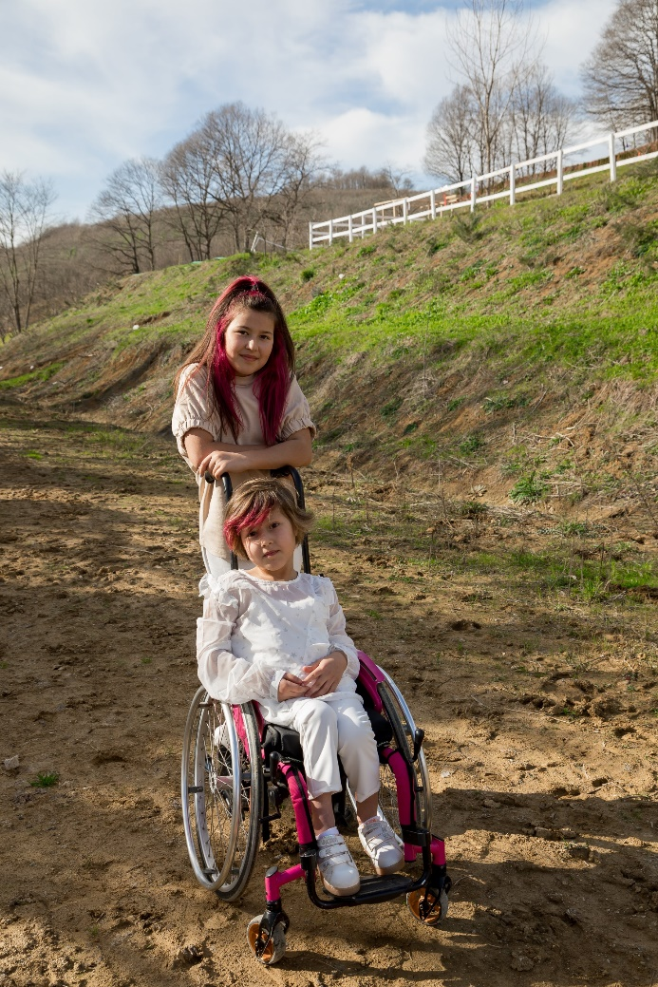London Rhymes we’re all amazing (KS1)

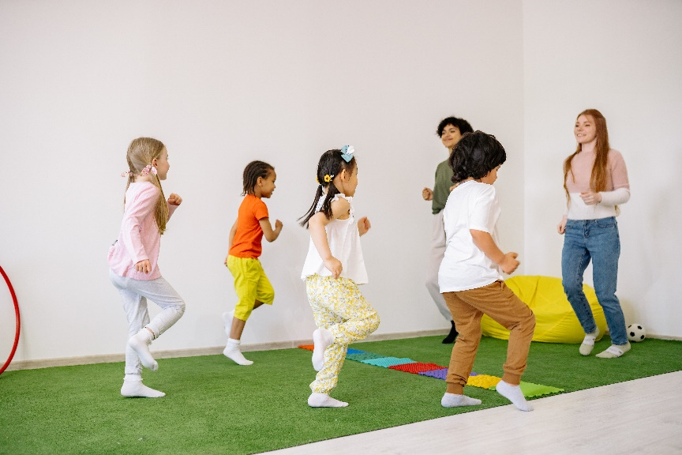

**Resources**

* [📚 READ ALOUD: All People are Beautiful By Vincent Kelly (youtube.com)](https://www.youtube.com/watch?v=MymGV242MSo)

A story by Vincent Kelly to illustrate that all people are beautiful (KS1)

* [Acceptance Is My Superpower by Alicia Ortego | A Story of Diversity and Equality | Read With Me (youtube.com)](https://www.youtube.com/watch?v=AQMBowvLLOM)

A story by Alicia Ortego exploring accepting differences in each other

**Reflective questions**

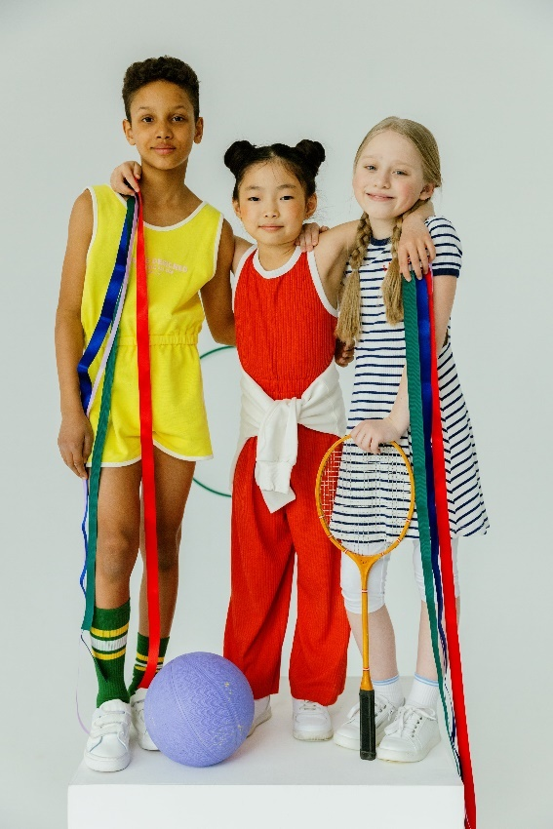(Try exploring these reflective questions with a CYP)

* What is the difference between diversity, equality, and inclusion?
* Can you describe three ways your school is inclusive?
* What diversity can be found in your friendship group(s)?
* How do you promote inclusion?

**Quiz**

Once you have gone through this resource with a CYP try this quiz

questions with them:

* Can you describe what diversity means?
* Can you describe what equality means?
* Can you describe what inclusion means?
* Name six differences that make people diverse?
* Describe three ways you can help someone feel more included?

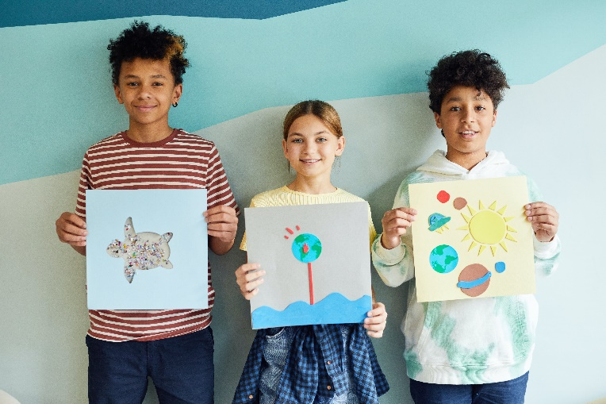

**Signposting to Support**

For additional support we recommend you take a look at the following links:

* [Getting help for your child: where to start](https://www.youngminds.org.uk/parent/parents-a-z-mental-health-guide/getting-help-for-your-child/)
* [Childline](https://www.childline.org.uk/info-advice/your-feelings/mental-health/?&&&&gclsrc=aw.ds&&gclid=EAIaIQobChMIqryktIeP_wIVicPtCh3QZQs6EAAYASAAEgJr5vD_BwE&gclsrc=aw.ds) - 0800 1111 – [when contacting ChildLine what to expect](https://www.youtube.com/watch?v=_KNtMOKwTco)
* [Hopeline 0800 068 41 41](https://www.papyrus-uk.org/papyrus-HOPELINE247/) offering confidential support and practical advice
* [Text ‘SHOUT’ to 85258](https://giveusashout.org/get-help/?gclid=Cj0KCQiA6vaqBhCbARIsACF9M6nG--bxZCnflhd5C3jT-d9dS48o5t6XTTTidI0MLTgwjjRAlxszRT8aAnvvEALw_wcB) for free, confidential, anonymous text support service
* [NHS 111](https://www.nhs.uk/nhs-services/mental-health-services/)
* [Southend, Essex & Thurrock Children and Adolescent Mental Health Service (SET CAMHS)](https://www.nelft.nhs.uk/set-camhs/)
* [Explore counselling/therapy](https://www.nhs.uk/mental-health/talking-therapies-medicine-treatments/talking-therapies-and-counselling/counselling/)
* [Where to get urgent mental health support from: Advice from NHS](https://www.nhs.uk/nhs-services/mental-health-services/where-to-get-urgent-help-for-mental-health/)



* SET CAMHS Instagram account

**How to help a friend**

* Start a conversation about diversity, equality, and inclusion.
* Explore how your friendship group is aware of diversity and promotes equality and inclusion for each other.
* Share this resource with your friend.

**The adult box** (for professionals and parent/carers to read)

* [How to explain DIVERSITY to children and young people with SEND (youtube.com)](https://www.youtube.com/watch?v=iZh4oDXKWts)

YouTube video by sunshine support helping to explain diversity to children and young people with SEND

* [Primary Resources - KS2, KS1, Early Years (EYFS) KS3, KS4, Twinkl](https://www.twinkl.co.uk/equality-diversity-inclusion-hub)

Twinkl resources from the equality, diversity, and inclusion teaching hub

* [Diversifying the curriculum to increase representation | Anna Freud](https://www.annafreud.org/resources/schools-and-colleges/diversifying-the-curriculum-to-increase-representation/)

Anna Freuds guide to diversifying the curriculum to increase representation

* [Working with families from diverse cultures (youtube.com)](https://www.youtube.com/watch?v=ENL2aPff2-I)

Anna Freud video on working with families from diverse backgrounds

* [Supporting children and young people who identify as gender diverse | Emerging Minds Families (youtube.com)](https://www.youtube.com/watch?v=wiSzRXs5_YA)

Emerging Minds Families podcast exploring how to support children and young people who identify as gender diverse.

* [Taking Action Against Racism: Helping Kids Embrace Diversity (youtube.com)](https://www.youtube.com/watch?v=dYnkJl3HDxM)

Nemours KidsHealth explores how to take action against racism and how this starts at home.

* [7 Ways to Teach Your Children about Diversity and Inclusion | Macaroni KID Mt Airy-Damascus-Urbana](https://mtairy.macaronikid.com/articles/645a8f6f69ea3f40944fe0fd/7-ways-to-teach-your-children-about-diversity-and-inclusion)

Ways of teaching and promoting diversity and inclusion in your family.

* [How to Promote Diversity and Inclusion in Your Child’s Life - CHC Resource Library | CHC | Services for Mental Health and Learning Differences for Young Children, Teens, and Young Adults](https://www.chconline.org/resourcelibrary/how-to-promote-diversity-and-inclusion-in-your-childs-life/)

Children’s Health Council article exploring how to promote diversity and inclusion in your child’s life.

   

 