**Let’s Talk: Suicidal thoughts and feelings**

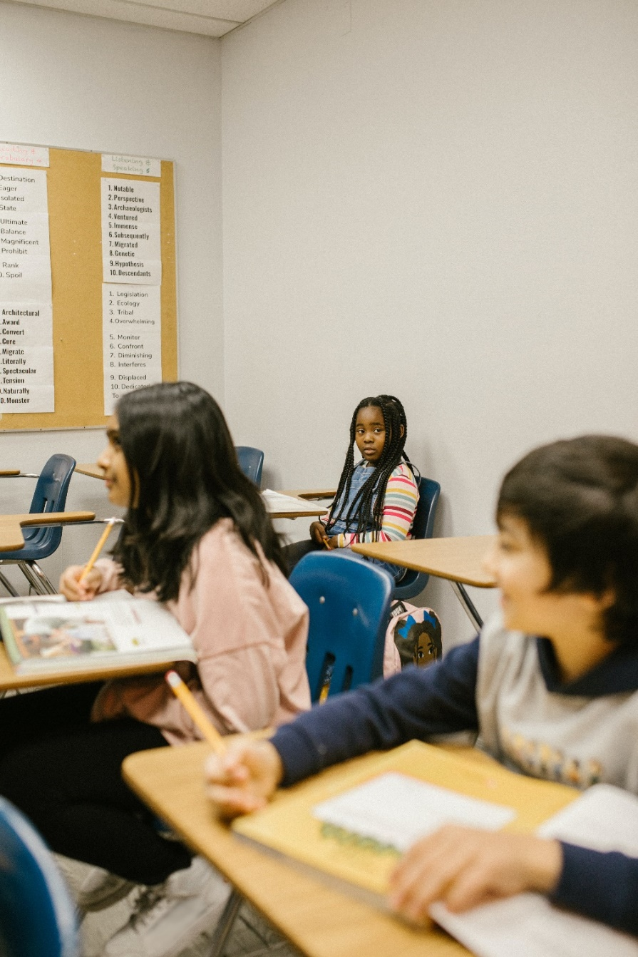**Primary (Upper Ks2)**



This resource is part of our self-care suite of resources and has been co-produced with children and young people living in Essex, for children and young people. They have also been developed and quality assured by the following stakeholders:

* Essex Educational Psychology Service
* Health Watch Essex
* Essex Mental Health Support Teams (MHSTs) NELFT NHS Foundation Trust
* Essex Multi-schools Council
* Essex Social, Emotional and Mental Health (SEMH) strategy team
* Essex Child and Family Wellbeing Service, HCRG Care Group in partnership with Barnardos
* NELFT NHS Trust Southend, Essex, and Thurrock (SET) Child, Adolescent and Mental Health Service (CAMHS)
* Professionals in schools and settings can access all these resources via the [Essex info link SEMH portal](https://schools.essex.gov.uk/pupils/social_emotional_mental_health_portal_for_schools/Pages/Self-care-for-CYP-Library.aspx). Children and young people (CYP), parents/carers and professionals can also access these resources via the SET CAMHS website. Our self-care content can also be accessed via SET CAMHS Instagram account:

The resources are intended to be accessed by CYP independently or trusted adults use these resources with CYP through 1:1 conversation, whole school/group discussion and assemblies.

Please note: some of the content within our self-care resources may be emotive for CYP. We recommend that you make use of the ‘signposting to support’ section of this document should any of the content be triggering.

   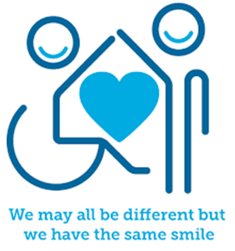

 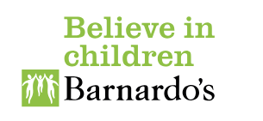

**Introduction**

It is a normal part of life to feel down and sad sometimes. But if you’re finding those feelings very overwhelming or intense and you don’t know what to do about them, you might think the only solution is to end your life. These can be called suicidal thoughts or feelings. If you have been feeling like this there is help for you and you can feel better again.





**Facts**

* Lots of young people can have these feelings at times and you are not alone.
* There are lots of ways of dealing with these feelings and making them feel better.
* Anyone can have these thoughts and feelings for any reason, and it can be different for different people. What causes one person to feel this way, may not have the same effect on someone else.
* Suicidal feelings can build up over time, or they can start very quickly.
* Some signs of having suicidal thoughts and feelings might include:
* feeling a deep sadness which doesn’t go away
* Not feeling interested in the things you normally enjoy
* having trouble sleeping when you used to sleep well
* feeling there is no hope or feeling you are worthless
* feeling angry about your life

**Myth Buster**

* Suicidal thoughts and feelings only happen when you already self-harm in some way X
* Suicidal thoughts and feelings don’t happen to people very often X
* There is nothing you can do to feel ok again X
* Having suicidal thoughts and feelings means you will take your own life X
* You should not talk about your suicidal thoughts and feelings with friends or adults in school or at home X

**Video clips**

Check out these videos about suicidal thoughts and feelings:

|  |
| --- |
| * [Just ask](https://www.youtube.com/watch?v=PwL--ZIPD68)   Stop suicide animation |
| * [Sinking feeling](https://www.youtube.com/watch?v=dKU1OLrvOn4&t=7s)   Papyrus suicide awareness video |
| * [Coping with suicidal feelings](https://www.youtube.com/watch?v=vFJeRUgqT9Y)   Childline’s animation talking about suicidal feelings |
|  |

**Resources**

|  |
| --- |
| These resources are for upper Ks2 pupils. |
| * [Tips on how to cope](https://www.samaritans.org/how-we-can-help/if-youre-having-difficult-time/signs-you-may-be-struggling-cope/practical-ways-help-yourself-cope/)   Practical ways to help yourself cope with suicidal thoughts and feelings: |
| * [A letter to myself](https://www.themix.org.uk/mental-health/suicide/a-letter-to-myself-and-to-anyone-struggling-with-suicidal-thoughts-47353.html)   The mix resource to support anyone struggling with suicidal thoughts and feelings write themselves a letter to themselves |
| * [CAMHS resources](https://camhs.hacw.nhs.uk/5-11) (resources for ages 5-11)   Videos, resources and more to help with exploring sadness, worry and managing big emotions.   * [Suicidal feelings](https://www.youngminds.org.uk/young-person/my-feelings/suicidal-feelings/)   Young minds guide for young people about suicidal feelings |
| You may also find it helpful to look through the following:   * Create a [Safety Plan](http://www.papyrus-uk.org/wp-content/uploads/2018/10/Suicide-Safety-Plan-Template-1.pdf) * Create a [Self-Soothe box](http://www.papyrus-uk.org/wp-content/uploads/2018/09/Hope-box.pdf) * Take a look at the Samaritans [Self-Help App](http://selfhelp.samaritans.org/) * Download the [“Stay Alive” App](http://prevent-suicide.org.uk/find-help-now/stay-alive-app/) |

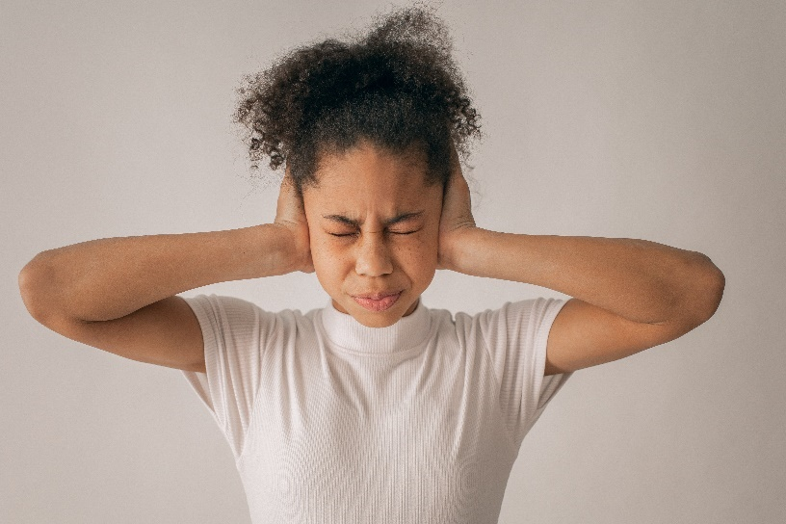

**Reflective questions**

(Try exploring these reflective questions with a CYP)

* What do you think ‘suicidal thoughts and feelings might mean?
* How would you know if you were having these feelings or thoughts?
* What kind of thoughts and feelings have you been having?
* What can you do to feel better?
* What would you like to do to feel better?
* What advice would you give to a friend if they were having these thoughts and feelings?

**Quiz**

Once you’ve gone through this resource with a CYP try this quiz questions with them:

* What does ‘suicidal thoughts and feelings’ mean?
* What things are true and not true about this?
* What are some things you can do to feel ok again?
* Who can you talk to about this?
* How can someone else help you?



**Additional ideas**

Other things to try:

Apps for young people:

* **For Me** – free app from Childline, offering counselling, group message boards and advice. Calm Harm – free app providing a range of techniques to relieve emotional distress and particularly helpful for individuals who self-injure.
* **Clear Fear** – free app to help with managing anxiety.
* **MindShift** - free app with advice managing anxiety and relaxation methods.
* **SAM** (Self-help for Anxiety Management) - has games and tools to help you understand and manage anxiety.
* **distrACT** - is a free app that provides help around self-harm and suicidal thoughts.
* **Combined Minds** - Combined Minds uses a ‘Strengths-Based’ Approach which has been shown to be effective in recovery and builds on resourcefulness and resilience.
* **Headspace** – Relax with guided meditations and mindfulness techniques that bring calm, wellness, and balance to your life in just a few minutes a day.
* **Stay Alive -** suicide prevention resource for the UK, packed full of useful information and tools to help you stay safe in crisis. The app links you directly to local and national crisis resources, so you won’t need to carry around slips of paper with contact details on – it’s all stored there within the app. If the resource isn’t listed, simply add in your own.
* **WYSA**: An ‘emotionally intelligent’ penguin that learns to react to the emotions you express. Overtime it gets to know you better and proactively reaches out to help you.
* **Cove:** With Cove, you can capture your mood or express how you feel by making music and storing it in a personal journal.
* **Mend**: The number one breakup app, is a self-care app for heartbreak. It guides you through your breakup day by day (free for 7 days).
* **Stop, Breathe and Think**: A friendly app to guide people through meditations for mindfulness and compassion.
* **Smiling Mind:** A non-profit web and app-based meditation programme developed by psychologists and educators to help bring mindfulness into your life.

**Signposting to Support**

For additional support we recommend that trusted adults use these resources to support children and young people access support when required:

* [Where to get urgent mental health support from: Advice from NHS](https://www.nhs.uk/nhs-services/mental-health-services/where-to-get-urgent-help-for-mental-health/)
* [Hopeline 0800 068 41 41](https://www.papyrus-uk.org/?gclid=Cj0KCQiAr8eqBhD3ARIsAIe-buPX2wxJnAgwWhiwGGy_R_USTlZ9o6tbE_3RlcOYnLbbF0TA4jIO0B4aAkHmEALw_wcB)
* Text ‘SHOUT’ to 85258 (available 24/7)
* [Getting help for your child: where to start](https://www.youngminds.org.uk/parent/parents-a-z-mental-health-guide/getting-help-for-your-child/)
* [Childline](https://www.childline.org.uk/info-advice/your-feelings/mental-health/?&&&&gclsrc=aw.ds&&gclid=EAIaIQobChMIqryktIeP_wIVicPtCh3QZQs6EAAYASAAEgJr5vD_BwE&gclsrc=aw.ds) 0800 1111 when [contacting ChildLine what to expect](https://www.youtube.com/watch?v=_KNtMOKwTco)?
* [NHS 111](https://www.nhs.uk/nhs-services/mental-health-services/)
* [Southend, Essex & Thurrock Children and Adolescent Mental Health Service (SET CAMHS)](https://www.nelft.nhs.uk/set-camhs/)
* [Explore counselling/therapy](https://www.nhs.uk/mental-health/talking-therapies-medicine-treatments/talking-therapies-and-counselling/counselling/)



* SET CAMHS Instagram account

**How to help a friend**

* Share this resource with them
* Tell them about the SET CAMHS Instagram account
* Talk to them about the resources, links, and apps above
* Listen to them and help them to find positive coping strategies
* Talk about who can help them and who they can talk to (an adult at home or at school) about their feelings
* If you are really worried about a friend, find a trusted adult you can speak to for advice.

**The adult box** (for professionals and parent/carers to read)

|  |
| --- |
| * [At home safety guide for self-harm or suicide](https://www.nationwidechildrens.org/family-resources-education/health-wellness-and-safety-resources/helping-hands/children-at-risk-for-self-harm-or-harm-to-others-home-safety-guidelines-for-families)   Nationwide Children’s guidance for ways to support your child at this time. This includes writing a safety plan and assessing the safety of your home environment(s). Keep having discussions about your child’s safety with their doctor or health care providers. |
| * [Worried about my child’s mental health](https://www.england.nhs.uk/blog/advice-for-parents-guardians-and-carers-on-how-to-support-a-child-or-young-person-if-youre-concerned-about-their-mental-health/)   NHS England’s advice for parents/carers on how to support a child or young person. |
| * [A guide for parents/carers about suicidal thoughts](https://www.youngminds.org.uk/parent/parents-a-z-mental-health-guide/suicidal-thoughts/)   Young minds guide for parents and carers to support a child or young person manage suicidal thoughts and feelings |
| * [Essex ‘Let’s Talk reducing the risk of suicide’ guidance](https://schools.essex.gov.uk/pupils/social_emotional_mental_health_portal_for_schools/Documents/Let's%20Talk%20-%20reducing%20the%20risk%20of%20suicide%20-%20February%202021.pdf#search=let%27s%20talk%20reducing%20the%20risk%20of%20suicide)   Promoting positive emotional wellbeing and reducing the risk of suicidal thoughts and actions in children and young people. I guide for schools and settings. |
| * [Suicidal feelings and thoughts](https://mentallyhealthyschools.org.uk/mental-health-needs/suicidal-feelings-and-thoughts/)   Mentally healthy schools support for school staff |
| * [My child is having suicidal thoughts](https://parents.actionforchildren.org.uk/mental-health-wellbeing/low-mood-depression/my-child-is-having-suicidal-thoughts/)   Action for children’s advice for parents/carers about supporting their child through suicidal thoughts and feelings |
| * [Building suicidal safer schools and colleges](https://www.papyrus-uk.org/wp-content/uploads/2018/08/toolkitfinal.pdf)   Papyrus guidance on supporting a whole school approach in developing suicide-safer learning environments |
| * [CAMHS resources](https://www.camhs-resources.co.uk/websites)   This is a collection of websites that provide information and support to young people and families. If you click on the image it will open the website in a new window. Most of the sites are free though some have paid components to them to access added resources and support. |



   

 