Exam Access for children with a PNI

Exam access and dispensations are updated every year so you will need to check with the Joint Council for Qualifications (<https://www.jcq.org.uk/>) for specific details. However, there are some top tips for ensuring that the pupils you support with a PNI receive the adaptations they require to succeed:

1. Ensure that the adaptations you request are the pupil’s normal way of working for long enough to provide evidence of this.
2. Ensure the pupil has opportunities to use their access arrangements for all work that is being assessed to measure progress of their exam curriculum.
3. If you feel unsure that an access arrangement will be beneficial, trial it during class/lesson assessments to show the difference in achievement without the arrangement and another assessment with the arrangement.
4. Consider whether extending the time available will add any value to the child or whether this will purely lead to increased fatigue.
5. If at first you don’t succeed, try, try again! It should be expected that more unusual requests will be rejected by JCQ but resubmitting under 'other' opens the opportunity to work directly with the exam board to find an acceptable solution. Be prepared to have further conversations with the exam board and provide additional evidence/justification if necessary.
6. Try to be more flexible with your exam offer in the first place and explore personalised learning paths for some pupils with a PNI. BTEC, Functional Skills or ASDAN may suit some learners better.

Please see the following summary of access arrangements relevant to children and young people with a PNI in the academic year 2024-25:

This information has been put together as a quick access to highlight changes (in yellow) to this year’s examinations access arrangements and to highlight some key points that may be relevant to C/YP in your school or setting. All the information is taken from the JCQ 124 document for EAA for your information so that suggestions and recommendations can be made to support pupils with a PNI.

**Examinations Access Arrangement 2024-2025 – changes for this year and key points with PNI relevance.**

There is greater emphasis on the role of the SENCO to ensure integrity of the use of Examinations Access Arrangements.

Whereby:

|  |  |
| --- | --- |
| There is an emphasis that SENCOs should receive CPD training each year. |  |
| It is for the SENCO to determine the access arrangements for candidates.  Specialists can make recommendations they cannot make the decision for a centre. |  |
| Form 8: Profile of Learning Difficulties | Where more than 25% Extra Time is approved, this cannot roll-forward from GCSE to A’Level but must be reassessed and re-requested. |

Application Deadlines:

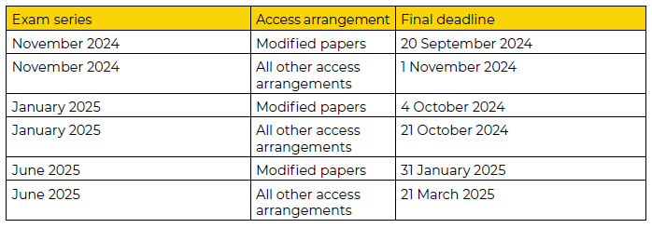

Access Arrangements Available (each carries its own criteria to be applied):

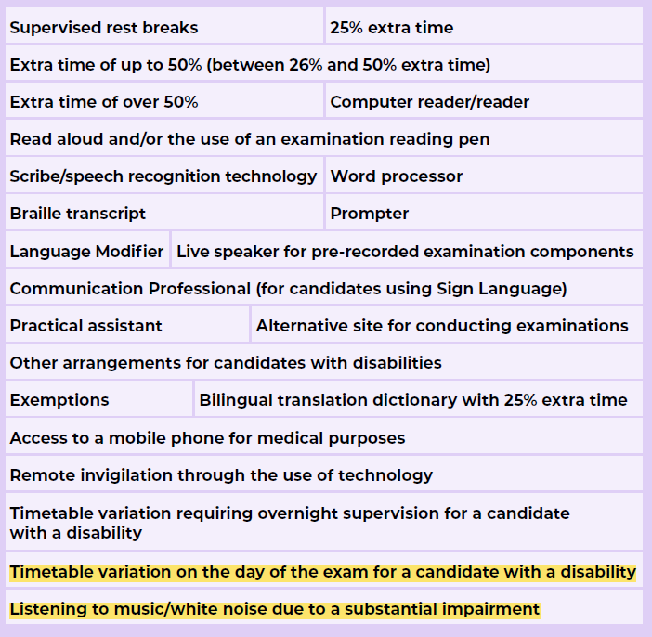

**Changes regarding Rest Breaks:**

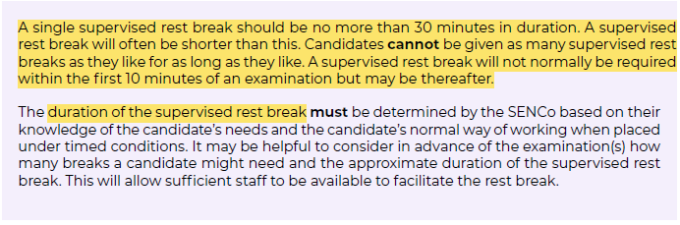

**Changes regarding Extra Time:**

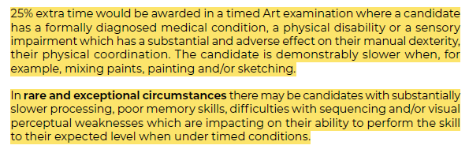

**Computer Reader/ Reader:** (there are some exceptions for papers where reading is a primary assessment)

This access arrangement is now available for

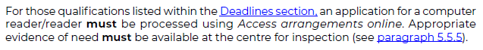

**Use of a word processor with spell and grammar check and/or predictive text** –

This falls under arrangements for Scribe / Speech Recognition Technology and must be processed through Examinations Access Online.

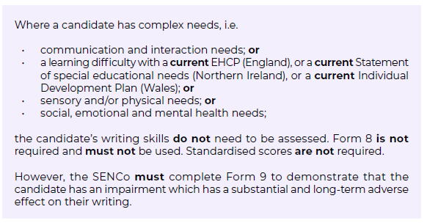



**Use of a word processor without spellcheck, grammar check or predictive text:**

Must be the normal way of working for the candidate within their centre (thus where word processing is used regularly in school/setting and not just at home or put in place only for examinations).

As a normal way of working, this does not need to be logged on Access Arrangements Online but should be supported by a policy for the centre.



**Practical Assistants:**

There have been no changes to this for the 2024-2025 period but a reminder of the key principles set out:

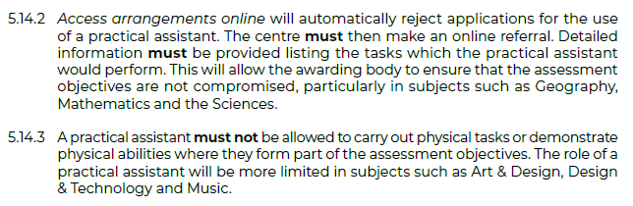

**Other Arrangements now Available:**

* Non-electronic headphones
* Timer on a candidate’s desk – a small countdown clock, a small analogue or digital clock, digital timer.

On the basis of:



**Exemptions:**

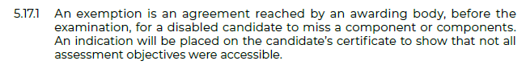

The centre should log ‘other’ on the Access Arrangements Online to then be able to make an individual application with the relevant awarding body.

***Note*** *the certificate awarded will show that not all assessment objectives were accessible.*

* It is useful to know this method to access any special requests that will need to go to individual exam boards for approval.

**Other information with relevance to PNI:**

* Access to a mobile phone for medical purposes – e.g. to monitor condition.
  + The candidate will be handed the phone by the invigilator and supervised throughout its use.
* Remote invigilation through the use of technology, for example Microsoft Teams.
  + This will only be considered when all other forms of in person invigilation have been exhausted both in centre and in an alternative location.
* Timetable variation requiring overnight supervision for a candidate with a disability.
  + Only used in exceptional circumstances.
  + Can be used for only one examination in the series to move from a published afternoon session to the following morning. Where more than one timetable variation is required, this will be rejected by Access Arrangements Online, and the centre will need to then make a referral to the awarding body.
  + Centre must secure confirmation of overnight supervision and completion of a declaration form.
* Timetable variation on the day of the exam for a candidate with a disability.
  + Must be processed using Access Arrangements Online
  + To sit an exam earlier or later than the published time
  + For a morning exam to be moved to the afternoon
  + For an afternoon exam be brought forward to the morning
  + The centre is required to secure adherence to supervision arrangements.
* Listening to music/ white noise due to a substantial impairment.
  + Using a device that cannot be connected to the internet.
  + Playlist must be checked for content that does not provide any advantage.