**Let’s Talk: Taking Healthy Risks**

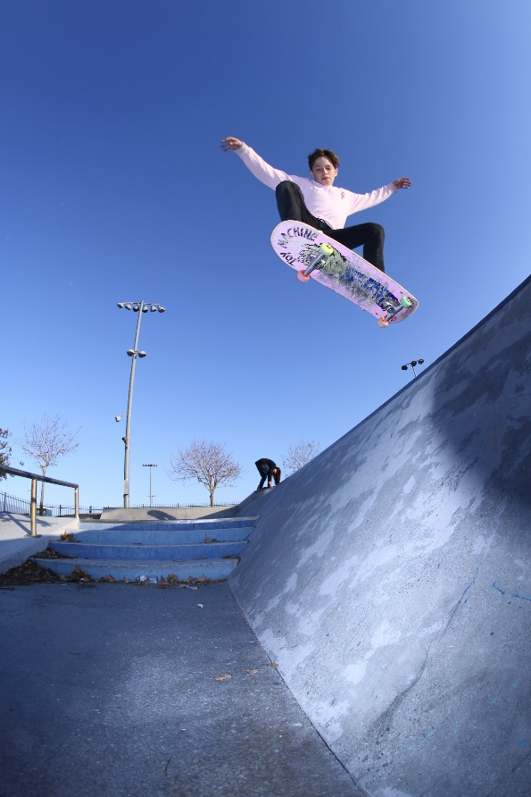**Secondary**

This resource is part of our self-care suite of resources and has been co-produced with children and young people living in Essex, for children and young people. They have also been developed and quality assured by the following stakeholders:

* Essex Educational Psychology Service
* Health Watch Essex
* Essex Mental Health Support Teams (MHSTs) NELFT NHS Foundation Trust
* Essex Multi-schools Council
* Essex Social, Emotional and Mental Health (SEMH) strategy team
* Essex Child and Family Wellbeing Service, HCRG Care Group in partnership with Barnardo’s
* NELFT NHS Trust Southend, Essex, and Thurrock (SET) Child, Adolescent and Mental Health Service (CAMHS)
* 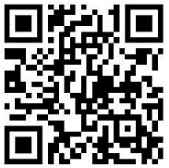Professionals in schools and settings can access all these resources via the [Essex info link SEMH portal](https://schools.essex.gov.uk/pupils/social_emotional_mental_health_portal_for_schools/Pages/Self-care-for-CYP-Library.aspx). Children and young people (CYP), parents/carers and professionals can also access these resources via the SET CAMHS website. Our self-care content can also be accessed via SET CAMHS Instagram account:

The resources are intended to be accessed by CYP independently or trusted adults use these resources with CYP through 1:1 conversation, whole school/group discussion and assemblies.

Please note: some of the content within our self-care resources may be emotive for CYP. We recommend that you make use of the ‘signposting to support’ section of this document should any of the content be triggering.

   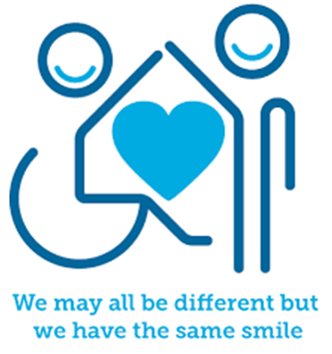

 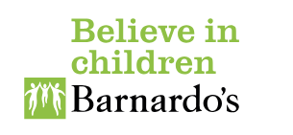

**Introduction**

Risks can often be thought of as situations or actions you take, which can lead to some sort of danger, harm, or loss. You must be very careful with risk taking especially if it compromises your safety. If it is not safe to take a risk do not do it or seek the support of a trusted adult to make that risk safe and supervised for you. Healthy risks or responsible risks however are actions you take which benefit you and your development as a person. Healthy risks are about trying something new. It could be as simple as raising your hand to answer a question in class, going out with your friends somewhere new, saying no to peer pressure or making your own decisions.

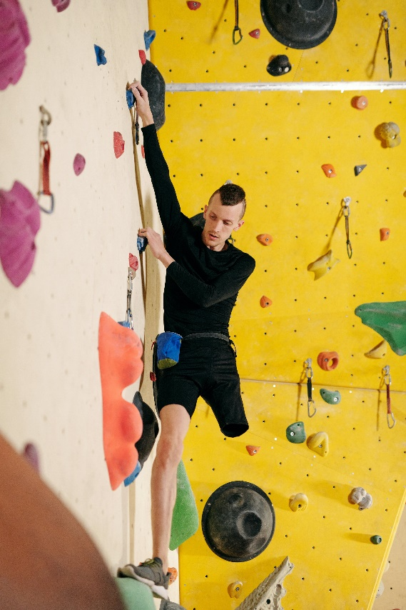

**Facts**

Healthy/responsible risks:

* teach us responsibility
* improve our confidence and self-esteem
* help us to develop problem-solving skills and assess risk
* become more aware of safety

**Myth Buster**

Here are some of the myths about risk taking:

* Risk taking is always bad X
* Risks are always dangerous X
* You should never take risks X
* You should always take risks X

**Video clips**

Check out these videos about boundaries:

|  |
| --- |
| * [Decision making and the adolescent brain](https://www.youtube.com/watch?v=kvk4sqNPa4M)   Dovetail Qld describe how teens brain development affects decision making |
| * [Teens and Risk Taking](https://www.youtube.com/watch?v=kh4-R9xFAys)   The National Academy of Science, Engineering and Medicine have created a video exploring teens taking risks |
| * [Why do we take risks](https://www.youtube.com/watch?v=I0IKYrMNM0M)   BBC Bitesize explore the reasons why teens take risks |
| * [Risky Decisions -- They Can Be a Good Thing for Teens to Make](https://www.youtube.com/watch?v=dIiN2jLBbCU)   Decision Education Foundation describe risk taking |
| * [Decision-Making Strategies](https://www.youtube.com/watch?v=pPIhAm_WGbQ)   Learn free offer strategies to support decision making |
|  |
| * [Adolescent risk-takers: The power of peers](https://www.youtube.com/watch?v=2Q4tlPEihAM)   Nature video explores increased risk taking when teens are with their peers |

**Resources**

|  |
| --- |
| * [Drugs and Alcohol | Support For Young People | YoungMinds](https://www.youngminds.org.uk/young-person/coping-with-life/drugs-and-alcohol/)   Young minds advice to young people who are risk taking by taking drugs and alcohol |

**Reflective questions**

(Try exploring these reflective questions with a CYP)

* What is a risk?
* What is a healthy/responsible risk?
* Can you name three unsafe risks?
* What risks have you taken that have been beneficial to you?
* Name three risks you would not take

**Quiz**

Once you have gone through this resource with a CYP try these quiz questions with them:

* What do taking safe and responsible risks help you to develop?
* Why might you take a risk?
* When would you not take a risk?
* Name three safe risks
* Name three unsafe risks

**Signposting to Support**

For additional support we recommend you access:

* [Anna Freud Centre – On My Mind](https://www.annafreud.org/on-my-mind/)
* [Kooth.com](https://www.kooth.com/) (Age 11-25)
* [Togetherall](https://togetherall.com/en-gb/faqs/becoming-a-member-and-managing-your-profile/#:~:text=Togetherall%20is%20only%20for%20adults,is%20only%20available%20to%2018%2B.) (age 16+)
* [Explore counselling/therapy](https://www.nhs.uk/mental-health/talking-therapies-medicine-treatments/talking-therapies-and-counselling/counselling/)
* [Childline](https://www.childline.org.uk/info-advice/your-feelings/mental-health/?&&&&gclsrc=aw.ds&&gclid=EAIaIQobChMIqryktIeP_wIVicPtCh3QZQs6EAAYASAAEgJr5vD_BwE&gclsrc=aw.ds) - 0800 1111 – [when contacting ChildLine what to expect](https://www.youtube.com/watch?v=_KNtMOKwTco)
* [Hopeline 0800 068 41 41](https://www.papyrus-uk.org/papyrus-HOPELINE247/) offering confidential support and practical advice
* [Text ‘SHOUT’ to 85258](https://giveusashout.org/get-help/?gclid=Cj0KCQiA6vaqBhCbARIsACF9M6nG--bxZCnflhd5C3jT-d9dS48o5t6XTTTidI0MLTgwjjRAlxszRT8aAnvvEALw_wcB) for free, confidential, anonymous text support service.
* [Share any concerns about your mental health with your GP](https://www.mind.org.uk/information-support/guides-to-support-and-services/seeking-help-for-a-mental-health-problem/talking-to-your-gp/) and [Understanding Confidentiality](https://www.mind.org.uk/for-young-people/your-rights/understanding-confidentiality/)
* [NHS 111](https://www.nhs.uk/nhs-services/mental-health-services/)
* [Southend, Essex & Thurrock Children and Adolescent Mental Health Service (SET CAMHS)](https://www.nelft.nhs.uk/set-camhs/)
* [Where to get urgent mental health support from: Advice from NHS](https://www.nhs.uk/nhs-services/mental-health-services/where-to-get-urgent-help-for-mental-health/)
* SET CAMHS Instagram account 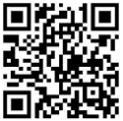

**How to help a friend**

* Start a conversation with a friend about taking risks (both safe, healthy, and responsible risks as well as unsafe risks).
* Suggest a friend seeks help from a trusted adult if they are going to take a risk that they need help with.
* Speak to a trusted adult if you are concerned a friend is taking unsafe risks.

**The adult box** (for professionals and parent/carers to read)

|  |
| --- |
| * [Risk-Taking Behaviour in Teenagers](https://www.children1st.org.uk/help-for-families/parentline-scotland/guidance-advice/articles/risk-taking-behaviours/)   Children 1st provides parents with information on tackling risk-taking behaviours |
| * [Why Risk-Taking is Essential for Child Development](https://www.psy-ed.com/wpblog/risk-taking-children/)   Advanced Psychology Services article looking at why risk taking is essential for child development |
| * [Challenging Behaviour | Parents' Guide to Support](https://www.youngminds.org.uk/parent/parents-a-z-mental-health-guide/challenging-behaviour/)   Young minds advice for parents in managing your child’s challenging behaviour |
| * [Why Are Teen Brains Designed for Risk-taking?](https://www.psychologytoday.com/gb/blog/the-wide-wide-world-psychology/201506/why-are-teen-brains-designed-risk-taking)   Psychology today article on why teens brains designed to take risks |

