**School Funding Consultation 2025/26**

**OCTOBER 2024**

**Contents**

|  |  |  |
| --- | --- | --- |
|  | **Section** | **Page** |
| 1 | Overview | 3 |
|  |  |  |
| 2 | Introduction | 3 |
|  |  |  |
| 3 | Essex Formula for Funding Schools  Minimum / Maximum Funding Values  KS3 / KS4 Basic Entitlement Weighting  Minimum Funding Guarantee  Capping  London Weighting | 4  5  6  6  7 |
|  |  |  |
| 4. | Proposal to Transfer 1% from the Schools Block to the High Needs Block  Background and Context  Previous Movements between Blocks  Budget Pressures 2024/25 and beyond  Financial Position of the High Needs Block  How will the Transfer be Used  Action Taken to Address the Over Spend  SEND Strategy  Timeline to Setting School Budgets  Impact of Transfer on School Budget | 7  9  10  16  18  18  19  20  20 |

# **Overview**

This consultation has been approved by Schools Forum and concerns the following:

* The requirement to adhere to the Schools National Funding Formula (NFF); and
* A transfer from the Schools Block to the High Needs Block

The consultation is for all primary and secondary schools, both maintained and academies. The Essex Formula for Funding Schools 2025/26 will calculate budget allocations for maintained schools between April 2025 and March 2026 and academies between September 2025 and August 2026.

**Why We Are Consulting**

We are seeking the views of schools on how the Authority should ensure the requirements of the Schools NFF are met.

We are also seeking the views of schools on the proposal to transfer 1% from the Schools Block to the High Needs Block in 2025/26 due to demand increasing at a higher rate than the grant funding awarded to the authority by the Department for Education (DfE).

**Introduction**

Due to the general election the provisional Dedicated Schools Grant (DSG) funding settlement for 2025/26 has been delayed. The settlement is usually announced at the start of the school summer holidays. Whilst the DfE did announce a delay, there has been no indication as to when the provisional settlement will be announced.

The DfE has indicated the usual annual timetable will be extended but it is not known if this will fully reflect the delay in the announcement. The Authority must therefore consult with schools as the timetable is usually very tight, especially as the Authority will need to seek approval for the proposed 1% transfer from the Secretary of State.

To lessen the burden on schools the Authority proposes to conduct one consultation for 2025/26, unless there are significant changes within the provisional settlement that require a further consultation.

**Essex Formula for Funding Schools**

Unless any changes are announced for 2025/26, the Authority will need to comply with the following rules to determine budget allocations for schools:

* setting the value for each funding formula factor within the allowed minimum / maximum values;
* implementing the set minimum per pupil level: and
* setting the minimum funding guarantee within the allowed limit.

**Minimum / Maximum Allowable Local Factor Values**

Over the last 2 years in preparation for the introduction of the Direct NFF, where the DfE will calculate school budget allocations, local authorities have been required to move their local formula factor values at least 10% closer to the NFF factor value.

Local authorities that set their local factor values within 2.5% of NFF factor values are deemed to be mirroring the NFF. Essex mirrors the NFF for all factors except the basic entitlement.

For 2024/25 **Table 1** shows for primary schools the minimum and maximum values which are +/- 2.5% of the NFF value uplifted by the area cost adjustment for Essex. It can be seen that Essex funded schools at the mid-point value between the minimum and maximum values allowed, with the exception of the basic entitlement which is below the mid-point.

|  |  |  |  |  |
| --- | --- | --- | --- | --- |
| **Primary** | **Minimum 2024/25** | **NFF uplifted by ACA 2024/25** | **Maximum 2024/25** | **Essex Value 2024/25** |
| Primary Basic Entitlement | 3,485.73 | 3,575.11 | 3,664.49 | 3,552.59 |
| Primary FSM | 479.51 | 491.80 | 504.10 | 491.80 |
| Primary FSM6 | 802.44 | 823.02 | 843.49 | 823.02 |
| Primary IDACI F | 229.97 | 235.86 | 241.76 | 235.86 |
| Primary IDACI E | 278.90 | 286.05 | 293.20 | 286.05 |
| Primary IDACI D | 435.47 | 446.64 | 457.80 | 446.64 |
| Primary IDACI C | 474.62 | 486.78 | 498.95 | 486.78 |
| Primary IDACI B | 503.97 | 516.90 | 529.82 | 516.90 |
| Primary IDACI A | 665.44 | 682.50 | 699.56 | 682.50 |
| Primary LPA | 1,144.95 | 1,174.31 | 1,203.66 | 1,174.31 |
| Primary EAL3 | 577.37 | 592.17 | 606.98 | 592.17 |
| Primary Mobility | 939.44 | 963.53 | 987.62 | 963.53 |
| Primary Lump Sum | 131,522.23 | 134,894.59 | 138,266.96 | 134,894.59 |
| Primary Sparsity | 55,877.37 | 57,310.13 | 58,742.88 | 57,310.13 |
| Primary Split Site Basic Eligibility | 52,550.18 | 53,897.62 | 55,245.06 | 53,897.62 |
| Primary Split Site Distance | 26,324.02 | 26,998.99 | 27,673.97 | 26,998.99 |

**Table 2** shows for secondary schools the minimum and maximum values which are +/- 2.5% of the NFF value uplifted by the area cost adjustment for Essex. It can be seen that Essex funded schools at the mid-point value between the minimum and maximum values allowed, with the exception of the KS3 and KS4 basic entitlement, with the KS3 basic entitlement below the mid-point and the KS4 basic entitlement is just within the maximum value allowed.

|  |  |  |  |  |
| --- | --- | --- | --- | --- |
| **Secondary** | **Minimum 2024/25** | **NFF uplifted by ACA 2024/25** | **Maximum 2024/25** | **Essex Value 2024/25** |
| Secondary Basic Entitlement | 4,914.47 | 5,040.48 | 5,166.49 | 4,975.15 |
| Secondary FSM | 5,539.79 | 5,681.83 | 5,826.89 | 5,826.84 |
| Secondary FSM6 | 479.51 | 491.80 | 504.10 | 491.80 |
| Secondary IDACI F | 1,174.31 | 1,204.42 | 1,234.53 | 1,204.42 |
| Secondary IDACI E | 332.72 | 341.25 | 349.78 | 341.25 |
| Secondary IDACI D | 616.51 | 632.32 | 648.13 | 632.32 |
| Secondary IDACI C | 675.23 | 692.54 | 709.85 | 692.54 |
| Secondary IDACI B | 724.16 | 742.72 | 761.29 | 742.72 |
| Secondary IDACI A | 924.77 | 948.48 | 972.19 | 948.48 |
| Secondary LPA | 1,736.99 | 1,781.53 | 1,826.07 | 1,781.53 |
| Secondary EAL3 | 1,551.06 | 1,590.83 | 1,630.60 | 1,590.83 |
| Secondary Mobility | 1,350.45 | 1,385.08 | 1,419.71 | 1,385.08 |
| Secondary Lump Sum | 131,522.23 | 134,894.59 | 138,266.96 | 134,894.59 |
| Secondary Sparsity | 81,222.80 | 83,305.44 | 85,388.08 | 83,305.44 |
| Secondary Split Site Basic Eligibility | 52,550.18 | 53,897.62 | 55,245.06 | 53,897.62 |
| Secondary Split Site Distance | 26,324.02 | 26,998.99 | 27,673.97 | 26,998.99 |

The minimum / maximum values are one method the Authority has available to ensure the requirements of the Schools NFF are met by adjusting values within the allowed range.

**Question 1 –** do schools approve the Authority adjusting the minimum / maximum values to ensure the requirements of the Schools NFF are met?

**Question 2 –** should the Authority be required to move the amount funded for any factor towards the minimum value allowed, the Authority can do this by either adjusting the deprivation factors or lump sum. Should this action be required, do schools prefer that the Authority adjusts the deprivation factors or the lump sum?

**KS3 / KS4 Basic Entitlement Weighting**

To reflect the additional costs of key stage 4 the basic entitlement is weighted compared to the key stage 3 basic entitlement. The current weighting in Essex is 1.01:1.183, whereas the weighting used in the NFF is 1:1.128.

Over the last two years as the DfE prepare for the Direct NFF, the Authoriy has been required to reduce the weighting to be able to set a KS4 basic entitlement value within the maximum value allowed. It is highly likely this will be required in 2025/26.

**Question 3 –** do secondary schools agree that the Authority moves the KS3 / KS4 basic entitlement weighting towards the NFF weighting if required by the minimum amount necessary to meet the maximum value allowed for the KS4 basic entitlement?

**Minimum Funding Guarantee**

The minimum funding guarantee (MFG) protects schools from excessive year-on-year changes. In 2024/25 local authorities could set the MFG between 0.0% and 0.5% per pupil.

Essex set the MFG at 0.5% for 2024/25 which ensured schools received a minimum 0.5% per pupil increase. Depending on the funding allocated for 2025/26 an option available to the Authority to ensure the requirements of the NFF are met is to set a lower MFG within the parameters allowed.

**Question 4 –** do schools agree that the Authority, if required, lowers the value of MFG in 2025/26 to meet the requirements of NFF?

**Capping**

To ensure the local formula is affordable local authorities can choose to cap any gains schools receive. Capping and scaling must be applied on the same basis to all schools, but cannot be applied to new schools that have opened in the last 7 years and have not reached their full number of year groups.

Local authorities in consultation with their Schools Forum must determine whether and how to limit gains. Capping and scaling cannot take a school below the minimum per pupil level and must be set at least as high as the MFG threshold to ensure schools retain any gains due through MFG.

An example of where capping could be needed is where there in insufficient funding in the schools block to set the basic entitlement at or above the minimum value allowed. This can occur where the cost of protecting schools through the minimum funding guarantee and the minimum per pupil level is high. The use of capping will allow sufficient funding to set an allowable basic entitlement value.

**Table 3** shows an example of how capping works. For example, if the Authority sets the maximum amount a school can gain at 3% capping works as shown in Table 3.

|  |  |  |  |  |  |
| --- | --- | --- | --- | --- | --- |
| School | 2024/25  £ | 2025/26  £ | % Change | 3% Threshold  £ | Reduction  £ |
| School A | 1,000,000 | 1,090,000 | 9% | 1,030,000 | 60,000 |
| School B | 750,000 | 771,000 | 2.8% | 772,500 | 0 |
| School C | 500,000 | 522,500 | 4.5% | 515,000 | 7,500 |
| School D | 1,200,000 | 1,236,000 | 3% | 1,236,000 | 0 |

**Question 5 –** if necessary, do schools support the use of capping school gains above the agreed level?

**London Weighting**

To reflect the additional costs of schools in the London fringe area, London weighting is applied to all pupil-led factors, the lump sum, sparsity and the splits site factor.

Prior to 2024/25, local authorities could choose between 2 different values for the London weighting multiplier, either 1.0156 or the ratio of the area cost adjustment of the London fringe and non-London fringe zones, which for Essex is 1.0345.

For 2024/25 local authorities needed to move their London weighting multiplier closer to NFF and Essex moved the multiplier 10% closer to 1.0173.

It is expected that local authorities will be required to contine the movement in the London weighting multipllier to NFF in 2025/26.

**Question 6 –** do schools support that the Authority moves the London weighting multiplier as necessary to meet the minimum allowed value for 2025/26?

**Schools Block (SB) Transfer to the High Needs Block (HNB)**

**The Proposal for Transferring 1% in 2025/26**

**Background and Context**

Essex working in partnership with schools has a vital role in supporting children with SEND to achieve the best possible educational and other outcomes. However, the system is driving the volume which along with funding constrained, makes it very difficult for the Authority administering the system.

The Authority does not believe the composition of the High Needs National Funding Formula funds the increased demand appropriately. The National Funding Formula also fails to recognise the interaction between the SB and the HNB. There needs to be sufficient funding for all funding blocks which would prevent the need to move funding between blocks.

The Authority will continue to work with local MPs, the Local Government Association, the Chartered Institute of Public Finance and Accountancy, the Ministry of Housing, Communities and Local Government and the Department for Education to lobby the Treasury for additional funding for the HNB.

Chart 1 shows how the High Needs Block is allocated in 2024/25.

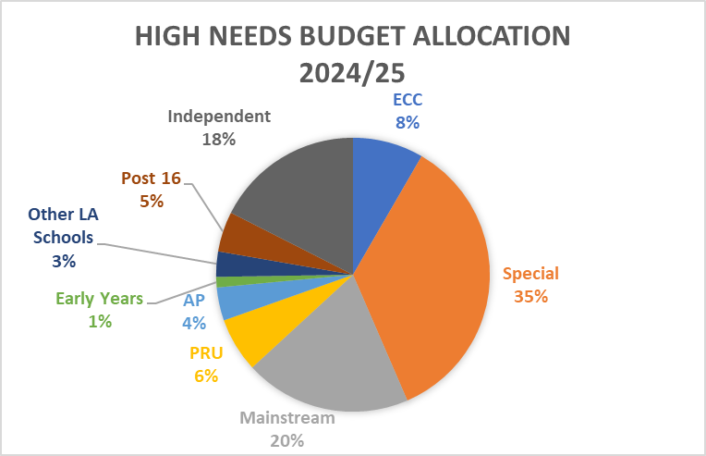

**Chart 2** shows the same comparison when the last transfer was made. It can be seen that Special schools remain at 35% with mainstream increasing by 1%, independent schools by 5% and the funding retained by ECC decreases by 3%.

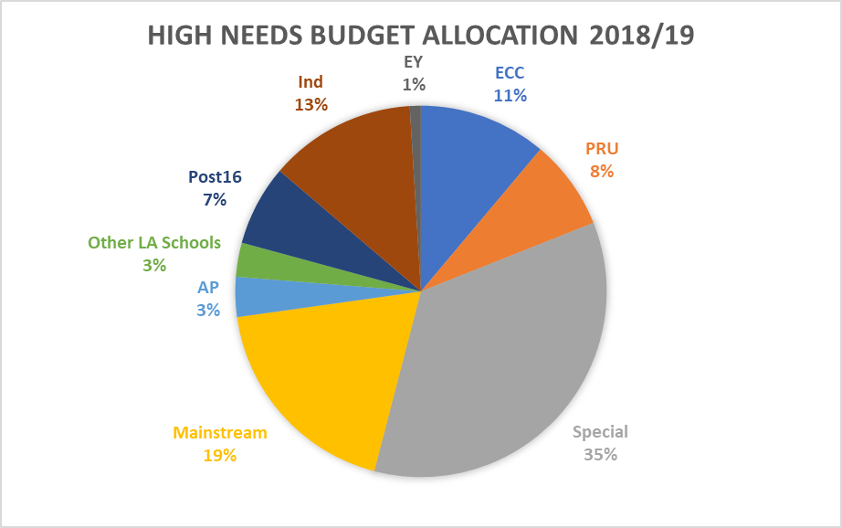

**Previous Movements between Blocks and the Pressures that were Covered by the Movement**

**Table 5** shows previous movements between blocks.

|  |  |  |  |
| --- | --- | --- | --- |
| Financial Year | Schools Block £m | High Needs Block  £m | Early Years Block  £m |
| 2015/16 | (1.6) | 1.6 | 0 |
| 2016/17 | (4.6) | 1.6 | 3.0 |
| 2017/18 | (1.6) | 1.6 | 0 |
| 2018/19 | 0 | 0 | 0 |
| 2019/20 | (4.3) | 4.3 | 0 |
| Total | **(12.1)** | **9.1** | **3.0** |

There have been no movements between blocks since 2019/20.

In 2015/16 the £1.6m movement to the HNB was to fund the pressure created from the incremental growth of 197 places in Essex special schools. This avoided additional expenditure as it prevented pupils going into more expensive Independent School Provision. In 2015/16 the HNB over spent by £512,000.

In 2016/17 there was an additional £1.6m movement to the HNB to fund the pressure in the Post 16 FE created from an increase from 123 places to 475 places. In 2016/17 the High Needs Block over spent by £325,000. The £3m transfer to the Early Years Block was needed due to the insufficient early years guaranteed unit of funding. The Early Years Block was £3m over spent at the end of 2016/17.

For 2017/18 the Authority reported to Forum that there was a £4.9m pressure on the High Needs Block primarily around the incremental growth in Essex special school places (184 places) and an increase in Post 16 FE places (73 places). It was agreed to move a further £1.6m from the Schools Block to the High Needs Block. The High Needs Block over spent by £2.9m in 2017/18

For 2018/19 the Authority chose not to request a transfer from the Schools Block. At the January 2018 meeting it was reported that there were financial pressures of £4.3m, which the Authority would attempt to mitigate. The High Needs Block over spent by £1m in 2018/19.

In 2019/20 the Authority asked Schools Forum to approve a 0.5% transfer from the Schools Block, £4.3m, due to a forecast £4.8m over spend. Schools Forum did not approve the transfer so a disapplication request was submitted to the Secretary of State who did approve the 0.5% transfer to the High Needs Block. The High Needs Block over spent by £8.5m resulting in a cumulative deficit of £10.1m.

The Authority re-organised the Specialist Teachers team and overall reduced central expenditure within the High Needs Block by £2m. At the same time, the Government significantly increased the funding within the High Needs Block and Essex received increases of 11.5% or above for 2021/22, 2022/23 and 2023/24.

In 2024/25 the High Needs Block allocation was capped at a 5% increase. There is a forecast over spend of £15.0m which will result in an overall deficit of £3.6m. There is a high risk that this deficit will increase by year end. The key pressures are shown in **Table 6**.

|  |  |
| --- | --- |
| Pressures | £m |
| Top-up Funding Mainstream Schools - due to an increase in volume of EHCPs. | 6.2 |
| Individual Packages of Education Support – due to an increase in pupils not in a school setting who access education through tuition services within the IPES framework. | 4.2 |
| Special Schools Top-up – due to an increase in volume and cost of placements. | 4.1 |
| Essex Pupils attending other local authority schools – due to an increase in the volume of placements and an increase in cost of placements. | 1.0 |
| Independent Schools – due to an increase in cost and volume of placements | 2.3 |
| High Needs Block Contingency – contingency held to offset pressures. | (2.0) |
| Contribution to Pension Deficit – pension deficit contribution for ECC employee posts funded by the High Needs Block is deferred for 2024/25. | (0.8) |
|  | **15.0** |

**Budget Pressures in 2024/25 and beyond**

The High Needs Block moved into surplus in 2022/23 and started 2024/25 with a surplus balance, however the forecast for 2024/25 will result in a deficit at the end of the year of £3.6m due to the following pressures.

**Education, Health and Care Plans**

Each of the following charts show actual data plus the forecasts for 2024/25 and 2025/26 as a solid line. The dotted line shows the forecast to 2028/29 which is the worse-case scenario if nothing changes.

**Chart 3** shows that when the original request for a Schools Block transfer was made in November 2018 that there were 8,759 EHCPs. In 2024/25 this has increased to 13,659 EHCPs, an increase of 55.9%. The forecast by 2028/29 is a further increase to 17,042 EHCPs, an increase of 24.8% from 2024/25.

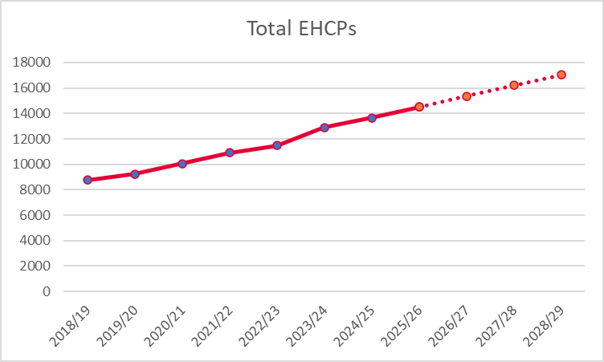

**Chart 4** shows the growth in EHCPs between mainstream and special schools. It can be seen the growth in mainstream is at a higher rate than the growth in special schools as the gap between the lines widens.

**Chart 5** shows the average cost of Top-up funding for mainstream schools and special schools. Whilst the average Top-up funding is forecast to increase for both mainstream and special schools, the forecast growth in mainstream is significantly higher at 101.4% compared to 22.7% in special schools.

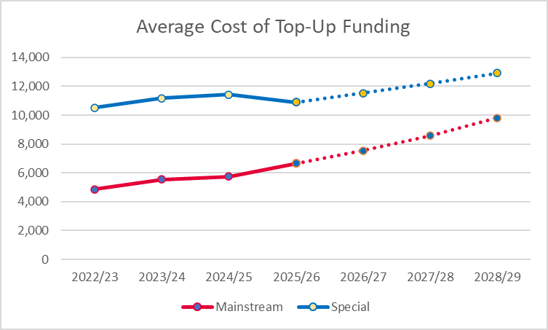

**Chart 6** shows the growth in EHCPs between primary and secondary. Primary initially increased at a higher rate in 2023/24. From 2024/25 growth between primary and secondary is fairly even with secondary forecast to grow at a slightly higher rate from 2027/28.

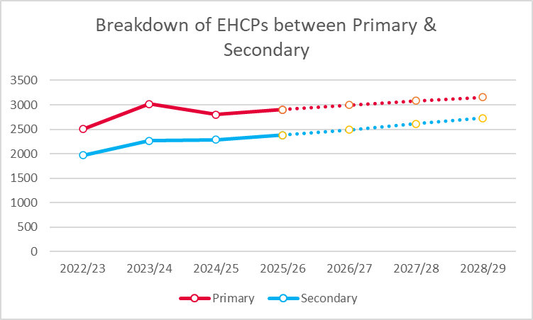

**Independent Schools**

**Chart 7** shows the forecast growth in Independent School placements. It can be seen that expenditure was £28.9m in 2022/23 and is forecast to increase to £76.9m by 2028/29.

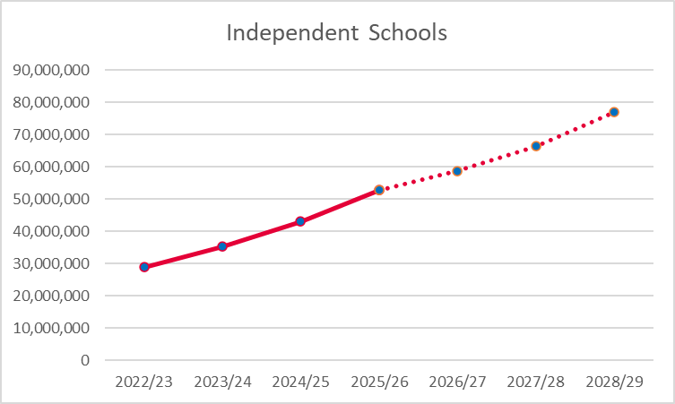

**Chart 8** shows the growth in placements for independent schools where it can be seen there is significant growth forecast in 38 week day places.

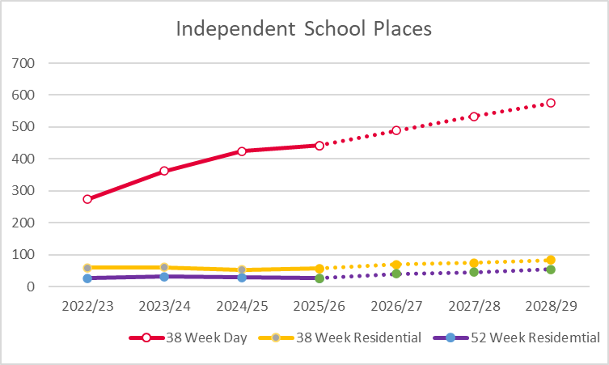

**Chart 9** shows the average cost of independent places which are increasing due to inflation and the increasing complexity of children.

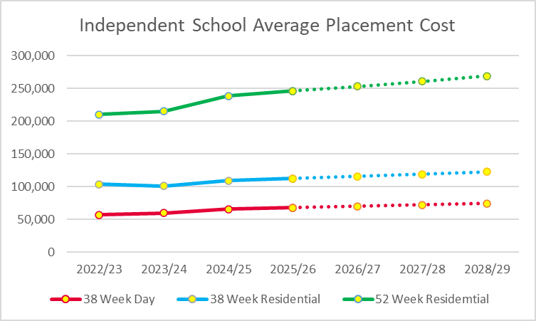

**Individual Package of Education Support (IPES)**

IPES supports pupils with EHCPs who are not in a school setting and pupils who are excluded from schools.

**Chart 10** shows the forecast growth in cost for pupils with EHCPs accessing IPES provision.

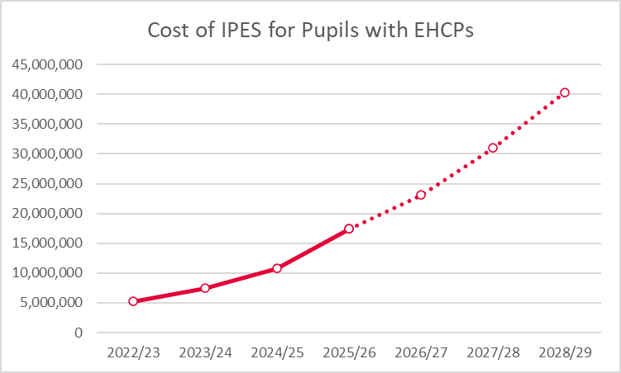

**Chart 11** shows the forecast growth in the cost of excluded pupils accessing IPES provision.

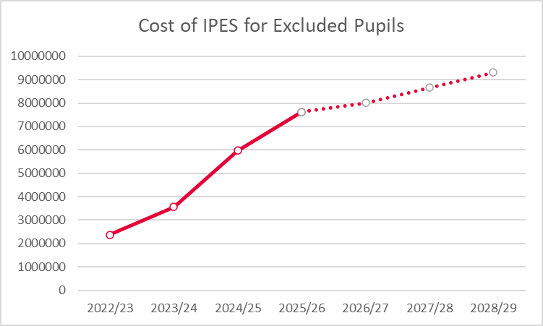

**Charts 12 and 13** show the increasing levels of fixed term exclusions and permanent exclusions which are contributing to the increase in the cost of pupils accessing IPES provision.

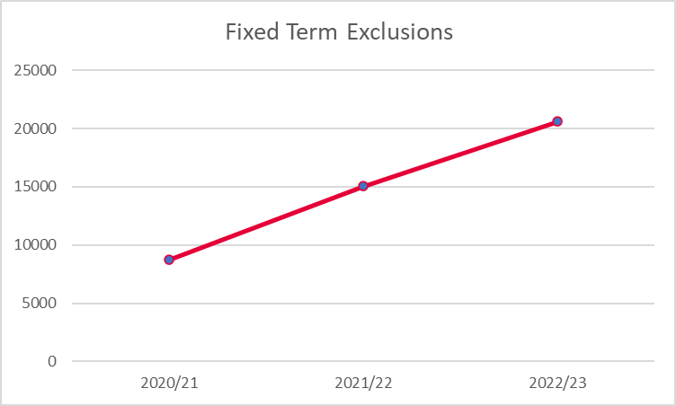

Exclusions mainly occur in secondary schools.

**Financial Implications**

**Table 7** shows the forecast High Needs Block position based on the forecast increase in demand, price and the increasing complexity of pupils.

|  |  |  |  |  |  |
| --- | --- | --- | --- | --- | --- |
| HNB | 2024/25  £m | 2025/26  £m | 2026/27  £m | 2027/28  £m | 2028/29  £m |
| Expenditure | 254.1 | 288.5 | 320.1 | 357.3 | 402.9 |
| Income | (239.1) | (246.2) | (253.6) | (261.2) | (269.1) |
| (Surplus) / Deficit | 15.0 | 42.3 | 66.5 | 96.1 | 133.8 |
| Balance b/fwd. | (11.3) | 3.7 | 46.0 | 112.5 | 208.6 |
| Balance c/fwd. | **3.7** | **46.0** | **112.5** | **208.6** | **342.4** |

The Authority proposes the following actions to reduce the deficit in 2025/26:

* To transfer 1% (c.£11.6m) from the Schools Block to the High Needs Block
* To transfer £1m from the Central School Services Block (CSSB) surplus balance to the High Needs Block
* To move all expenditure on the Early Years Inclusion Fund from the High Needs Block to the Early Years Block from 2024/25 ongoing. This will not impact on current funding rates, but may impact on funding rates increasing in line with the national increase in future years.

At the Schools Forum meeting on 24th September, Forum indicated support for the 1% transfer and agreed the £1m transfer from the CSSB surplus balance and to move all expenditure for the early years inclusion fund to the Early Years Block.

**Table 8** represents the forecast High Needs Block financial position including the above proposals.

|  |  |  |  |  |  |
| --- | --- | --- | --- | --- | --- |
|  | 2024/25  £m | 2025/26  £m | 2026/27  £m | 2027/28  £m | 2028/29  £m |
| Expenditure | 254.1 | 288.5 | 320.1 | 357.3 | 402.9 |
| Income | (239.1) | (246.2) | (253.6) | (261.2) | (269.1) |
| (Surplus) / Deficit | 15.0 | 42.3 | 66.5 | 96.1 | 133.8 |
| 1% SB Transfer | 0 | (11.6) | 0 | 0 | 0 |
| CSSB Surplus Transfer | 0 | (1.0) | 0 | 0 | 0 |
| Move SENIF to HNB | (3.0) | (4.0) | (5.4) | (7.4) | (10.0) |
| Surplus) / Deficit | **12.0** | **25.7** | **61.1** | **88.7** | **123.8** |
| Balance b/fwd. | (11.3) | 0.7 | 26.4 | 87.5 | 176.2 |
| Balance c/fwd. | **0.7** | **26.4** | **87.5** | **176.2** | **300.0** |

The Authority will continue to look to reduce expenditure. However, based on this forecast, the Authority will need to seek a Schools Block transfer on an annual basis

The impact on the transfer not being supported is:

* The DfE could invite the Authority to join the Safety Valve programme which is an intervention scheme that will require significant cuts and annual School Block transfers. It is common for a 1.5% transfer for local authorities with the highest deficits. Authorities in the Safety Valve scheme have clawed back balances from maintained schools and have reduced top-up funding midway through the financial year.
* If the Authority remains outside the Safety Valve programme, the Authority will need to make significant reductions in expenditure, in particular by reviewing Independent School placements, Top-up Funding and Individual Packages of Education Support, as well as other areas, which will reduce the amount of high needs funding paid to schools

Whilst funding levels are currently unknown, **Table 9** shows the level of school balances at the end of the 2023/24 financial year for maintained schools and the 2022/23 academic year for academies. The overall level of school balances increased by £4.2m between 2022/23 and 2023/24 and have increased by £55.5m since 2019/2020, which represents a 43.2% increase.

|  |  |  |  |  |
| --- | --- | --- | --- | --- |
| Phase | No. of Schools | Maintained School Balances at 31/03/24  £000 | Academy Balances at 31/08/23  £000 | Total Balances  £000 |
| Nursery | 2 | 235 | 0 | 235 |
| Primary | 447 | 35,325 | 50,347 | 85,672 |
| Secondary | 79 | 3,168 | 73,980 | 77,148 |
| All-Through | 2 | 0 | 1,958 | 1,958 |
| Special | 22 | 2,713 | 9,289 | 12,002 |
| PRU | 6 | 1,775 | 4,971 | 6,746 |
| Total | **556** | **43,216** | **140,545** | **183,761** |

**How will the Transfer be Used**

The Authority will continue to invest £3.5m in early intervention strategies through the continuation of the inclusion strategy and outreach.

The balance of the transfer will be used to fund the increasing cost within the system to continue to provide high needs funding at the current level to schools

**Action taken to Address the Over Spend**

Schools Forum approved funding for the Inclusion Framework which enables schools to access pre-statutory funding to develop inclusive practice. An update report will be presented to Schools Forum in November, but one example is a secondary school that was awarded £130,000 to develop inclusive practice within the school. The school has identified that this has prevented £143,000 additional cost to the High Needs Block to date. This is due to the school being able to meet pupil needs without an EHCP and so this is an annual saving to the top-up funding budget.

Schools Forum has also agreed funding for Outreach. The outreach is focussed on meeting needs in mainstream both at SEN Support and at EHCP to prevent escalation to special school; the outreach from PRUs is focussed on reducing permanent exclusions.

The Authority has invested significant funding in the system as shown in **Table 10.**

|  |  |  |
| --- | --- | --- |
| Investment | £000 |  |
| EHCP Backlog | 1,296 | Funding to award a contract for the processing of 900 EHCP applications. |
| SEND Assistance Plan | 2,896 | Funding to accelerate the pace of improvement in SEND statutory responsibilities. |
| Inclusion Strategy | 1,710 | An early intervention and prevention inclusion offer. |
| Assistant Education Psychologists[1] | 1,795 | To pilot a new delivery model by using Assistant Education Psychologists. |
| Total | **7,697** |  |

The Authority has established a working group to review expenditure on independent school placements and to look at investment options in more cost-effective provisions.

The Authority met with the ESFA on 10th September to discuss the DSG Management Plan but also to discuss how the ESFA can support in managing the price and volume demand within the grant allocation. The Authority awaits to hear of the next steps following the announcement that the functions of the ESFA will move to the DfE.

**SEND Strategy**

Our focus is on ensuring that we continue to invest in the SEN system to enable a systemic and long-term sustainability rather than making cuts to individual budgets which may have adverse impacts.

We have invested in a SEN workforce via ECC funding and HNB which allows strategic as well as operational support to schools. We have strong special schools but increased pressure on their physical capacity is making that more challenging.

Our sufficiency plan, due for publication in autumn 2024, will set out our intention to manage special school growth by reducing the numbers of children and young people with lower levels of need overtime as we work with mainstream schools to be better able to manage their needs locally. This will enable us to accommodate more children and young people with higher levels of need in special schools.

We are looking at a more strategic engagement with the independent market that allows ECC to be clear about our areas of need and to work with providers on more cost effective delivery models. We are in the process of carefully introducing a new banding model which will match banding to need. We have been clear via Schools Forum that the budget is finite and that schools need to be aware that increased requests for assessment will lead to individual banding being lower.

The Finance Review Group and High Needs Review Group have considered all the proposed actions to address the over spend and the SEND strategy and recommend that Schools Forum agree the proposals to reduce the deficit.

**Timeline to Setting School Budgets**

Schools Forum met on 25th September 2024 where they approved this consultation and indicated support for the proposed 1% transfer from the Schools Block to the High Needs Block.

The Consultation will be held between Monday 30th September and Sunday 27th October.

Once the provisional funding settlement is announced the Authority will review the proposed transfer.

Results of the consultation will be presented to a joint FRG and HNRG on 5th November where the outcome of the consultation will be discussed along with the implications of the provisional funding settlement. FRG/HNRG will agree the recommendations to take to Schools Forum.

Schools Forum will be presented with the results of the consultation, the implications of the provisional funding settlement and the outcome of the discussion on 5th November along with the recommendations of the FRG and HNRG. Schools Forum will then make their final decision on whether or not to support the 1% transfer.

Any disapplication request will be submitted to the Secretary of State after the Schools Forum meeting as the request is above the 0.5% limit Schools Forum can approve.

DSG final settlement expected week commencing 9 December.

The proposed DSG Budget for 2025/26 will be presented to Schools Forum at the January meeting for approval.

**Impact of Transfer on School Budgets**

As there has been no announcement of the provisional settlement the following figures are an **estimate**. The estimated funding includes the teacher’s pay and pension grants that will be added to DSG in 2025/26. The Core Schools Budget Grant is excluded as there are no funding allocations announced yet.

**Table 11** shows the **estimated** basic entitlement values for 2024/25 and a re-based 2024/25 AWPU for the Teachers’ Pay Grant (TPG) and the Teachers’ Pension Employer Contribution Grant (TPECG). The 2024/25 allocation is increased by an estimated 1.5% to calculate estimated values for 2025/26. The Schools Core Budget Grant for the September 2024 teachers’ pay award will also be included in the DSG allocation for 2025/26, however as no allocations have been announced it is not included in the following figures.

|  |  |  |  |
| --- | --- | --- | --- |
| Basic Entitlement | Primary  £ | KS3  £ | KS4  £ |
| 2024/25 | 3,552.59 | 4,975.15 | 5,826.84 |
| 2024/25 rebased for TPG / TPECG | 3,791.38 | 5,214.78 | 6,107.49 |
| 2025/26 – No Transfer | 3,829.10 | 5,826.79 | 6,191.83 |
| 2025/26 – 1% Transfer to HNB | 3,794.46 | 5,416.52 | 5,825.22 |

It is usual for the consultation to contain an annex showing the impact on each school but due to so many unknowns it has been decided that it is not reasonable / appropriate to try to model the impact.

**Question 7** – Do schools support the proposal to transfer 1% from the Schools Block to the High Needs Block?

1. The business case is still to be approved.