**Schools Forum Agenda**

Wednesday 10th July 2024, **Chelmsford City Racecourse CM3 1QP**

From 8am for an **8.30am start**; breakfast **10am** finish by **11:45am**.

|  |  |  |  |  |
| --- | --- | --- | --- | --- |
|  |  | Author | Voting / Relevance | Page |
| 1 | Apologies for Absence (and substitute notices) | Chair |  |  |

**Confidential Business**

|  |  |  |  |  |
| --- | --- | --- | --- | --- |
| 2 | SEND Funding and Capacity | Ralph Holloway | All schools | See separate report |
| 5a | Confidential Minutes of HNRG – 17th June 2024 |  |  | See separate report |

**Decision Papers**

|  |  |  |  |  |
| --- | --- | --- | --- | --- |
| 3 | Falling Rolls Fund | Yannick Stupples-Whyley | All schools | 3 |
| 4 | Building Schools for the Future -Refinancing Gain | Yannick Stupples-Whyley | All Schools | 22 |

**Forum Business**

|  |  |  |  |  |
| --- | --- | --- | --- | --- |
| 5 | Any other business, feedback from schools through Associations and from Schools Forum representatives on other Bodies | Chair | All schools | 25 |
| 6 | Minutes of 10th January 2024 | Chair | All schools | 31 |
| 7 | Minutes of 5th March 2024 | Chair | All Schools | 47 |
| 8 | Minutes Action Log | Yannick Stupples-Whyley | All schools | 51 |

**Information Papers for Discussion**

|  |  |  |  |  |
| --- | --- | --- | --- | --- |
| 9 | Early Years and Childcare Update | Carolyn Terry | All schools | 52 |
| 10 | Schools Budget and Education Functions Draft Outturn 2023/24 | Yannick Stupples-Whyley | All schools | 60 |
| 11 | Schools Budget and Education Functions Draft Budget Update 2024/25 | Yannick Stupples-Whyley | All schools | 65 |
| 12 | School and Academy Balances | Yannick Stupples-Whyley | All schools | 69 |
| 13 | Constitution and Membership of Schools Forum | Yannick Stupples-Whyley | All schools | 78 |
| 14 | Forward Plan | Yannick Stupples-Whyley | All schools | 87 |

**Closing Comments**

|  |  |  |  |  |
| --- | --- | --- | --- | --- |
| 15 | Closing Comments | Chair |  |  |

|  |  |
| --- | --- |
| Schools Forum | **Agenda Item 2** |
| Date: 10 July 2024 |  |

**CONFIDENTIAL REPORT: SEND Funding and Capacity Update**

|  |  |
| --- | --- |
| Schools Forum | **Agenda Item 3** |
| Date: 10 July 2024 |  |

**REPORT TITLE: FALLING ROLLS FUND 2024/25**

Report by Yannick Stupples-Whyley

Contact details: Telephone (03330 138464); e-mail: yannick.stupples-whyley@essex.gov.uk

**1. Purpose of report**

1.1 To present to Schools Forum the schools recommended by the Finance Review Group (FRG) to be funded through the Falling Rolls Fund for 2024/25

**2. Recommendations**

2.1 To approve the recommendation of FRG that the schools currently in the falling rolls fund listed at 4.6 continue to receive funding in 2024/25;

2.2 To approve the recommendation of FRG that Holt Farm Infant is removed from the falling rolls fund as the school does not meet the balance criteria at 4.7;

2.3 To approve the recommendation of FRG to remove The Alderton Junior School from the falling rolls fund unless the balance at 31st August 2024 complies with the balance criteria at 4.7;

2.4 To approve the recommendation of FRG that the schools listed at 4.8 are added to the falling rolls fund for 2024/25;

2.5 To note further applications for falling rolls funding may be received from academies where they meet the balance criteria on their published balance at 31st August 2024 at 4.9; and

2.6 To approve the recommendation of FRG that the schools listed at 4.10 do not qualify for the falling rolls fund.

2.7 To approve the funding of **£679,000** as shown at 5.2.

###### 3. Relevant Schools Forum Power and Responsibility

3.1 **Table 1** is an extract from the Schools Forum Operational and Good Practice Guide (September 2018), which sets out the role of the Authority, Schools Forum and the Secretary of State for the Falling Rolls Fund.

|  |  |  |  |
| --- | --- | --- | --- |
| Function | Local Authority | Schools Forum | DfE |
| Central spend on and the criteria for allocating funding for falling rolls where growth in pupil numbers is expected within three years. | Proposes | Decides | Adjudicates where schools forum does not agree local authority proposal |

###### 4. Background

4.1 Schools Forum agreed the criteria for the falling rolls fund at the January 2023 meeting and the balances criteria at the May 2023 meeting.

4.2 The requirement for schools to be judged good or outstanding by Ofsted has been removed from 1st April 2024.

4.3 There are 7 schools currently within the falling rolls fund for 2023/24.

* Prettygate Infant School
* St Mary’s Primary, Hatfield Broad Oak
* Clavering Primary
* Holt Farm Infant School
* Wethersfield Primary
* The Alderton Junior School
* Finchingfield Primary

4.4 The Authority contacted a further 21 schools that met the initial criteria of two consecutive falling rolls. Each school was given a template to complete and details of the Falling Rolls Fund. Table 2 shows the schools that were contacted and those that have submitted an application for funding.

|  |  |
| --- | --- |
| School | Application Submitted |
| All Saints' Church of England Voluntary Aided Primary School, Dovercourt | No |
| Belchamp St Paul Church of England Primary School | Yes |
| Birch Church of England Voluntary Aided Primary School | Yes |
| Chigwell Primary Academy | Yes |
| Chigwell Row Infant School | No |
| Dr Walker's Church of England Voluntary Controlled Primary School, Fyfield | No |
| Fingringhoe Church of England Voluntary Aided Primary School | No |
| Fordham All Saints Church of England Voluntary Controlled Primary School | No |
| Highwood Primary School | Yes |
| Hilltop Infant School | No |
| Langenhoe Community Primary School | No |
| Little Waltham Church of England Voluntary Aided Primary School | Yes |
| Maldon Primary School | No |
| Mistley Norman Church of England Primary School | Yes |
| Monkwick Infant and Nursery School | No |
| Priory Primary School, Bicknacre | No |
| St John the Baptist Church of England Voluntary Aided Primary School Pebmarsh | Yes |
| St Mary's Church of England Voluntary Controlled Primary School, Ardleigh | Yes |
| Tollesbury School | Yes |
| William Read Primary School and Nursery | Yes |
| Wimbish Primary School | Yes |

4.5 Annex A shows the full details of each application.

4.6 The schools that are currently in the falling rolls fund were asked to submit updated pupil forecasts and they have been assessed to ensure they still meet the balance criteria. FRG has reviewed the applications in Annex A and recommend the following schools continue to receive falling rolls funding:

* Clavering Primary
* Finchingfield Primary
* Prettygate Infant
* St Mary’s Primary, Hatfield Broad Oak[1]
* Wethersfield Primary

4.7 Holt Farm Infant and The Alderton Junior School do not meet the balance criteria. FRG did discuss keeping the schools within the falling rolls fund but not to allocate any funding for 2024/25. The recommendation to Schools Forum is to remove Holt Farm Infant from the falling rolls fund. As The Alderton Junior School is an academy the school will be allowed to apply later in the year should their balance at 31st August 2024 comply with the balance criteria. If no application is received the school will be removed from the falling rolls criteria as recommended by FRG.

4.8 FRG have reviewed the applications from the new schools listed in Table 2 above and recommends the following schools are added to the falling rolls fund for 2024/25

* Tollesbury Primary[2]
* St John the Baptist Primary, Pebmarsh
* St Mary’s Primary, Ardleigh

4.9 The following schools do not meet the balance criteria on their publish 31st August 2023 balance, but do on the forecast balance for 31st August 2024. FRG recommends these schools are allowed to resubmit their applications once the actual balance for 2023/24 is known.

* Mistley Norman Primary
* Chigwell Primary

4.10 FRG recommends the following applications, shown in Annex A, are not recommended as the schools do not meet all the required criteria:

* William Read Primary
* Little Waltham Primary
* Highwood Primary
* Wimbish Primary
* Birch Primary
* Belchamp St Paul’s Primary

**5. Financial Implications**

5.1 Schools Forum approved a budget of **£836,000** for 2024/25.

5.2 Table 3 shows the funding that will be paid to each school if Schools Forum approves the schools listed at 4.6

|  |  |
| --- | --- |
| School | £ |
| Clavering Primary | 113,683 |
| Finchingfield Primary | 88,815 |
| Prettygate Infant | 145,656 |
| St Mary’s Primary, Hatfield Broad Oak | 88,815 |
| Wethersfield Primary | 42,631 |
| Tollesbury Primary | 28,421 |
| St John the Baptist Primary | 142,104 |
| St Mary’s Primary Ardleigh | 28,421 |
| Total | **678,546** |
| Mistley Norman Primary | 56,841 |
| Chigwell Primary | 142,104 |
| Total | **877,490** |

5.3 The required funding of **£679,000** is lower than the approved budget of **£836,000**. If Mistley Norman and Chigwell Primary meet the balance criteria at 31st August 2024 the required funding will increase to **£877,000**. As agreed at January’s Schools Forum, the additional **£41,000** if required will be funded from the Schools Block surplus balance, which is shown in Agenda Item 8.

**6. Other Resource Implications**

**7. Consultation with stakeholders**

**8. Background / Supporting papers.**

8.1 Annex A – School Applications

**Falling Rolls Fund – Annex A**

**Schools Currently in the Falling Rolls Fund**

**Clavering Primary School**



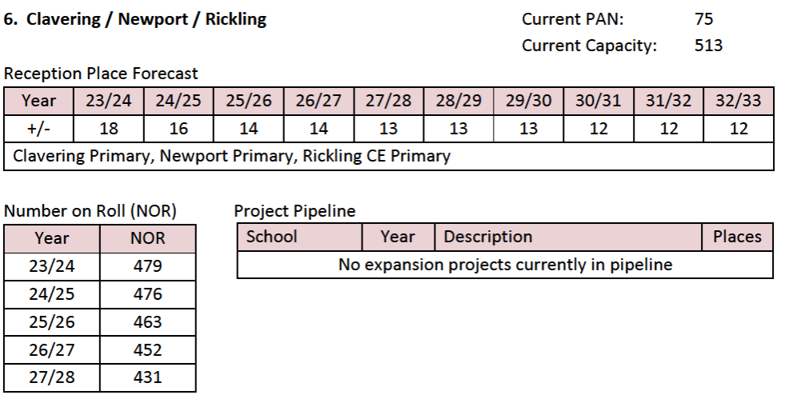

The falling roll and subsequent rising roll criteria were met in 2023/24 and the updated pupil forecast above shows the school expects pupils to increase annually from Year 3 (October 2024).

The only requirement for 2024/25 is the balance criteria. The school has a balance of £4,799, which is 0.61% of revenue funding.

The funding based on pupil forecasts is:

|  |  |  |
| --- | --- | --- |
| Year | Pupils | £ |
| 2024/25 | 32 | 113,683 |
| 2025/26 | 32 | 113,683 |
| 2026/27 | 32 | 113,683 |
| 2027/28 | 32 | 113,683 |
| 2028/29 | 32 | 113,683 |

The Finance Review Group (FRG) recommends Clavering Primary receives **£113,683** for 2024/25.

**Finchingfield St John the Baptist Primary School**



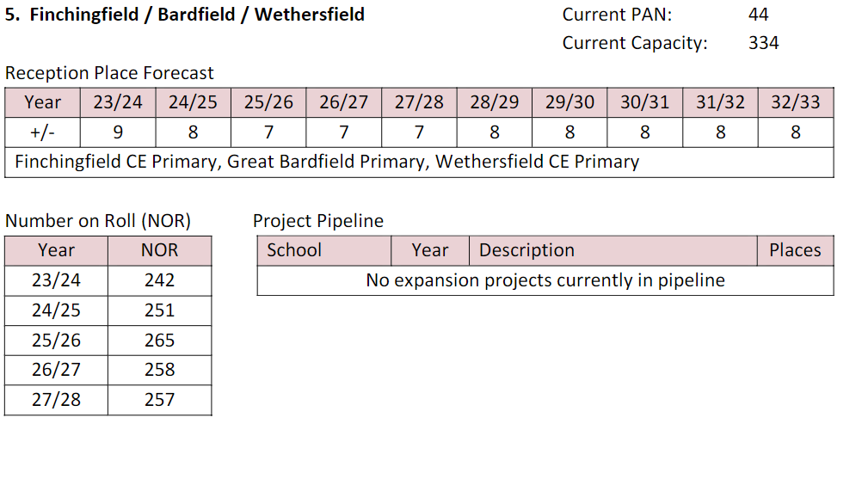

The falling roll and subsequent rising roll criteria were met in 2023/24 and the updated pupil forecast above shows the school expects pupils to increase annually from Year 3 (October 2024).

The only requirement for 2024/25 is the balance criteria. The school has a balance of £68,904, which is 17.5% of revenue funding. Although the balance is above 8% of revenue funding, the average balance has increased to £105,927 and therefore the school meets the balance criteria.

The funding based on pupil forecasts is:

|  |  |  |
| --- | --- | --- |
| Year | Pupils | £ |
| 2024/25 | 25 | 88,815 |
| 2025/26 | 25 | 88,815 |
| 2026/27 | 25 | 88,815 |
| 2027/28 | 25 | 88,815 |
| 2028/29 | 25 | 88,815 |

FRG recommends Finchingfield Primary receives **£88,815** for 2024/25.

**Holt Farm Infant**



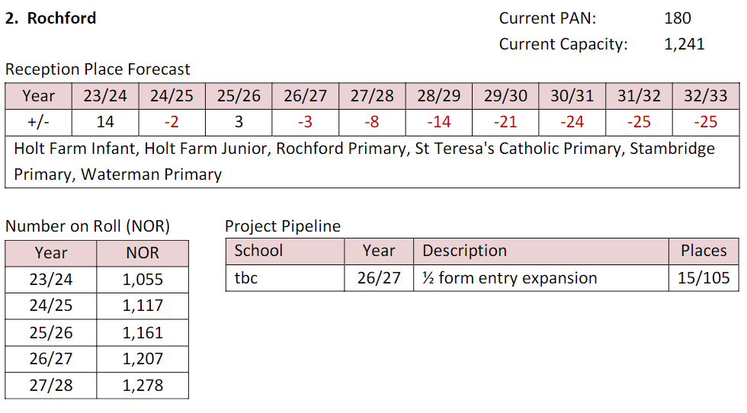

The falling roll and subsequent rising roll criteria were met in 2023/24 and the updated pupil forecast above shows the school expects pupils to increase annually from Year 3 (October 2024).

The only requirement for 2024/25 is the balance criteria. The school has a balance of £147,327, which is 16.07% of revenue funding. Although the average balance has increased to £105,927, the balance criteria is not met. The school receive an allocation of £179,432 in 2023/24 and the balance has increased by £141,991.

FRG recommends the school no longer receives falling rolls funding.

Should Schools Forum disagree with FRG’s view, the funding based on pupil forecasts is:

|  |  |  |
| --- | --- | --- |
| Year | Pupils | £ |
| 2024/25 | 75 | 266,444 |
| 2025/26 | 75 | 266,444 |

**Prettygate Infant School**



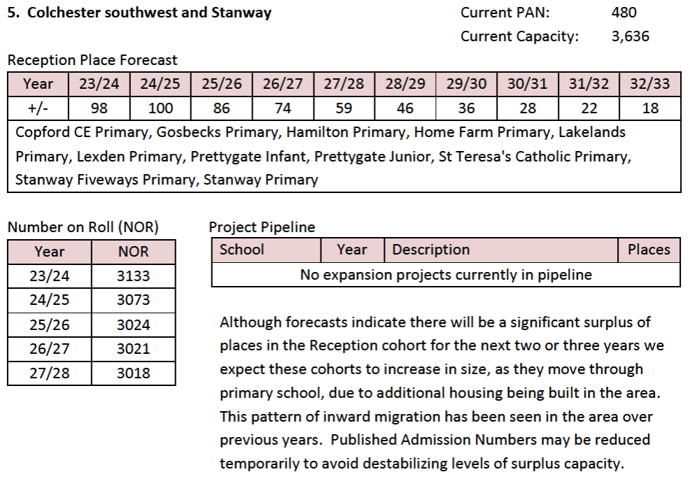

The falling roll and subsequent rising roll criteria were met in 2023/24 and the updated pupil forecast above shows the school expects pupils to increase annually from Year 3 (October 2024).

The only requirement for 2024/25 is the balance criteria. The school has a balance of £28,918, which is 3.95% of revenue funding.

The funding based on pupil forecasts is:

|  |  |  |
| --- | --- | --- |
| Year | Pupils | £ |
| 2024/25 | 41 | 145,656 |
| 2025/26 | 41 | 145,656 |

FRG recommends Prettygate Infant receives **£145,656** for 2024/25.

**St Mary’s Primary, Hatfield Broad Oak**



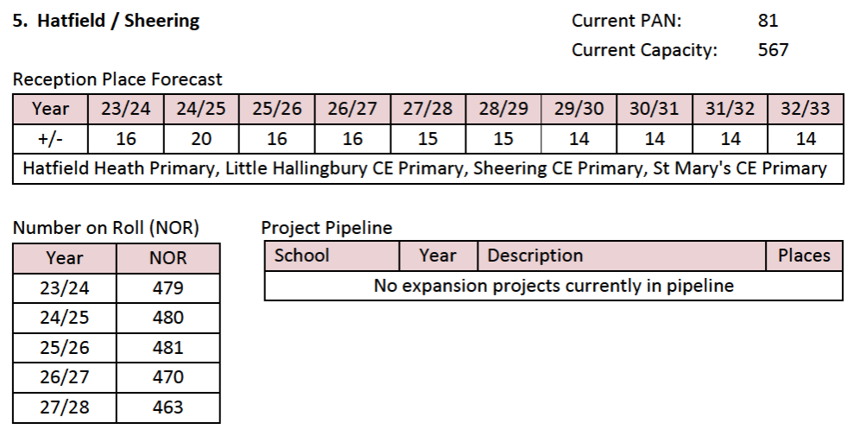

The falling roll and subsequent rising roll criteria were met in 2023/24 and the updated pupil forecast above shows the school expects pupils to increase annually from Year 3 (October 2024).

The only requirement for 2024/25 is the balance criteria. The school has a balance of £67,597, which is 16.75% of revenue funding. Although the balance is above 8% of revenue funding, the average balance has increased to £105,927 and therefore the school meets the balance criteria.

The funding based on pupil forecasts is:

|  |  |  |
| --- | --- | --- |
| Year | Pupils | £ |
| 2024/25 | 25 | 88,815 |
| 2025/26 | 25 | 88,815 |
| 2026/27 | 25 | 88,815 |
| 2027/28 | 25 | 88,815 |
| 2028/29 | 25 | 88,815 |

FRG recommends St Mary’s Primary Hatfield Broad Oak receives **£88,815** for 2024/25.

**The Alderton Junior**



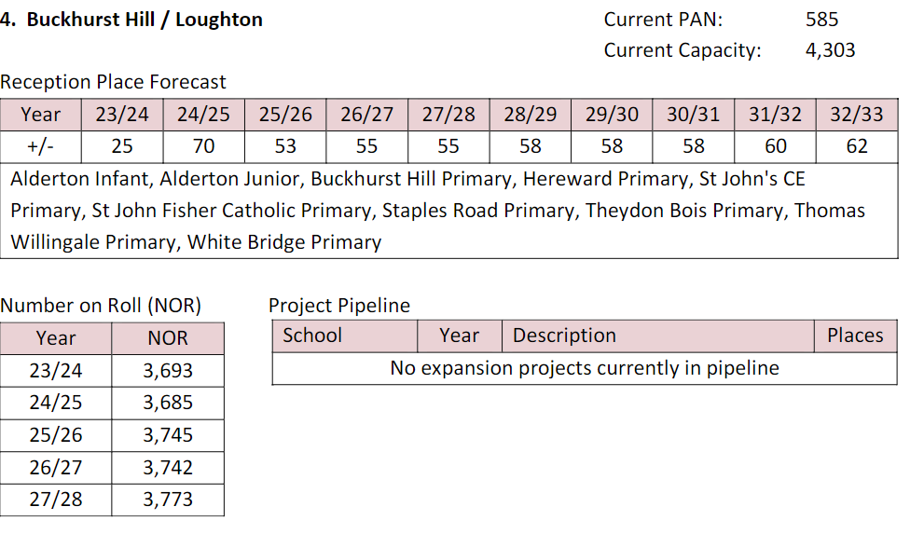

The falling roll and subsequent rising roll criteria were met in 2023/24 and the updated pupil forecast above shows the school expects pupils to increase annually from Year 3 (October 2024).

The only requirement for 2024/25 is the balance criteria. The school has a balance of £271,367, which is 24.4% of revenue funding. The school receive an allocation of £67,710 in 2023/24 and the balance has increased by £194,006.

The school has not returned the proforma it was sent to complete.

FRG recommends the school no longer receives falling rolls funding. However, as the school is an academy it should be allowed to resubmit its application should the balance at 31st August 2023 meet the balance criteria. Should Schools Forum disagree with the view of FRG the funding based on pupil forecasts is:

|  |  |  |
| --- | --- | --- |
| Year | Pupils | £ |
| 2024/25 | 30 | 106,578 |
| 2025/26 | 30 | 106,578 |
| 2026/27 | 30 | 106,578 |

**Wethersfield Primary**



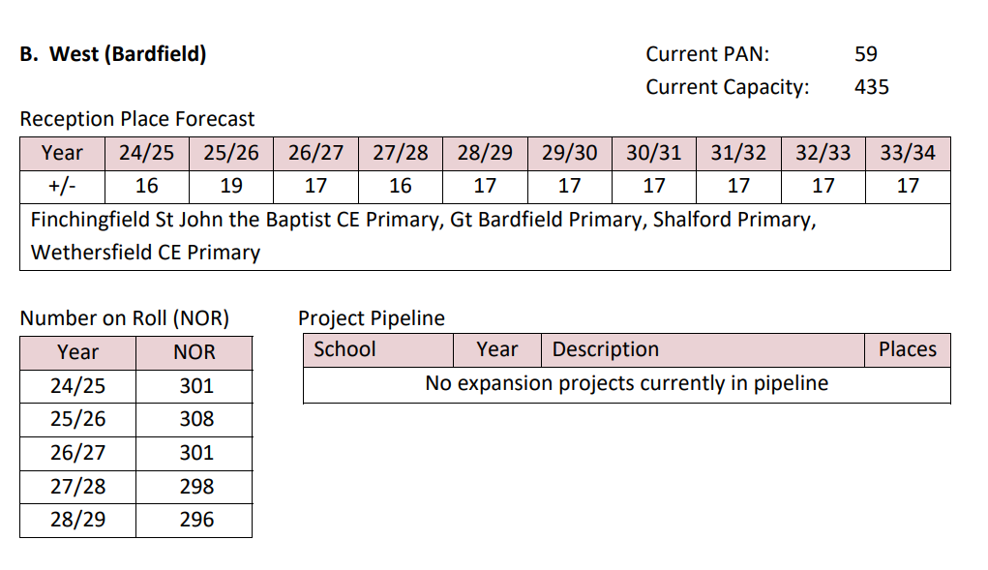

The falling roll and subsequent rising roll criteria were met in 2023/24 and the updated pupil forecast above shows the school expects pupils to increase annually from Year 3 (October 2024).

The only requirement for 2024/25 is the balance criteria. The school has a balance of £54,904, which is 13.40% of revenue funding. Although the balance is above 8% of revenue funding, the average balance has increased to £105,927 and therefore the school meets the balance criteria.

The funding based on pupil forecasts is:

|  |  |  |
| --- | --- | --- |
| Year | Pupils | £ |
| 2024/25 | 12 | 42,631 |
| 2025/26 | 12 | 42,631 |
| 2026/27 | 12 | 42,631 |
| 2027/28 | 12 | 42,631 |
| 2028/29 | 12 | 42,631 |

FRG recommends Wethersfield Primary receives **£42,631** for 2024/25.

**New Applications**

**Tollesbury Primary School**



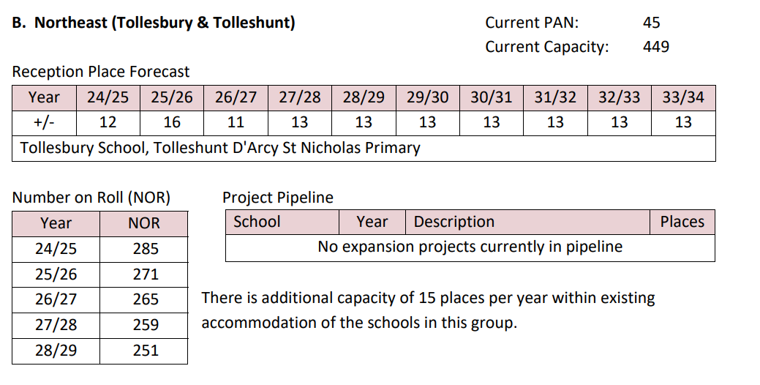

The school meets the consecutive two years of falling rolls of 4% or greater. The roll must increase by Year 3 (October 2025) and in subsequent years, which is demonstrated in the school’s pupil forecast above.

The school has a balance of £66,481, which is 7.52% of revenue funding and therefore meets the balance criteria.

The funding based on pupil forecasts is:

|  |  |  |
| --- | --- | --- |
| Year | Pupils | £ |
| 2024/25 | 8 | 28,421 |
| 2025/26 | 14 | 49,736 |
| 2026/27 | 14 | 49,736 |
| 2027/28 | 14 | 49,736 |
| 2028/29 | 14 | 49,736 |

FRG recommends Tollesbury Primary receives **£28,421** for 2024/25.

**St John the Baptist Primary, Pebmarsh**



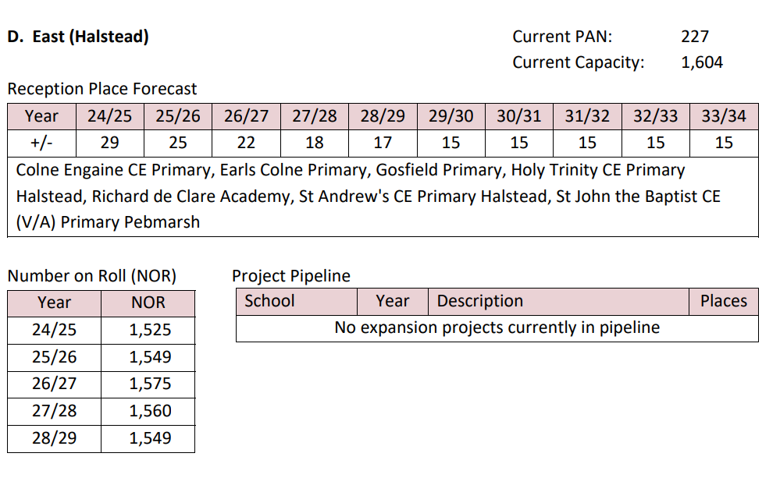

The school meets the consecutive two years of falling rolls of 4% or greater. The roll must increase by Year 3 (October 2025) and in subsequent years, which is demonstrated in the school’s pupil forecast above.

The school has a balance of £47,313, which is 9.83% of revenue funding. Although the balance is above 8% of revenue funding, the average balance has increased to £105,927 and therefore meets the balance criteria.

The funding based on pupil forecasts is:

|  |  |  |
| --- | --- | --- |
| Year | Pupils | £ |
| 2024/25 | 40 | 142,104 |
| 2025/26 | 55 | 195,392 |
| 2026/27 | 55 | 195,392 |
| 2027/28 | 55 | 195,392 |
| 2028/29 | 55 | 195,392 |

FRG recommends St John the Baptist Primary receives **£142,104** for 2024/25.

**St Mary’s Primary, Ardleigh**



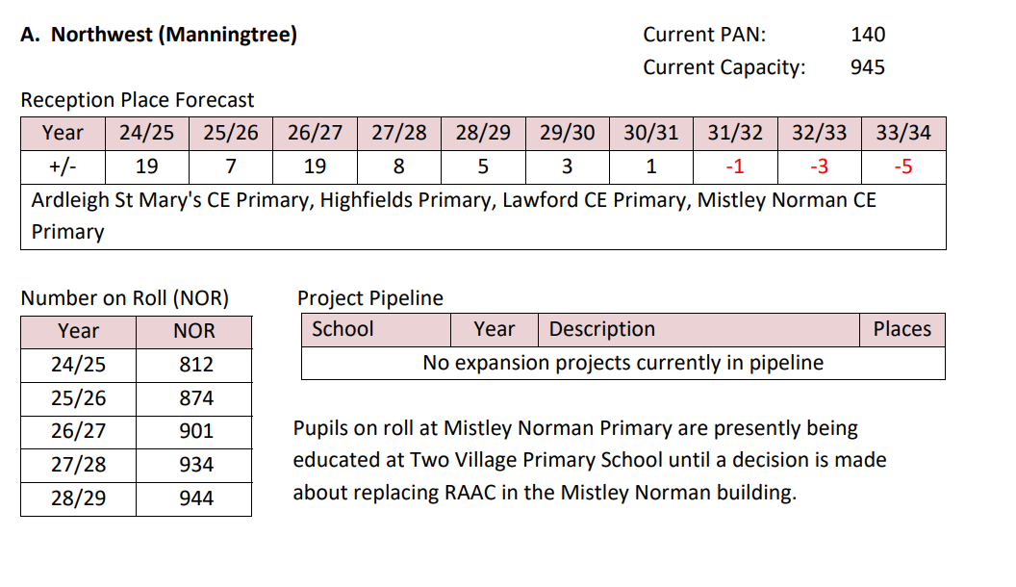

The school meets the consecutive two years of falling rolls of 4% or greater. The roll must increase by Year 3 (October 2025) and in subsequent years, which is demonstrated in the school’s pupil forecast above.

The school has a balance of £32,802, which is 5.38% of revenue funding and therefore meets the balance criteria.

The funding based on pupil forecasts is:

|  |  |  |
| --- | --- | --- |
| Year | Pupils | £ |
| 2024/25 | 8 | 28,421 |
| 2025/26 | 20 | 71,052 |
| 2026/27 | 20 | 71,052 |
| 2027/28 | 20 | 71,052 |
| 2028/29 | 20 | 71,052 |

FRG recommends that St Mary’s Primary, Ardleigh receives **£28,421** for 2024/25.

**Mistley Norman Primary**





The school meets the consecutive two years of falling rolls of 4% or greater. The roll must increase by Year 3 (October 2025) and in subsequent years, which is demonstrated in the school’s pupil forecast above.

The school has a balance of £119,728, which is 26.50% of revenue funding, which therefore does not meet the balance criteria. As we are closer to the end of the current academic year than the previous year, academies have been given an option to provide their forecast balance for 31st August 2024. The forecast balance for Mistley Norman is £27,633, which does meet the balance criteria.

The funding based on pupil forecasts is:

|  |  |  |
| --- | --- | --- |
| Year | Pupils | £ |
| 2024/25 | 16 | 56,841 |
| 2025/26 | 31 | 110,130 |
| 2026/27 | 31 | 110,130 |
| 2027/28 | 31 | 110,130 |
| 2028/29 | 31 | 110,130 |

FRG recommends that Mistley Norman Primary resubmits an application once the actual balance for 2023/24 is known.

**Chigwell Primary**



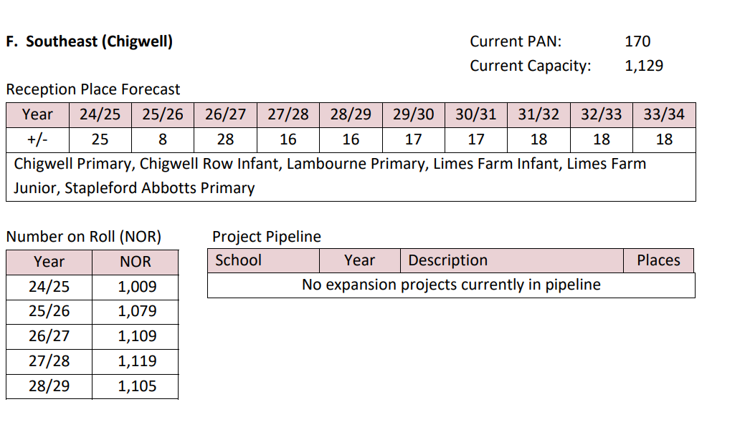

The school meets the consecutive two years of falling rolls of 4% or greater. The roll must increase by Year 3 (October 2025) and in subsequent years, which is demonstrated in the school’s pupil forecast above.

The school has a balance of £198,000, which is 19.25% of revenue funding, which therefore does not meet the balance criteria. As we are closer to the end of the current academic year than the previous year, academies have been given an option to provide their forecast balance for 31st August 2024. The forecast balance for Mistley Norman is a deficit balance of £156,620, which does meet the balance criteria.

The funding based on pupil forecasts is:

|  |  |  |
| --- | --- | --- |
| Year | Pupils | £ |
| 2024/25 | 40 | 142,104 |
| 2025/26 | 50 | 177,630 |
| 2026/27 | 50 | 177,630 |
| 2027/28 | 50 | 177,630 |
| 2028/29 | 50 | 177,630 |

FRG recommends that Chigwell Primary resubmits an application once the actual balance for 2023/24 is known.

**William Read Primary**



The school meets the consecutive two years of falling rolls of 4% or greater. The roll must increase by Year 3 (October 2025) and in subsequent years, which is not demonstrated in the school’s pupil forecast above, as the roll decreases at October 2025.

The school has a balance of £280,115, which is 19.95% of revenue funding. The school does not meet the balance criteria.

FRG recommends that William Read Primary receive no falling rolls funding as the rising roll and balance criteria are not met.

**Little Waltham Primary**



The school meets the consecutive two years of falling rolls of 4% or greater. The roll must increase by Year 3 (October 2025) and in subsequent years, which is demonstrated in the school’s pupil forecast above.

The school has a balance of £228,941, which is 23.71% of revenue funding. The school does not meet the balance criteria.

FRG recommends that Little Waltham Primary receive no falling rolls funding as the school does not meet the balance criteria.

**Highwood Primary**



The school meets the consecutive two years of falling rolls of 4% or greater. The roll must increase by Year 3 (October 2025) and in subsequent years, which is not demonstrated in the school’s pupil forecast above, as the roll decreases at October 2026 and 2027.

The school has a balance of £143,877, which is 31.68% of revenue funding. The school does not meet the balance criteria.

FRG recommends that Highwood Primary receive no falling rolls funding as the rising roll and balance criteria are not met.

**Wimbish Primary**



The school meets the consecutive two years of falling rolls of 4% or greater. The roll must increase by Year 3 (October 2025) and in subsequent years, which is not demonstrated in the school’s pupil forecast above, as the roll decreases at October 2025 and October 2027.

Wimbish Primary is part of Anglian Learning who pool their balances. A pro-rata share gives Wimbish a balance of £23,878, which is 4.85% of revenue funding. The school therefore meets the balance criteria.

FRG recommends that Wimbish Primary receive no falling rolls funding as the rising roll criteria is not met.

**Birch Primary**



The school meets the consecutive two years of falling rolls of 4% or greater. The roll must increase by Year 3 (October 2025) and in subsequent years, which is not demonstrated in the school’s pupil forecast above, as the roll decreases at October 2025 and October 2026.

The school has a balance of £100,953, which is 15.34% of revenue funding. Although the balance is above 8% of revenue funding, the average balance has increased to £105,927 and therefore meets the balance criteria.

FRG recommends that Birch Primary receive no falling rolls funding as the rising roll criteria is not met.

**Belchamp St Paul’s Primary**



The school meets the consecutive two years of falling rolls of 4% or greater. The roll must increase by Year 3 (October 2025) and in subsequent years, which is not demonstrated in the school’s pupil forecast above, as the roll decreases at October 2026.

The school has a balance of £213,756, which is 50.68% of revenue funding and therefore does not meet the balance criteria.

FRG recommends Belchamp St Paul’s Primary receive no falling rolls funding as the rising roll and balance criteria are not met.

|  |  |
| --- | --- |
| Schools Forum | **Agenda Item 4** |
| Date: 10 July 2024 |  |

**REPORT TITLE: Building Schools for the Future PFI Refinancing Gain**

Report by Yannick Stupples-Whyley

Contact details: Telephone (03330 138484); e-mail: yannick.stupples-whyley@essex.gov.uk

**1. Purpose of report**

1.1 To present to Schools Forum the recommendation of the Finance Review Group (FRG) for allocating the gain from refinancing the Building Schools for the Future (BSF) contract.

**2. Recommendations**

2.1 For secondary school members to approve the recommendation of FRG that the refinancing gain should be allocated to Castle View School and Cornelius Vermuyden School rather than distributed through the Essex Formula for Funding Schools.

2.2 For all members to approve the recommendation of FRG that the refinancing gain should be allocated to Columbus School rather than an additional allocation to the High Needs Block.

###### 3. Relevant Schools Forum Power and Responsibility

3.1 Table 1 is an extract from the Schools Forum Operational and Good Practice Guide (September 2018), which sets out the role of the Authority, Schools Forum and the Secretary of State for PFI.

|  |  |  |  |
| --- | --- | --- | --- |
| Function | Local Authority | Schools Forum | DfE |
| Contracts (where the LA is entering a contract to be funded from the schools budget). | Proposes | Gives a view. | None |

###### 4. Background

4.1 On 30 April 2010 the Authority entered into a Project Agreement with Essex Schools Limited under the Building Schools for the Future (BSF) programme for the refurbishment and/or construction and provision of facilities management services for Columbus School, Castle View and Cornelius Vermuyden. The PFI contract commenced in 2011/12.

4.2 Woodlands School was added in Wave 4 of the BSF Programme and the PFI commenced in 2013/14.

4.3 The proposals in this report exclude Woodlands School as they relate to the original project agreement.

4.4 It is typical for such agreements to allow the parties to refinance the debt once the projects are more mature and the risk profile has reduced. The relevant Project Agreement is now 14 years old, with 12 years left to run.

4.5 The Project Agreement sets out that ECC shall be entitled to receive a 50% share if the refinancing gain up to **£1m**, a 60% share if the refinancing gain is between **£1m and £3m**, or a 70% gain if over **£3m**.

4.6 As ECC does not financially contribute to the contract the gain will be made to the Schools Block, for Castle View and Cornelius Vermuyden schools and High Needs Block for Columbus School.

4.7 The indicative refinancing gain is **£2.37m** of which the Schools Budget and High Needs Block would indicatively receive **£1.42m**. The actual gain will not be known until the refinancing closes which is expected in the near future.

4.8 The split of the refinancing gain is **£1.26m** to the Schools Block and **£160,000** to the High Needs Block.

4.9 The Schools Block gain will reduce the affordability gap over the remaining 12 years of the contract at £104,962 per annum. On current secondary pupil numbers this equates to £1.15 per pupil, however once allocated through the formula depending on the impact on the minimum per pupil level and minimum funding guarantee it could be less.

4.10 The schools contribution to facilities managements costs increases annually by inflation (RPIx) and each school has to fund this from their annual budget which often increases less than inflation. In 2011/12 the total school contribution for the 3 schools was £636,000. This has increased to £2.4m in 2024/25. Whilst all schools have had increased costs, non PFI schools can choose to reduce facilities management costs where PFI schools have no choice.

4.11 FRG therefore proposes, as the costs for the 3 schools have significantly increased and that the gain for each secondary school will be minimal, that the refinancing gain is allocated to each of the 3 schools on a per pupil basis. The indicative allocations are:

* Castle View £707,000
* Cornelius Vermuyden £521,000
* Columbus School £192,000

4.12 The decision to proceed with the refinancing proposal was based on the affordability gap and High Needs Block seeing the gain, so this proposal needs the agreement of the Authority’s s151 Officer. The s151 Officer has been consulted and approves this proposal.

**5. Financial Implications**

5.1 The financial implications are embedded in the report.

**6. Other Resource Implications**

**7. Consultation with stakeholders**

**8. Background / Supporting papers.**

|  |  |
| --- | --- |
| Schools Forum | **Agenda Item 5** |
| Date: 10 July 2024 |  |

Any Other Business and Feedback from Associations and Other Forum Members

|  |  |
| --- | --- |
| Schools Forum | **Agenda Item 5a** |
| Date: 10 July 2024 |  |

Confidential Minutes – see confidential papers.

|  |  |
| --- | --- |
| Schools Forum | **Agenda Item 5b** |
| Date: 10 July 2024 |  |

**Finance Review Group Minutes of 17th June 2024**

**Microsoft Teams**

**14:30 – 16:04**

*(subject to approval)*

In Attendance

|  |  |  |
| --- | --- | --- |
| Jeff Fair (JF) – Chair | Ruth Bird (RB) | Rod Lane (RL) |
| John Hunter (JH) | Sue Bardetti (SB) | Nigel Hill (NH) |
| Sean Moriarty (SM) | Carole Herman (CH) | Jo Barak (JB) |
| **LA Officers** |  |  |
| Clare Kershaw (CK) | Yannick Stupples-Whyley (YSW) |  |

|  |  |
| --- | --- |
| **1** | **Apologies for Absence and substitute notices**  Jeff Fair welcomed everyone to the meeting.  Apologies have been received from Pam Langmead. |
| **2** | **Falling Rolls Fund (Yannick Stupples-Whyley)**  YSW introduced the report setting out the Authority’s recommendations which schools should receive falling rolls fund.  **Questions**  JF asked how long will Holt Farm Infant remain in the falling rolls fund? YSW responded 3 years.  JF put forward a proposal that both Holt Farm Junior and The Alderton Junior do not receive any funding in 2024/25 but remain in the falling rolls fund as they may meet the criteria next year.  NH stated funding is an emotive subject that could get very complicated and you could get 50% of schools putting forward a sob story. We have a criteria to apply and he preferred to be very prescriptive.  CK agreed with NH knowing what is happening in parts of the County where some schools have invoked their freedoms to introduce a bulge class which impacts on other local schools. Whilst this is rare it strengthens what NH has said about opening ourselves up to a precedent.  SM and JH agreed with what NH has said.  NH questioned the average balance increasing as he did not think it was part of the criteria. YSW responded that small schools could have a small balance that will be in excess of 8% of their funding. Therefore, we added a level of protection to allow them to have a balance up to the average balance for schools with 210 pupils or less.  SM questioned the opportunity for academies to give a forecast balance. YSW explained that as academies are close to their year-end whilst the balance at 31st August 2023 did not meet the balance criteria, the forecast balance could if balances were decreasing. The Authority was therefore putting forward Mistley Norman Primary and Chigwell Primary.  SM asked for the views of the group. NH stated he liked the sentiment but it could allow for academies to report a lower balance to qualify.  CK explained the situation at Mistley Norman that the school had suffered severely from RAAC and that the new housing in the village requires a school.  SM asked about Chigwell. CK explained the school has extenuating circumstances as the buildings are in a dire state. The school will be rebuilt in the School Rebuilding Programme.  JF asked was it possible for schools to apply at another time for falling rolls funding. YSW explained we try and bring everything in one go but schools can be allowed to apply at other times.  JF felt if we allowed the schools to apply once they know their actual balance at 31st August 2024 that this keeps us within the rules. CK, NH and SB supported this approach.  JF asked FRG subject to not recommending Mistley Norman or Chigwell Primary and allowing later applications are members happy to put forward the recommendations to Schools Forum.  The recommendations subject to the above changes were agreed. |
| **3.** | **Building Schools for the Future Refinancing Gain (Yannick Stupples-Whyley)**  YSW introduced the report setting out the BSF PFI scheme, the refinancing proposal and the Authority’s recommendation to share this between the 3 original schools in the BSF Wave.  **Questions and Comments**  CK outlined the financial positions of Castle View which is in deficit and Cornelius Vermuyden which has a significant in-year deficit.  JF summed up the paper as being do you want to focus this funding back to the schools that are paying significantly more for facilities management or back to the schools who have funded the affordability gap each year.  NH stated putting the money back to all secondary schools would make very little difference where it could make a significant difference if allocated to the 3 schools.  SM agreed the funding could make a significant impact in a smaller area than across all schools.  CH agreed with NH and SM and stated it would make a difference to these schools in areas of deprivation that struggle with their PFI costs.  JH asked could we seek from the schools what they would do with the funding. CK stated the schools were unaware as we still need s151 agreement to do this.  JF said that subject to s151 approval that FRG makes the recommendation to Schools Forum giving the local authority permission to allocate the funding to the 3 schools.  FRG approved the recommendation. |
| **4.** | **School and Academy Balances (Yannick Stupples-Whyley)**  YSW introduced the paper setting out School and Academy Balances.  **Questions and Comments**  JF commented it was surprising and concerning in some ways as we have sat in many meetings of Schools Forum that we are in financial difficulty.  SM asked for clarification of the Authority’s role over academies. YSW responded that we have no authority over academy balances. There are no proposals to clawback balances from maintained schools. The reasons we are seeking information from academies is to build an understanding of why high balances are being held so we can target lobbying for additional funding.  FRG noted the paper. |
| **5.** | **Schools Budget Draft Outturn 2023/24 (Yannick Stupples-Whyley)**  YSW introduced the paper stating the draft outturn position for 2023/24 and outlining the reasons causing the position.  **Questions and Comments**  JF asked about the removal of expenditure from DSG and the impact on the Council’s budget. YSW stated the 2023/24 budget had an underspend but going forward this will increase Council expenditure unless we are successful lobbying the DfE.  JF asked if this was the Education budget or wider Council budget. YSW responded it was mainly the Education budget.  JF stated that looking at things a £80k underspend on central services looks good but it is on staffing which impacts on the services schools receive. There are several things in here that says there is a problem here that is not shown by school balances. That is the fundamental issue.  FRG noted the report. |
| **6.** | **Any Other Business (Jeff Fair)**  None |
| **7.** | **Closing Comments (Jeff Fair)**  JF thanked members for their time and looked forward to seeing everyone at Schools Forum. |

|  |  |
| --- | --- |
| Schools Forum | **Agenda Item 6** |
| Date: 10 July 2024 |  |

**Schools Forum Meeting Minutes of 10th January 2024**

**held via Microsoft Teams**

**08.30 – 10.07**

*(subject to forum approval)*

In Attendance

|  |  |  |
| --- | --- | --- |
| Carole Herman (CH) | Charlotte Little (CL) | Claire Styles (CS) |
| Dan Leonard (DL) | Ferliene Willis (FW) | Harriet Phelps-Knights (HP-K) |
| James Saunders (JSau) | Jeff Fair (JF) | Jo Barak (JB) |
| Jo Santinelli (JSan) | Jody Gee (JGe) | John Hunter (JH) |
| Luke Bulpett (LB) | Lyn Wright (LW) | Marilyn Smith (MS) |
| Nigel Hill (NH) | Pam Langmead (PL) | Philomena Cozens (PC) |
| Robin Taverner (RT) | Rod Lane (RL) | Ruth Bird – Chair |
| Ruth Sturdy (RS) | Sean Moriarty (SM) | Simon Wall (SW) |
| Stuart Roberts (SR) | Sue Bardetti (SB) |  |
|  |  |  |
| **LA Officers** |  |  |
| Cllr Tony Ball (TB) | Andrew Page (AP) | Carolyn Terry (CT) |
| Val Cleare (VC) - Minutes | Yannick Stupples-Whyley (YSW) |  |
|  |  |  |
| **Observers** |  |  |
| Ashley Milum (AM) | Jennifer Grotier (JGr) | Maggie Loveday (ML) |
|  |  |  |

|  |  |
| --- | --- |
| **1** | **Apologies for Absence and substitute notices**  Apologies were received from Debs Watson, Emily Welton, S. Roberts, Clare Kershaw, Chanel Lassman, Jinnie Nichols, Scott Bowak.  RB welcomed Dan Leonard who joined Schools Forum for the first time today as Secondary Academy Headteacher.  Ferliene Willis substituted for Debs Watson and Pam Langmead substituted for Primary Headteacher vacancy. |
| **2** | **DSG Budget 2024/25** (Yannick Stupples-Whyley)  YSW informed Schools Forum on the updated School Funding Settlement for 2024/25 of the assumptions built into the budget and seeks agreement of the relevant elements of the Dedicated Schools Grant budget for 2024/25.  YSW referred to Section 3. We consulted with schools in October 2023, so that once this has been achieved movement of the up to 0.5 from the School's Block applicable any exclusions for the minimum funding. However, guarantee is not applicable in terms of delegation. These decisions were agreed in September 2023 for general duties and met for maintained schools also agreed.  In September 2023, Central Spend on pupil growth is in Section 5 and fully involved in Section 7 Central Spend on Early Years Block provision and is in section 11 spend on the High Needs Block is in section 12.  Section 4 showed the settlement itself as of 19th December. 2023. Overall, the national level is a **£3.4 billion** increase, which was **£917,000,000** went into Schools Block, **£440,000,000** into the High Needs Block and Early Years Block got **£2 billion**.  **Table 2** showed the settlement at the December stage, which is still provisional. Because the Early Years Block is not funded on the January 2024 and January 2025 Censuses and behind this we import/ export to an adjustment which is also funded on the January 2024 Census, though overall we've gone from one point of **£467 billion** if we base the 23/24 on the two additional grants that came in for mainstream schools and Early Years and then we have an overall settlement of **£1.563 billion** which is a **£95.9 million** increase or 6.5%.  If a School Block goes up to 31 point **£9,300,000**, Central School Services Block **£12.6 million** on behind these blocks and the biggest increase on the earliest block is **£51 million**. With regards to the Schools Block we have the primary and secondary unit of funding which gets multiplied by the October 23 Census. YSW explained we then add in premises funding, which is at the previous level, unless it is PFI which gives operated by the retail price index excluding mortgage interest. We then have funding for positive growth based on middle super output areas and we also have new 24/25 funding for falling both funds. That is the opposite to the Growth Fund, but any fall in funding has to be within a middle layer super output area (MSOA) which has to be a 10% reduction, so there will be a **£31.9 million** increase.  Figure 2 showed that has two elements of the ongoing responsibility than historic commitments and an ongoing responsibility. This is funded on a per pupil rate, and this includes the **£3.08 million** element of the former Education services grant, which is for the Central Services for all schools and that has increased by **£320,000** due to the increase in pupil numbers.  Then we have the historic commitment, which is the funding for PRU and Capital SEND project. For a number of years, the DfE have been trying to wind down historic commitments and they apply a 20% reduction each year. We have applied again for 24/25 and it has been agreed, but 24/25 is the last contribution to the PRU and Capital SEND project.  YSW indicated he needed to block that diagram slight changed from previous years. Where we have had the 5% cap applied, it is actually only on the second block of and its overly boxy factors, which is the historic spend factor, the population disability, bad health, key stage 2, low attainment, key stage 4, low attainment, free school meals. They are comparing it to the 23/24 baseline. If it is, the increase is less than 3%, then you get a different funding floor.  If the increase is 3 to 5%, it goes through with no change. If it is above 5%, it is then capped to 5% and we have been capped at 5%. But in terms of the **£12.6 million** increase, **£11.8 million** came from the **£440 million** natural increase. And then we have had an increase of 146 places in special schools, which increases funding by **£859,000**. Figure 4 showed how that block is calculated and we have new for 24/25 under 2 funding and also within two-year old funding everything new from April.  With regards to the two-year old funding for working families, Table 3 showed the funding rates that come into Essex and we had the supplementary grant for 23/24.  The provisional increase is **£51.0 million** due to:  The increase in the hourly rate for 3 and 4 year olds, **£8.9m**  The increase in the hourly rate for disadvantaged 2 year olds, **£11.6m**  New funding for the 2 year old offer to working parents, **£12.3m**  New funding for the under 2s offer to working parent, **£17.2m**  The extension of the early years pupil premium, **£556,000**; and  The extension of the disability access fund, **£441,000**.  **Question**  PC asked to confirm that the extra places with schools are with ECC and  not out of Borough places, the 146 in the special needs are something like  859, whatever it was that is funding for children within Essex schools, not  extra places for children going out of Essex?  YSW confirmed the extra places with schools are with ECC.  YSW explained the ever-changing Early Years funding is the central  retention. Up to and including the current financial year, we are allowed to  retain up to 5% to 3 and 4 year old funding. From 24/25 it would be 5% to 2  year olds working parents, 2 year olds, disadvantaged families and 3 – 4 year olds. Families SEN, at a date not mentioned, it will reduce to 3% retention.  With regards to benchmarking and how we compare to other Local Authorities, which we are ranked as 127 out of 151 Authorities, which is in the bottom quartile in the Central School Services Block, we received **£50** per pupil and that is ranked 42 out of 151 authorities. That puts it in the second quartile of the High Needs Block.  YSW mentioned with the exception of the Central Services Block, we are a  lower funded authority, and we will be doing some more detailed benchmarking which we will bring to a future meeting.  RT wondered on the benchmarking for clarity purposes, how we are ranked,  is this due to decisions made by ECC including the Schools Forum? Or, are  we ranked low because there is nothing that we can do about it.  YSW responded this is how the funding is allocated to us. As we  go through the detailed benchmarking, one thing we are going to be looking at is where we were before the national funding came in, and what has been the impact of the DfE's decision to put more funding through the deprivation factors. There is nothing we can do other than lobbying.  **Growth Fund**  The Authority has a statutory duty to provide sufficient school places.  The Growth Fund is known as explicit growth and provides funding for basic need growth where schools are expanding. It also provides funding for  bulge classes where temporary growth is required, for furniture and  equipment for new and expanding schools, for the infant class size contingency and funding for schools where growth is required due to Afghan or asylum seeking children.  The funding rates for 2024/25 have increased with primary growth being funded **£1,550** per pupil, an increase of **£30** per pupil and secondary growth is funded at **£2,320** per pupil, an increase of **£45** per pupil. For any new  schools that appear for the first time on the October 2023 census, Local  Authorities receive an allocation of **£76,195**, an increase of **£1,495** per new school. An area cost adjustment is applied.  For each local authority, schools are allocated into middle super output areas (MSOAs). For each school, the October 2022 census is deducted from the October 2023 census. A total is calculated for each MSOA for primary and secondary and where the total is positive growth funding is allocated.  **Table 5** showed an example of how this works at MSOA level.  Basildon has negative growth minus 3.  The MSOA Basildon 1 would generate no funding as there is no growth.  Basildon 13 would generate **£40,000** for primary growth for the net growth of  26 pupils and **£132,000** for secondary growth for the net growth of 57 pupils.  The allocation for Essex for 2024/25 is **£7 million**, which is a decrease of  **£300,000** from 2023/24.  **Table 6** shows the growth fund requirement for 2024/25. The growth fund request for 2024/25 is **£7.2 million**, which is **£224,000** higher than the **£7.0** **million** allocation. Agenda Item 7 shows there is a **£800,000** contingency for the Growth Fund so it is proposed to take the shortfall from the contingency.  **Questions**  SM wanted clarification on the example of the MSOA looking at the example for Basildon 1 and you have a reduction of minus 3.  If, say, for example Mayflower High showed a significant increase in numbers, but that increase was matched by Buttsbury junior reduction so that overall figure was still minus 3, would that mean under this formula that Mayflower High would not be eligible to receive any growth funding under the formula and therefore Mayflower High would not get any?  YSW explained it is done separately for primary and secondary schools. If Mayflower High did have a positive growth, it would be the primary school that would not get any growth due to the minus 3.  **Varying Pupil Numbers**  This is known as implicit growth and is an alternative method of funding a significant change in pupil numbers. **Table 7** showed the number of growth places funded by varying pupil numbers. In 2023/24 we had 1390 additional places. If no schools were funded on estimated numbers the primary basic entitlement would be **£17.96** per pupil higher and the KS3 basic entitlement would be **£13.25** per pupil higher. However, the Authority would need to seek an additional **£3.3 million** for the Growth Fund.  **Falling Rolls Fund**  The only change to the criteria is that the DfE has removed the requirement for schools to be judged as Good or Outstanding by Ofsted from 1st April 2024. The falling rolls allocation for 2024/25 is **£427,000**. There are currently 7 primary schools within the Falling Rolls Fund. Table 8 showed the budget requirement for 2024/25.  **PFI Affordability Gap**  **Table 9** showed the schools contributions for facility management, cost reasons, costs increase from one year to the next will be based on inflation, so RPI and also if schools have variations in years add cost that will then get added on to the next year.  **Questions**  RL asked how many more years has the PFI scheme got to run?  YSW responded:  Debden will be ceasing in 2026/27  Clacton runs out in 2032/33  BSF runs out in 2035/36.  **Action**: YSW to confirm these dates.  **Delegated Budgets**  **Schools Block**  YSW stated we have to submit how we are funding schools for 2024/25 by  22nd January 2024. There is a small risk that figures in **Table 13** that will  follow could change but overall delegation will remain the same.  **Early Years Block**  **Table 12** showed the proposed hourly rates that will be funded in 2024/25.  In consultation with the Early Years Sub Group, it was agreed there should a  higher rate paid for disadvantaged 2 year olds than 2 year olds from working families.  In line with the new retention of funding arrangements as set out in 4.20 the  Authority has split the retained costs (**£3.7 million**) proportionately across  each funding block. The Authority is provisionally passporting a minimum  97% of each funding block.  The Early Years Block provisional allocation is based on the January 2023  census. Actual funding for 3&4 year olds and 2 year olds from deprived  backgrounds will be calculated on the January 2024 census (5/12ths) and  January 2025 census (7/12ths). It may be necessary to adjust the rates in  **Table 13** once the January 2024 census is published in July.  Funding for 2 year olds from working families and under 2s will be based on  termly census returns as there will be no data for these children on the  January 2024 Census.  **Essex Formula for Funding Schools**  **Table 13** showed the breakdown of the formula how it comes across each of the formula factors.  **Table 14** showed now the Essex Formula has transitioned to NFF the  largest funding increase is within the basic entitlement.  **Table 15** showed the increase schools will receive per pupil in 2024/25.  **Minimum Per Pupil Level**  The minimum per pupil levels (MPPL) of **£4,610** for primary and **£5,995** for  secondary have been fully implemented.  **Table 16** showed the number of schools in 2024/25 that require additional funding through the minimum per pupil level.  **High Needs Block**  **Table 18** showed:  The proposed allocation of the High Needs Block (HNB)  for 2024/25.  Total forecast expenditure against the HNB in 2023/24 is **£227.9 million**  leaving an in-year deficit of **£1.2 million**.  Significant variations between 2023/24 and 2024/25, above **£500,000**, are explained below.  Place funding increases **£591,000** due to an additional 59 special school  places.  The growth in Education, Health & Care Plans (EHCPs) has increased over the last 2 years by 14% and 5.8% of total pupils have EHCPs. Top-up  funding increases **£18.9 million** due to:  The application of a 3.4% in funding to Special Schools and PRUs funded from the contingent budget in 2023/24.  £500,000 Outreach Provision to be provided by the PRUs in 2024/25. This is one-off funding in 2024/25 pending evaluation and future funding settlements.  Increased demand for Post 16 FE places  There is a forecast increase of an additional 139 (35%) independent school places from April 2024.  The number of pupils in other local authority schools is forecast to increase by 7.5% in 2024/25  All costs listed above are forecast to be ongoing cost burdens to the High Needs Block unless stated.  **Questions**  RL asked regarding the top up for independent schools, is that increase in pupil numbers? Is it an increase in their charges?  YSW responded built into the **£4.7million** overspend for the coming year, we built the increase of 139 places which was built around bullet point 12.5 and there will be some increase based on inflation for prices increases.  RL asked how do costs of special schools per pupil compare with independent schools costs per pupil?  YSW offered to check this and report back.  RL felt that comparing any amount of huge increase in costs, we as a Forum need to have some oversight.  YSW stated a Sub Group has been set up to look at independent schools. We have had one meeting so far. There will be a report coming to Forum about that.  HPK enquired about **Table 18** on page 21 – what is the support for inclusion?  YSW replied **£1.2 million** increase, but potentially the **£1 million** of that is what we brought to two Schools Forums in September and November. The £1 million increase will be inclusion framework.  HPK asked, what is the rest of it?  Just because, as Rod said, we need to know what is in all of these sections because it seems an awful lot of money when further on your then talking about a transfer potentially.  I know that's not on the cards at the moment, but it's a lot of money that I think we need to know exactly what is being spent for what, and actually is it necessary that all of that is being spent, which I'm talking as chair of IIFA, but we would not support another transfer from the Schools Block to the High Needs Block this time. And we have said that all the way along.  So, we need to look at all of those bits that you have got on there and why is PFI shown in this High Needs Block table when you have got that in the other section as well?  YSW stated it is because one of the PFI schools is a special school. For mainstream schools we have to de-delegate the affordability gap and invoice schools to return the funding. The regulations for special schools are different and the affordability gap is charged to the High Needs Block  HPK replied with hindsight, I know that is a wonderful thing. Would Schools Forum have agreed the inclusion framework money if we had known this was the situation? Because we are paying it out to now be saying, well, actually, we are going to need some money.  Hindsight is a wonderful thing, but that is something we need to consider. Do we need to be looking longer term when we are making these decisions, so we are not in this position?  YSW replied, the inclusion framework is one of early interventions initiatives implemented by the Authority. A paper on the effectiveness of the inclusion framework will be brought to a future Schools Forum meeting.  HPK asked are there any solutions? I know we have talked about this and independent schools and trying to mitigate that and everything else, but what are the other solutions to avoid the High Needs Block not being overspent to this extent?  YSW said we have set up the Independent Schools Working Group and it has only had one meeting and various proposals have been put forward from different people in that group. YSW stated that group is going to be meeting regularly on a monthly basis and we will be bringing reports to you on that.  HPK said finally, if there was to be a transfer from the Schools Block, that would mean a lot of vulnerable schools going into deficit and therefore needing a loan. So where would that loan money come from?  YSW stated if there is no surplus balance then we would need to be talking to the Local Authority how we could offer loans.  JB said it mentions the **£500,000** for outreach for 2024/25. JB informed we have yet to receive the **£250,000** out for outreach for 2023/24. Could JB be assured that has not disappeared somewhere and when would we be likely to get that when we were already moving into the next financial year?  JF believed we needed to remind ourselves that we are aware of the difficulties, the High Needs Block has been in for some time. It was raised at the last Forum meeting by Claire to identify that there was an issue in terms of which is why some of the proposals were already reduced at the last meeting of the Schools Forum to actually reduce the commitment.  JF spoke about funding budgets in that he has not had a year in all the years that he has been involved with the Schools Forum and before Schools Forum where we have not had an issue with High Needs funding because it has always exceeded the amount of money apart from the unusual event for the last two or three years where the Government seemed to do a catch up and because we had put in place strategies to minimize our costs as far as possible, we put pressure on mainstream schools  JF felt we need to be thinking ahead, which is what part of the Independence Working Group is saying what capital works do we need to do to expand our own provision.  The one thing JF could say to RL to answer his question about the funny difference there is a huge difference amount of funding that special schools get per pupil compared with independent schools, which is why the independent sector is always so much more expensive and the difficulty is when you read the papers and you look at the inclusion framework that has been published, it is also to do with trying to manage parental expectations.  JF went on to say we are trying to ensure that we have our own in-house provision. Within, however, we tend to do it and that it is part of the reason we can be looking for the support for inclusion in the early intervention. It is to try and manage the system as well as it can be managed and in a structure which has been decimated over many years because of austerity and funding cuts that have gone through in terms of the Local Authority.  JF also remembered when we had a lot more people who were working to provide services to mitigate these events that we have currently within Essex simply because there is not the funding anymore.  JF stated he would not want to be transferring money from the Schools Block to High Needs Block any more than you would, but the difficulty actually is that is the DfE approach that if there is a difficulty in the High Needs Block that is their go to solution and that is what they implement and if it has not necessarily been in the Schools Forum in those Local Authorities that are in difficulty with their High Needs Blocks.  JF said it is an instruction from on high that is going to be transferred and what Yannick identified, the half percent there, the minimum that the DfE is transferring is 1% and have felt it when we were looking at these papers, it felt important that we actually knew the difficulty of what is and what as a whole forum and all our schools in Essex need to be doing to work together to try and minimise that risk and that impact.  AP was picking up on HPK’s point and just reinforcing what JF had said. AP had previously made people aware of his nervousness around the risk and the volatility of this block. It is such a real concern for us and that is why we wanted to increase the reporting on this and, we will increase the reporting, how it will bring back that analysis and continue that all through the Schools Forum.  But it is really important that we must try the early intervention. If we do not impact through early intervention, then the cost base will continue to grow and it just gets bigger and bigger and we have not got the funding that will keep pace with the spending that we have got at the moment.  AP felt it was just to make everyone aware of a conversation with a number of other Authorities yesterday and, for example, Norfolk is forecasting an in-year deficit of **£25 million**, we have a forecast deficit of **£1.2 million**.  We have surplus funds to cover that and in the immediate future, but it is just raising that at some point or other sooner, rather than later, we will be falling into deficit and so we need to look at the early intervention and also more importantly, we have the Independent Schools Group that has been set up.  AP explained that independent schools account for about 3% of our schools population, but they take about 20% at the High Needs Block funding. We need to look at that ratio and change that.  Cllr Ball responded to the difference between independent provision and free school provision for SEND. It is **£65,000** for independent provision for a 38-week placement on average compared to **£37,000** for a free school 38-week placement. Cllr Ball was aware that JF said we did discuss this and AP had mentioned the early intervention, but also when it comes to increasing the free school provision, we are very much on that as well. It is just that what is going to be paid to the independent sector is not sustainable.  YSW reminded we have the Outreach in here **£2,000,000** plus the **£500,000** training, a slight increase in therapies and overall, a **£12.7 million** increase, which is a 5.6% increase.  **Table 19** showed the three-year MTR position so we can see each of the years and they were in year deficits at the moment before cost is to go into deficit in 2026/27. However, should anything significantly change before then, it could come at an earlier date.  **Teachers Pay and Pensions**  YSW stated in July 23 the DfE announced £900 million for 2024/25 in relation to the September 23 Teachers Pay award.  What they have done is to erase that they are paid in 2023/24 and it will just be uplifted by 12 ICE though it was the main income for 2023.  4th full year Gram for 2024/25, though based on applying multiplying everything by 1218.  Looks like visually it will be a £62 per pupil, **£86 pound** KS3, £98 KS4. A lump sum of **£2305** and then eligible free school meals.  Of the six people will get **£53** in primary, **£77** in secondary and then special and alternative provision.  Schools will get **£445** per place.  Funding will continue to be paid as a letter grant, and in the December announcement they have announced further funding will be coming to the pool.  They are increasing the employer contribution rates to the Teachers’ Pension Scheme from April, but further details will be announced in due course.  In terms of risk then opportunities, it is built on known assumptions and pressures identified to date. There is from the continued effective COVID which is still being impacted on peoples’ complexities or volatility and, energy costs and all quantified pressures which will be monitored throughout the year and reported back in the usual monitoring reports. On the notification of budget shares, we have to notify primary schools of their Schools Block allocation in February.  Funding must be notified by the 31st March and the ESFA will inform academies of their GAG allocations by 31st March.  **Recommendations:**  The Forum noted the School Funding Settlement for 2024/25, including the allocation for each DSG Block at 4.4;  The Forum noted the funding for the PFI Affordability Gap at 8.2;  The Forum noted the total delegation for primary and secondary schools at 9.3;  The Forum noted the proposed allocation of the High Needs Block at 12.1;  The Forum noted the risks and opportunities at 14.1;  The Forum agreed the funding for the Growth Fund at 5.10;  The Forum agreed the funding for the Falling Rolls Fund at 7.4;  The Forum agreed the funding rates for early years providers at 9.6; and  The Forum agreed the central expenditure for the Central School Services Block and Early Years Block at 11.1. |
| **3.** | **Any other business, feedback from schools through Associations and from Schools Forum representatives on other Bodies.**  **ASHE**  CH reported, from the secondary school perspective, the focus is on attendance, behaviour, alternative provision and changing that balance offsite direction and managed moves and T levels, all of which were reported previously. Otherwise concerns remain the same.  **EPHA**  PHK informed funding pressures continue for primary schools due to Unfunded Pay Awards and special educational needs putting huge pressures on budgets. Several schools are having to restructure and make redundancies and putting more pressure on remaining staff. When we last spoke about the School Meals Advisory Service, PL has had feedback from some headteachers concerning that rising cost, and that they accept a similar service would cost much the same.  **ESSET**  SW reported it is numbers and demand is through the roof. We have got nowhere to put the children and tribunals continue.  **PRU’s**  JB confirmed we are working through the demand of permanent exclusions.  JB commented about the funding to be released so that we can get the early intervention and outreach support. Our hands are tied because we have not received the funding. PC agreed with these comments.  **Early Years** – nothing to add.  **ESGA**  RB reported ESGA only met on Monday, and it was agreed like others it had only been about two weeks since last reported, so this would be carried over to the next meeting.  **Unions**  JF had concern looking at Heads for the future. The pay review was not good for retention of staff with a fairly small pay increase because it has to be within the budget already got to maintain things. It is not good in terms of funding overall. Unions are already looking at the fact that the battle will be about funding at the next general election, and that schools actually do not have enough money despite the fact there are large balances sitting in some schools.  MS is looking forward to what is happening in the next budget year. It is not certain if we will be going into support staff through restructuring again.  **Church Reps**  CL echoed attendance concerns relating to anxiety and SEMH needs have increased massively. Also reduced timetables across the trust and the funding pressures everybody has already mentioned, along with the potential for restructuring and redundancies.  JS commented there was nothing different from what colleagues have already said, and nothing specific relating to the Catholic sector to report.  **High Needs Review Group** – Have not met since November Forum  **Finance Review Group** – Have not met since November Forum  **Early Years Sub-Group** – Met in December but minutes are not available.  RL had noted the Early Years Sub-Group have not met. We have now entered a phase where the minimum wage has gone up and are still in a situation where many settings cannot afford to pay minimum wage, and I know the real rate is going up for settings, but we are in a situation where staff are leaving nurseries and going to supermarkets where they can earn more money on the checkout, and not only that they get the discount for their food and stuff. We are going to have a situation in Early Years of the Government pulling with one arm and saying we are going to increase facilities for young people, and on the other hand insufficient supply. We are going to be stuck in the middle of a great problem.  **Any Other Business** – none. |
| **4.** | **Minutes of 29th November 2023**  There was one amendment to be made. CH had noted NEAT should be changed to NEET (Not in Education, Employment or Training).  **Action**: YSW.  The minutes were a true record of the meeting held. |
| **5.** | **Minutes Action Log**  Two items around Early Years underspend.  YSW reported we are still reviewing these proposals for the final adjustment for 2022/23 and will bring to the next meeting in May and then based on that will be able to look at further proposals. We still need to do the cost benefit analysis but that is in progress. |
| **6.** | **Confidential Forum Minutes – 29th November 2023**  **Matters Arising.**  PL asked are we having further discussion about the School Meals Advisory Service at this meeting and whether any feedback around the letter to schools and take-up?  PL reminded everyone that we discussed at the last meeting if 10 schools indicate that they are coming out of the service, and we do not get any additional schools coming in, then the advisory service is not viable. PL was hoping for some sort of update on this matter, because headteachers are asking whether that service is able to continue.  YSW answered we are still in the period where schools can notify whether they want to continue or not. It closes about 21/1/24 and then we will know.  PL asked will it be possible to have some message to Schools Forum members before the next meeting?  YSW will talk to the team and ask to put out a communication.  PL asked, can we have an update from Anita Kemp and Gareth Honeyford about numbers and if any progress on the idea of having an alternative offer around basic compliance?  **Action**: YSW will talk to Gareth Honeyford.  Cllr. Ball stated as soon as he has the response, he will take a view as soon as possible with this information and where our thinking may be going. Let us see what the results are. |
| **7.** | **Schools Budget & Education Functions Forecast Outturn Report**  **Q3 Budget Update 2023/24 (Yannick Stupples-Whyley)**  YSW updated Schools Forum on the forecast outturn position for the year ended 31st March 2024 for both the Schools Budget and Education Functions.  YSW referred to 4.2 and reported the total Dedicated Schools Grant expected to be received for 23/24 is only **£599.3 million**. We have a few schools which could still convert before the end of the financial year so that amount could go down to **£3.6 million**, which is an adverse amount of **£6.9 million**.  YSW explained with the **£3.6 million** and **£27.9 million** underspend on Schools Block, there may be movement from the quarter still showing the £1.2 million and spend that is the **£800,000** held for contingency of the Growth Fund and then **£329,000** if you increase funding from the day fee for summer term payments for academies, and also forecast and cost of furniture and equipment for new and expanding schools **£23,000**.  The uses of the funding **£224,000** will come out of the **£800,000** the Growth Fund and that will leave a contingency at **£576,000** and then the **£433,000** will come out of the **£1.4 million** separate bonus paid forward.  **Questions/Comments**  SM commented potentially there is a further **£800,000** hit because of the schools that have been identified as potentially benefitting from the Falling Rolls Fund in the next year.  YSW responded, yes that would also come out as that balance. The Central School Services Block **£178,000** overspend which is an adverse movement of **£42,000**. As agreed before the team did support **£192,000** and that has been offset by some vacant posts.  YSW referred to Quarter 2 where we were forecasting **£656,000**.  Sorry underspend on vacant posts so some posts have now been recruited to in terms of the Schools Block for **£1.2 million** overspend adverse movement of **£6.9 million** for quarter to so Topper funded for maintained schools both schools and free schools is forecasting a **£3.7 million** overspend due to an increase in volume of people being more education, health and care plan than that and that may have adverse movement **£3.6 million** independent special schools forecasting **£4.9 million** lives spend due to an increase in volume and because the placements and that's an adverse movement of 176,000 essence services forecasting **£10.2 million** underspend main causes the high needs block contingency of **£9.4 million** which is written due to funding increasing faster than expected demand it's our team decided not to contribute to the pension deficit in 2324 which built in a **£753,100** bend and remaining £366,000 undefended due to a compose this is an advertisement **£2,000,000** since quarter two which is due to additional place and top of funding for schools as perfect as presented from in 29th of November 2023 being paid other alternative provision services or cut in **£2 million** overspend due to an increase in pupils being placed through the IPES contract.  This is an adverse movement of **£55,000** support for inclusion forecasting **£343** overspend due to increased expenditure through being inclusion framework of **£857,000** which is offset by underspend in the quadrant SEND teams £**514,000** due to vacancies where new posts have yet to be recruited to and this is an adverse movement of **£1.1 million**.  PC commented on the amount of money that was being spent on inclusion, but yet we are to see the impact in terms of expenditure on other alternative provisions, which is quite an extensive overspend. Have we accessed whether it is making any difference to be spending this amount of money in this way on inclusion?  YSW said the inclusion framework has had some analysis undertaken. This will be brought to a future meeting.  PC felt it needs to be looked at closely and maybe come to the High Needs Block. That is a significant amount of money, but it is not being balanced by a reduction in spending, nor it is being balanced by a reduction in permanent exclusion.  YSW reported about other health related services are forecasting **£426,000** overspend due to the increased use of independent therapists. We are undertaking a review and an update will be provided in a report and brought to the next meeting.  **Recommendation:**  The Forum noted the forecast outturn position for the year ending 31st March 2024. |
| **8.** | **Forward Plan**  YSW read this out and confirmed the dates of future meetings.  It was noted we will be seeking an Extraordinary meeting in March 2024 – date to be confirmed.  PL asked, can we add School Meals Advisory Service to the agenda for the Extraordinary meeting?  RL reminded the Chair that today’s meeting should have had, Election of Chair and Vice Chair on the agenda. This will be added to the agenda for the May Schools Forum meeting.  Also, there was a request to add Election of Chair and Vice Chair to the agenda for the January 2025 meeting.  **Recommendation**  The Forum noted the dates of future meetings and that additional items as proposed by Schools Forum are included in the Forward Plan. |
| **9.** | **Any Other Business** – none. |
| **10.** | **Chair’s Closing Comments (Ruth Bird)**  RB thanked everyone for attending. |
|  | **Extraordinary Schools Forum meeting**   * **Remote, via Microsoft Teams.** * **DATE TO BE CONFIRMED** |
|  | **Meeting – IN PERSON**  **Wednesday, 22nd May 2023 at 8.30 a.m.**  **at Hamptons Sports & Leisure, Tydemans,**  **Chelmsford, Essex CM2 9FH** |

|  |  |
| --- | --- |
| Schools Forum | **Agenda Item 7** |
| Date: 10 July 2024 |  |

**Schools Forum Meeting Minutes of 5th March 2024**

**held via Microsoft Teams**

**08.30 – 09:09**

*(subject to forum approval)*

In Attendance

|  |  |  |
| --- | --- | --- |
| Carole Herman (CH) | Charlotte Little (CL) | Claire Styles (CS) |
| Debs Watson (DW) | Emily Welton (EW) | Harriet Phelps-Knights (HPK) |
| Jeff Fair (JF) | John Hunter (JH) | Jody Gee (JG) |
| Luke Bulpett (LB) | Lyn Wright (LW) | Marilyn Smith (MS) |
| Nigel Hill (NH) | Pam Langmead (PL) | Philomena Cozens (PC) |
| Robin Taverner (RT) | Rod Lane (RL) | Ruth Bird – Chair |
| Stuart Roberts (SR) | Sue Bardetti (SB) |  |
| Maggie Loveday - observing |  |  |
| **LA Officers** |  |  |
| Cllr Tony Ball (TB) | Andrew Page (AP) | Gareth Rott (GR) |
| Ralph Holloway (RH) | Val Cleare (VC) - Minutes | Yannick Stupples-Whyley (YSW) |
|  |  |  |

|  |  |
| --- | --- |
| **1** | **Apologies for Absence and substitute notices**  Apologies were received from James Saunders, Dan Leonard, Jo Barak, Jo Santinelli, Scott Bowak, Clare Kershaw, Sean Moriarty, Ruth Sturdy, Simon Wall, Jennifer Grotier, Chanel Lassman, Jinnie Nichols,  Pam Langmead substituted for Jinnie Nichols and Carole Herman substituted for James Saunders. |
| **2** | **Update on the Implementation of the new SEN Top-up Funding System – Special Schools** (Ralph Holloway)  JF introduced the report on the behalf of the High Needs Review Group.  The report informed Schools Forum of the outcome of the financial modelling for special schools, of the risks to individual schools and the HNB as a result of the current iteration of the financial modelling and on the proposed next steps to mitigate individual and high-level risks including a further pause on the implementation of the new alpha banding for special schools.  JF drew attention to Section 3.5:  At the time the work on the new alpha banding system was started the High Needs Block was showing a large forecast surplus for 2023/24 and 2024/25. As has previously been reported the uplift in funding from the DfE for 2024/25 (the year of planned implementation of the new alpha banding model) has been significantly less than previous years (Schools Forum September 2023). The Autumn Statement in 2022 announced ‘*The core schools budget in England will receive* ***£2.3 billion*** *of additional funding in each of 2023-24 and 2024-25*’. The Authority forecasted an increase of **£23.4 million** for 2024/25 based on this announcement. However, it became clear in July 2023 that there was no **£2.3 billion** increase in 2024/25 and the actual increase was **£12.6 million**.  JF stated if you look at Appendix 1 and the sheet that highlights changes, he did not think it was possible, or that it is reasonable, to remove those levels of funding from any school. There are recommendations in Section 4 that RH would like to do which we fully endorse. There is a lot of detail in RH’s report and a lot of unknowns as well, in order to continue to work and revise the banding structure and to make sure in the long-term it is a sustainable system.  RH indicated this is about whether we have the resources at the level we think we need. Also, the outcome of the financial modelling for special schools and risks to individual schools and at the high level the resulting risk to the HN Block. The purpose is to approve the amended timeline and approve further work and exploration of those options.  RH informed we have completed two rounds of moderation with regards to special schools. RH went through the Excel spreadsheet with regards to the modelling (Tab 1) and the comparison (Tab 2).  As JF said in his introduction the thing that has changed is the uplift anticipated in the HNB. Some people will gain and some will lose funding. JF also mentioned there had been significant delays in the DfE for 3 new special schools. Only two of those schools have temporary accommodation at the moment. It is hoped they will be open in 2025.  RH asked is there a risk to the HNB and pushing us more into deficit. Also, we do not wish to make any schools unsustainable for the new system. RH indicated what we are asking is to do more work and bring a paper to the May 2024 meeting.  The following steps are proposed to enable greater confidence in the  introduction of the new banding system:   * Delay the introduction of the new alpha bands for special schools until September 2024 with a report to Schools Forum in May 2024; * Undertake further financial modelling for all special schools including reduction of funding at band C and an uplift at band E; * Explore other methodology for some schools such as SEMH special schools and the new free schools to maintain viability; * Explore other methodology for smaller special schools (e.g., introduce weighting) to maintain viability; * Work with ESSET collectively to look again at the allocation of higher bands – F and G – which have had a significant impact on the modelling when compared with the original numerical bands.   **Questions/Comments**  YSW had looked at the current modelling and he believed you have to have the Secretary of State’s permission whilst we will be working through and changing this in that we might need to have a further delay because it had to be in by November 2023. It may need to move to November 2024 and April 2025.  RL spoke about how we receive funding. As far as he could recall a large chunk of funding is based on historic data. RL asked is that still the case?  We have an increasing number of children currently and the funding from Government needs to relate more towards the current position, and not historic positions.  YSW informed this is still correct. The last consultation we reflected it back to the DfE that it needs to be updated but as of yet they have not done that.  RL stated we are not funded and as our numbers increase the situation is only getting worse. RL proposed we ought to be having a go at contacting our MP’s.  CH advised she had not been around long enough. She asked when had transfer from the Schools Block to the Higher Needs Block, at what point will this be out of our hands? You will be bringing a paper to the May 2024 meeting to implement September 2024.  YSW pointed out we have missed the boat and April 2025 and not resolving this at any time soon. At what point will it be inevitable?  CH asked when is the timescale to get this done for mainstream schools?  RH responded we are just starting to do the model for mainstream schools now and will bring that to the May meeting. If concerned whether we call High Needs Block and discuss this as soon as possible. RH’s understanding in 2024/25 we have in year deficit forecast and cumulative deficit will be issued until 2025/26 or 2026/27. Independent school has been working with a working group on that and it will come to Forum.  EW expressed that schools are concerned how setting budgets going forward. EW asked for more clarity as to what schools should be doing to set budgets for the forthcoming year.  RH replied we will have a collective conversation with ESSETT, but also individual conversations with schools.  AP gave context and reminded when this came to you in September and interventions were agreed showing an underspend. The latest forecast for January shows a £4.8 million overspend in the year which significantly eats into surplus. We were counting on surpluses to use up and looking potentially at 2026/27. However, AP could see funding surpluses will run out for 2025/26. AP agreed we will bring back a full analysis of 2023/24 outturn and compare with spending and what that looks like for 2025/26. Spend is continuing to increase significantly, Education Access Team in independent schools.  CH recapped the request to transfer will come to Schools Forum and what happens if the answer is no?  AP explained we would have to go to the Secretary of State to get this moved from one block to another block.  **Recommendations:**  Forum approved the amended timeline for the introduction of the financial element of the new banding system for special schools (3.6 and 4.1).  **Voting: 17 – Carried.**  Forum approved the further work and exploration of options to mitigate risk (4.1).  **Voting: 17 – Carried.**  RB thanked JF for chairing the High Needs Review Group and for his contribution to this paper and the High Needs Group. |
| **3.** | **Election of Chair and Vice-Chair** (Yannick Stupples-Whyley)  Ruth Bird agreed to put herself forward as Chair. Agreed unanimously.  Jeff Fair agreed to put himself forward as Vice Chair. Agreed unanimously.  **Voting: All approved.**  RB said thank you very much for voting both JF and myself in and hope to serve you in the following year. |
| **4.** | **Chair’s Closing Comments (Ruth Bird)**  RB thanked everyone for attending.  Cllr Ball thanked everyone for their contributions on an extremely complicated situation. Cllr Ball informed that he knew that RL had suggested contacting MPs. It was however noted MPs are fully aware as the LGA meets directly with the Chancellor across Local Government in England. |
|  | **Meeting – IN PERSON**  **Wednesday, 22nd May 2023 at 8.30 a.m.**  **at Hamptons Sports & Leisure, Tydemans,**  **Chelmsford, Essex CM2 9FH** |

|  |  |
| --- | --- |
| Schools Forum | **Agenda Item 8** |
| Date: 10 July 2024 |  |

**REPORT TITLE: Minute Action Log**

Report by Yannick Stupples-Whyley

Contact details: Telephone (03330 138464); e-mail: [yannick.stupples-whyley@essex.gov.uk](mailto:yannick.stupples-whyley@essex.gov.uk)

|  |  |  |  |  |  |
| --- | --- | --- | --- | --- | --- |
| Date of Meeting | Report | Action Owner | Action | Response | Status |
| 18 May 2022 | Agenda Item 9 – Early Years Update | Carolyn Terry | To bring proposals for allocating the surplus balance to the July / September meeting. | The Authority is reviewing the final adjustment for 2022/23 and will update Forum at the November meeting. | In progress |
| 18 May 2023 | Agenda Item 2 – Early Years | Carolyn Terry | Cost Benefit Analysis of Underspend proposals | To be brought to a future meeting. | In progress |
| 10 Jan 2024 | Agenda Item 2 – DSG Budget 2024/25 | Yannick Stupples-Whyley | To confirm the dates when each PFI scheme ceases. | Debden 2026/27  Clacton 2035/36  BSF 2036/37 | Complete |
| 10 Jan 2024 | Agenda Item 4 – Minutes of 29th November 2023 | Yannick Stupples-Whyley | To correct the minutes from NEAT to NEET | The minutes have been corrected. | Complete |
| 10th Jan 2024 | Agenda Item 6 - Confidential Minutes of 29th November 2023 | Yannick Stupples-Whyley | To contact Gareth Honeyford for an update on the School Meals Advisory Service. | A new service has been offered to schools. An update will be brought to the next meeting. | In progress |

|  |  |
| --- | --- |
| Schools Forum | **Agenda Item 9** |
| Date: 10 July 2024 |  |

**REPORT TITLE: EARLY YEARS FUNDING 2024-25**

Report by Carolyn Terry

Contact details: Telephone (03330 136481); e-mail: Carolyn.terry@essex.gov.uk

**1. Purpose of report**

* 1. To update Forum on the forecast budget requirement for 2024/25 of the two, three & four year old Free Early Education Entitlement (FEEE).
  2. To update Forum on the initial take up of the new working parent entitlements for eligible parents of two year olds.
  3. To update Forum on the progress of the roll out of the Childcare Reforms Expansion.
  4. To update Forum on the spend to-date on the agreed funding projects.

**2. Recommendations**

2.1 That Forum notes the forecast outturn for 2024/25 at 5.1.

2.2 That Forum notes the spend to-date on the agreed funding projects set out in 7.1.

###### 3. Relevant Schools Forum Power and Responsibility

3.1 Table 1 shows the relevant responsibilities in relation to Early Years which is taken from the Education and Skills Funding Agency’s Schools forum powers and responsibilities published in September 2018.

|  |  |  |
| --- | --- | --- |
| Local Authority | Schools Forum | DfE |
| Early Years Funding Formula – Proposes and Decides | Must be consulted | Checks compliance with regulations. |
| Retained Expenditure - Proposes | Decides | Adjudicates where Schools Forum does not agree local authority proposal. |

###### 4. Background

4.1 FEEE funding supports the statutory universal offer to all three- and four-year-olds and up to 40% of the least advantaged two-year-olds; these are children who meet predetermined eligibility criteria.

4.2 At the end of the Spring 2024 term report: -

* Across Essex, currently 21.3% of all two-year-olds are eligible to access the funding.
* The take-up of the two-year-old FEEE during the Spring 2024 term was 3,027, which was 86.2% of the 3,513 eligible two-year-olds in the county. This take-up figure remains significantly higher than the national take up level for the Spring 2024 term of 73.9%.
* The take up of the universal three- and four-year-old FEEE at the Summer term 2023 headcount was 21,545, which is 93.3% of the eligible three- and four-year-olds.  This is slightly below the national take up % of 93.7%

4.3 The data collection for the Summer 2024 term is not yet complete and so it is not yet possible to provide an overview of the take-up for this term; however, it is possible to report on the number of codes that were issued for the new two-year old working parent entitlement that came into operation from April 2024.

* 7,649 codes were issued to eligible working parents, and of these 6,793 were validated to allow for a childcare setting to claim the new entitlement.
* This is 89% of the codes issued and this percentage matches the national conversion rate of 89%

**5. Financial Implications**

**2023/24**

5.1 Table 2 shows the draft outturn for 2023/24.

|  |  |  |  |
| --- | --- | --- | --- |
|  | Budget  £’000 | Forecast Outturn  £’000 | Variance  £’000 |
| 2 Year Olds | 10,531 | 5,679 | (4,852) |
| 3 & 4 Year Olds | 90,611 | 85,144 | (5,466) |
| Early Years SENCOs | 1,300 | 1,300 | 0 |
| EY Quadrant Teams | 788 | 706 | (82) |
| Quality & Improvement | 550 | 550 | 0 |
| Contingency | 139 | (3,358) | (3,401) |
| Education Service Recharge | 151 | 151 | 0 |
| Corporate Overheads | 401 | 401 | 0 |
| Total | **104,374** | **90,573** | **(13,801)** |

5.2 The 2023/24 Early Years Block allocation is based on the January 2023 Census. The final allocation will be calculated on 5/12ths of the January 2023 Census and 7/12ths of the January 2024 Census and is usually announced in July.

5.3 The Authority has notified the DfE that it believes the January 2023 Census used to fund the 2022/23 and 2023/24 Early Years Block allocation is too high. The DfE were contacted on 15th March but no response has been received. Agenda Item 10 shows a closing balance for the Early Years Block of **£21.3m**, of which the Authority has calculated **£13.4m** could be clawed back. The Authority will update the Early Years Sub Group, the Finance Review Group and Schools Forum once the final outcome is known  
  
**2024/25**

5.4 Table 3 shows the budget and forecast outturn for 2024/25

|  |  |  |  |
| --- | --- | --- | --- |
|  | Budget  £’000 | Forecast Outturn  £’000 | Variance  £’000 |
| Under 2s | 17,191 | 17,191 | 0 |
| 2 Year Olds Deprived Backgrounds | 12,579 | 12,579 | 0 |
| 2 Year Olds Working Families | 24,035 | 24,035 | 0 |
| 3 and 4 Year Olds | 94,760 | 94,760 | 0 |
| Early Years SENCOs | 1,300 | 1,300 | 0 |
| EY Quadrant Teams | 789 | 796 | 7 |
| Quality & Improvement | 765 | 802 | 37 |
| Contingency | 12,434 | 12,397 | (37) |
| Education Service Recharge | 151 | 151 | 0 |
| Corporate Overheads | 401 | 401 | 0 |
| Total | **164,405** | **164,412** | **7** |

5.5 The provisional Early Years Block allocation for 2 year olds from deprived backgrounds and 3 and 4 year olds is based on the January 2023 Census and will therefore be affected by the response from the DfE. The Authority estimates the provisional allocation is overstated by **£12.1m** and this is included in the contingency budget.

5.6 Funding for Under 2s and 2 year olds from working families will be calculated based on termly census returns from local authorities.

**6. Update on the roll out of the Childcare Reforms Expansion programme**

6.1 An analysis of the number of new places for both the early years and wraparound elements that were needed to be created to meet the Childcare Reforms Expansion was undertaken. This analysis was used to advertise the areas where new places were needed.

6.2 The Childcare Reforms funding opportunities to support the creation of these places was advertised to the early years and schools’ sector which generated a lot of interest. The table below sets out the number and value of applications received, along with the district these relate to.

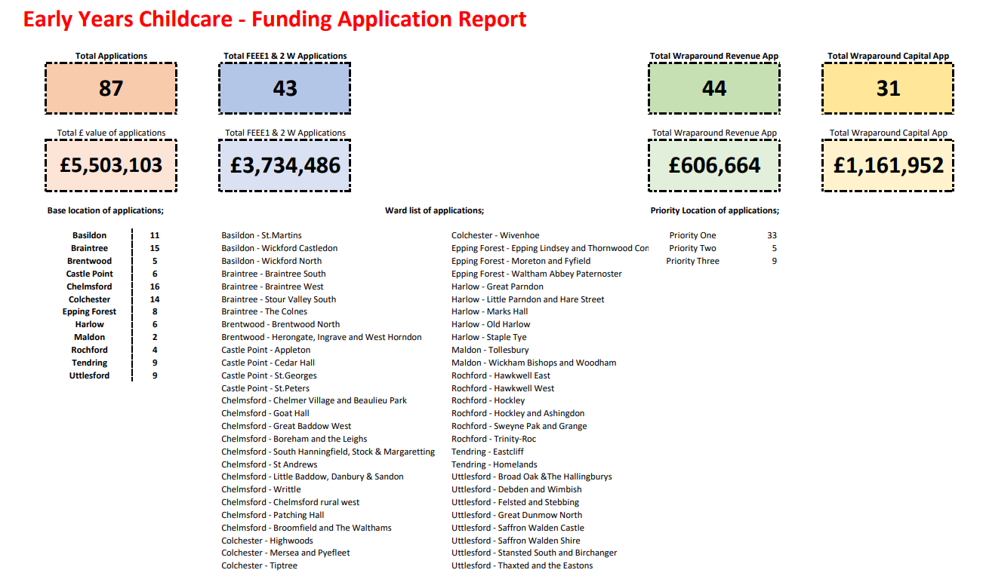

6.3 Following the evaluation process, Table 4 sets out the funding that is in the process of being agreed along with the number of new places to be created at a district level. These decisions require final sign off via the Council’s governance process and this is currently under way.

|  |  |  |  |  |  |
| --- | --- | --- | --- | --- | --- |
| District | FEEE1 & FEEE2  £ | FEEE1 & FEEE2  Places | Wraparound Capital  £ | *Wraparound Revenue  £ | Wraparound Places |
| Basildon | 105,000 | 30 | 126,000 | 240,000 | 145 |
| Braintree | 138,000 | 49 | 231,818 | 160,000 | 145 |
| Brentwood | 105,000 | 62 | 50,000 | 40,000 | 20 |
| Castlepoint | 224,000 | 65 | 0 | 0 | 0 |
| Chelmsford | 189,750 | 75 | 204,623 | 240,000 | 151 |
| Colchester | 143,890 | 94 | 49,890 | 120,000 | 60 |
| Epping Forrest | 0.00 | 0 | 0.00 | 40,000 | 15 |
| Harlow | 192,500 | 82 | 9,663 | 120,000 | 94 |
| Maldon | 40,000 | 15 | 0.00 | 0.00 | 0 |
| Rochford | 13,892 | 20 | 25,000 | 0.00 | 15 |
| Tendring | 28,000 | 12 | 63,215 | 80,000 | 65 |
| Uttlesford | 216,000 | 66 | 23,820 | 160,000 | 75 |
| Totals | **£1,396,032** | **570** | **£784,029** | **£1,200,000** | **785** |
| * calculation based on a max. of £10k per term for 4 terms | | |  |  |  |

6.4 Throughout this process, the DfE are requiring local authorities to submit regular updates and progress reports on the allocation of funding and creation of new places.

6.5 Next steps

6.5.1 A second phase of advertising revenue funding to create additional new wraparound childcare places was launched week commencing 17 June 2024, and it is intended that this will be a rolling monthly cycle until the funding is awarded to create sufficient new places.

6.5.2 A second phase of advertising capital to create additional new early years places will be launched before the end of the summer term and will remain open until the end of September 2024.

6.5.3 It may be possible to also advertise some additional capital funding to support the creation of new wraparound places and this will be confirmed as soon as possible.

6.5.4 Funding has been ringfenced from the grant received from the DfE to ensure there is financial support for schools and settings for any enhanced staffing levels that may be needed to support children with SEND to access a wraparound place.

**7.** **Update on spend against Early Years Block underspend proposals**

7.1 Table 5 below provides an update on the progress and financial commitment against each of the agreed projects to date. A cost benefit analysis of these projects will be brought to the November meeting : -

|  |  |  |
| --- | --- | --- |
| Proposal | Total Cost | Update |
| Creation of 4 Early Years Early Intervention Partner (EYEIP) full time posts for a time limited period of 24 months, with a possibility of a 1 year extension  All 4 posts in place from September 2023  10 months of funding been utilised to date (£230k) | Total **£550,000** over 2 years | The posts have now been in place for 3 terms and we are receiving positive feedback from settings that are being supported and continuing to see a reduction in the number of funded inclusion applications.  The number of inclusion funding applications funded between Sept 22 to June 23 and Sept 23 to Jun 24 has fallen from 835 to 688, a decrease of 147. The EYEIP role is a contributory factor to this reduction, as the team are providing practical support to settings rather than them needing financial support in certain circumstances.  The team are offering surgeries to support settings in their assessments and are effectively working with other ECC colleagues and bringing capacity to the system.  Based on feedback from some schools at the transition into reception last year, the team are also undertaking a data and research project to provide insight into how both the earlier identification of need and transition process can be improved |
| 1fte of temporary increased staffing levels to Early Years Sufficiency and Sustainability team  To provide additional business management consultancy and childcare sufficiency staffing support to early years sector for 2 years    £60,000 x 2 years  Increased staffing levels in place from June 2023 – 1 year of funding (£60k) been utilised since June 2023 | Total **£120,000** | This additional resource continues to be in place and, alongside additional funding from the DfE as part of the Childcare Reforms, there are now 4 business management consultants in place alongside the community development resource ensuring each quadrant has its own dedicated support.  The additional capacity has provided support to childcare settings and schools: -  to apply for the childcare reforms funding, and S106 capital to support the creation of new places  where there has been a need to adjust business models to ensure sustainability  workforce issues have required the settings to operate differently at short notice. |
| Speech and Language Club  On-line resource by SALT specialists in the six levelling up areas.  Target  Forty-two settings and five hundred children and their families supported through the setting, along with up to ten additional direct support for parents.  Supplier:  Essex Speech Club.  First tranche implemented from Summer 2023 term | Total **£94,500** | 29 settings are now accessing support across the county. The target was for each setting to support 12 children equating to 348 children for these 29 settings, but the feedback is that the settings are finding the support and interventions so effective they are actually also using this across whole cohorts as well as being a targeted offer and so the reach is far greater than had been anticipated.  Settings can also identify up to 10 parents to access a targeted home support – of the 270 vouchers available to date 89 have been activated and parents receiving direct support.  The feedback previously shared below remains and continues to be extremely positive.  Children are responding well to the sessions, practitioners are learning strategies to use outside of the intervention, the resources provided saves the practitioners preparation time, and when they need specific advice, the company is available over the phone and to visit face to face.  The programme compliments Essex’s training and interventions that are already embedded in the settings.  Some settings who have been approached and would like to be involved have so far not been able to due to weak Wi-Fi / technology issues. These issues are being looked into to try and identify solutions with the intention to roll the offer out to them too  Commitment to date £94,500 |
| Continuation of Speech and Language Club following a 1-year review  Should the project show success, a further 2–3-year funding, continuation and expansion of the Speech and Language Club. Potential for collaboration with Health colleagues and/or the High Needs Block. | Total **£350,000** | A full audit of the impact on the first tranche will be undertaken in the Autumn term, with plans to roll this out further to be reviewed and agreed based on the evaluation |
| Help for sufficiency of disadvantaged EY settings.  Funding for Early Years settings in levelling up and disadvantaged areas to help provide sufficiency and longevity in tough times. The settings would be distinguished through location, and if the setting is the only option for families in the area to access their funded place.  Funding implemented from start of Autumn 2023 term. | Total **£750,000** | To-date twelve settings have been supported with a sufficiency grant to provide financial support to overcome short term cashflow issues and / or time needed to amend business models to become sustainable.  This funding source is only considered when all other options have been exhausted.  £230,000 committed so far |
| Talk listen and cuddle is a platform for parents that provide information, advice and guidance. Potential to offer improvement and expansion of this platform and to allow access to more parents. | Total **£50,000** | Mackman Agency has been successful in securing this work. An initial meeting has been undertaken with them on the roll out of the improvement of the platform and reach to more parents to begin from the Autumn term.  Funding will start to be committed from September over a 3 year period with £20k scheduled to be paid for the Autumn term |
| Recruitment and retention support  Work underway to put together a package to support the early years sector.  Access to free access to ECC Jobs site from September 2023  Marketing Recruitment Campaign launched 4 October 2023 | Total **£300,000** | Targeted 11 month marketing campaign launched - **#‘Make a change. Build a future.’** [https://www.essex.gov.uk/news/2023/new-recruitment-campaign-launched-early-years-practitioners](https://eur02.safelinks.protection.outlook.com/?url=https%3A%2F%2Fwww.essex.gov.uk%2Fnews%2F2023%2Fnew-recruitment-campaign-launched-early-years-practitioners&data=05%7C01%7CCarolyn.Terry%40essex.gov.uk%7C4ef67ac466f740c0d52c08dbc4ef39e3%7Ca8b4324f155c4215a0f17ed8cc9a992f%7C0%7C0%7C638320303970276321%7CUnknown%7CTWFpbGZsb3d8eyJWIjoiMC4wLjAwMDAiLCJQIjoiV2luMzIiLCJBTiI6Ik1haWwiLCJXVCI6Mn0%3D%7C3000%7C%7C%7C&sdata=pyr%2BgjgVoyJw0FuRuj2pDRdOvYnIpMynBxVoCYxiEeY%3D&reserved=0)  The Make a change. Build a future campaign aims to:   * raise awareness of early years and childcare as a career option, while promoting training routes and progression opportunities * encourage qualified Level 2 and Level 3 practitioners to return to the sector. * raise awareness of the flexibility and opportunities available for those interested in becoming a registered childminder in Essex.   Since the start of the campaign last October, we have seen:  24,787 visits to the ‘general’ recruitment campaign <https://eycp.essex.gov.uk/discover-or-return-to-a-career-in-early-years-and-childcare/> - average of 689 per week  21,698 visits to our Level 2 / 3 (Essex School jobs vacancy page) – average of 603 per week  21,324 visits to our targeting ‘becoming a childminder’ section – average of 592 per week. In this period there has been an increase in the number of new childminders registered, and of these 64 have also accessed the DfE start up grant funding.  EYCC providers were given 12 months free access to the ECC Schools Job Vacancy site to advertise their job roles and being given advice on advert content etc and to provide central place to signpost interested candidates to from marketing campaign to find vacancies.  302 early years settings and 760 childminders have registered on the site and 484 adverts were advertised on the site as a result. Work is underway to gather data into the success rate of recruiting to these vacancies.  Spend to date.  Recruitment Campaign - £98,000  Job site access - £24,000 |

**8. Schools Forum Early Years and Childcare Reference Group**

8.1 The Schools Forum Early Years and Childcare Reference Group has continued to meet during 2024, with ongoing representation from all early years’ sector types and each district.

The key areas of discussion have continued to be around the following areas: -

* ongoing increasing number of early years children with emerging additional needs that need more support, alongside concerns over the level of support the sector is receiving for children with SEND from ECC.
* Financial pressures on the economy such as increases to the national minimum wage, NI contributions, utility, and food costs, which are causing sustainability concerns for the early years sector.
* Recruitment and retention of qualified staff is continuing to be an increasing issue for the early years sector; however, the new recruitment and retention programme has been launched to support this area of need.

Future meetings have been scheduled to coincide with reporting to Schools Forum

|  |  |
| --- | --- |
| Schools Forum | **Agenda Item 10** |
| Date: 10 July 2024 |  |

**REPORT TITLE: SCHOOLS BUDGET & EDUCATION FUNCTIONS FORECAST DRAFT REPORT 2023/24**

Report by Yannick Stupples-Whyley

Contact details: Telephone (03330 138464); e-mail: yannick.stupples-whyley@essex.gov.uk

**1. Purpose of report**

1.1 To update Schools Forum on the forecast outturn position for the year-ended 31st March 2024 for both the Schools Budget and Education Functions.

**2. Recommendations**

2.1 That Forum notes the forecast outturn position for the year ended 31st March 2024.

###### 3. Relevant Schools Forum Power and Responsibility

3.1 Table 1 shows the relevant responsibilities that Forum has in relation to the Schools Budget, which are taken from the Education and Skills Funding Agency’s **Schools forum powers and responsibilities** published in September 2018.

|  |  |  |
| --- | --- | --- |
| Local Authority | Schools Forum | DfE |
| De-delegation – proposes | Decides | Adjudicates where Forum disagrees with the Authority’s proposals |
| General Duties for maintained schools – propose | Decides | Adjudicates where Forum disagrees with the Authority’s proposals |
| Growth Fund and Falling Rolls Fund – proposes | Decides | Adjudicates where Forum disagrees with the Authority’s proposals |
| Central Spend on Early Years and Central School Services – proposes | Decides | Adjudicates where Forum disagrees with the Authority’s proposals |
| Central Spend on High Needs – Decides | None, but good practice to consult. | None |

###### 4. Background

4.1 The draft outturn for 2023/24 is set out at Annex A.

4.2 The total Dedicated Schools Grant (DSG) received for 2023/24 after academy recoupment is **£598.8m.**

4.3 The DSG draft underspend for 2023/24 is **£12.1m**, a favourable movement of **£8.5m** since Quarter 3. Table 2 shows the overall forecast DSG balance at 31st March 2024.

|  |  |  |  |  |  |
| --- | --- | --- | --- | --- | --- |
|  | Schools  Block  £m | Central  Schools  Block  £m | High  Needs  Block  £m | Early  Years  Block  £m | Total  £m |
| Opening balance 2023/24 | **(1.4)** | **(2.1)** | **(13.5)** | **(7.3)** | **(24.3)** |
| 2023/24 Draft Outturn | (0.5) | 0.0 | 2.2 | (13.8) | (12.1) |
| Closing Balance 2023/24 | **(1.8)** | **(2.1)** | **(11.3)** | **(21.3)** | **(36.5)** |

4.4 The significant variations contributing to the outturn position are:  
  
**Schools Block - £455,000 underspend – £696,000 adverse movement from Quarter 3.**

4.5 Forum are aware the Authority is holding a contingency within the Growth Fund for a future year where the allocation from the DfE is insufficient to meet the growth fund requirement. The remaining balance carried forward is **£463,000**. This has slightly been offset by overspends in the funding de-delegated from maintained schools due to academy conversions.

**Central School Services Block - £71,000 underspend – Favourable movement of £249,000 from Quarter 3.**

4.6 The underspend is due to vacancies within Safeguarding (**£58,000**), a reduction in statutory school consultations (**£9,000**) and a lower call on the free school uniform budget (**£3,000**).

**High Needs Block - £2.2m overspend – Adverse movement of £1m from Quarter 3.**

4.7 The DfE contacted all local authorities on 26th March concerning ineligible DSG expenditure in particular the following categories:

* SEN transport
* Educational psychologists
* SEN administration, assessment coordination, and monitoring
* Social care and health costs

4.8 The Authority reviewed all expenditure and removed **£2.2m** expenditure from DSG which was charged to the Council’s budget. Although the Authority believes some of the removed expenditure is eligible, it has been removed until discussion has been held with the DfE.

4.9 Top-up funding for maintained schools, academies and free schools **£6.1 million** over spend due to an increase in volume of pupils being awarded Education, Health and Care Plans (EHCPs). This is a favourable movement of **£1.4m** from Quarter 3.

4.10 Independent special schools **£3.9 million** overspend due to an increase in volume and the cost of placements. This is a favourable movement of **£1m from Quarter 3.**

4.11 SEN Services **£11.7 million** underspend The main cause of the under spend is the HNB contingency **£9.1 million** which has arisen due to funding increasing faster than expected demand. The Authority has decided not to contribute to the pension deficit in 2023/24 resulting in a **£753,000** underspend. Expenditure has decreased by **£2m** due to the removal of expenditure based on the DfE letter. This is a favourable movement of **£1.5m** since Quarter 3.

4.12 Other alternative provision services **£5.7m** overspend due to an increase in pupils being placed through the IPES contract. This is an adverse movement of **£3.7m** from Quarter 3.

4.13 Support for inclusion **£146,000** over spend due to increased expenditure through the Inclusion Framework **£506,000** which is offset by an under spend in the quadrant SEND teams **£301,000**, due to vacancies where new posts have yet been recruited to. This is a favourable movement of **£197,000** since Quarter 3.

4.14 Eligible expenditure towards the cost of personal budgets for SEND Transport has been identified and expenditure of **£690,000** has been charged to the High Needs Block.

4.15 Therapies and other health related services **£343,000** overspend due to an increased use of independent therapists whilst new contracts have been developed. This is a favourable movement of **£83,000** from Quarter 3.

4.16 SEN Transport **£3m** underspend as some expenditure has been removed which is not eligible following notification from DfE. This leaves **£1.5m** which is chargeable as per the Schools and Early Years Finance (England) Regulations.

**Early Years Block - £13.8 million underspend**

4.17 The Authority has notified the DfE that it believes the January 2023 Census used to fund the 2022/23 and 2023/24 Early Years Block allocation is too high. The DfE were contacted on 15th March but no response has been received. Table 2 shows a closing balance of **£21.3m** of which the Authority has calculated **£13.4m** could be clawed back. The Authority will update the Early Years Sub Group, the Finance Review Group and Schools Forum once the final outcome is known.

**Education Functions**

4.18 At the meeting of 30th November 2022 Schools Forum approved the authority’s proposals for services provided to all schools, as shown in Table 3.

|  |  |
| --- | --- |
| Education Functions – All Schools | £’000 |
| Education Welfare | 1,170 |
| Strategic Management | 1,577 |
| Asset Management | 333 |
|  | **3,080** |

4.19 Also at the meeting of 30th November 2022, maintained members of Schools Forum agreed to de-delegate from maintained school £48.10 per pupil to fund the education functions shown in Table 4.

|  |  |
| --- | --- |
| Education Functions – Maintained Schools | £000 |
| Asset Management | 279 |
| Statutory & Regulatory Duties | 2,101 |
| School Improvement | 437 |
|  | **2,817** |

4.20 The budgets in Table 4 are subject to recoupment each time a school converts to an academy. Table 5 reflects the effect of the 14 schools that have converted to academies in 2023/24.

|  |  |  |  |
| --- | --- | --- | --- |
|  | Asset Management  £000 | Statutory & Regulatory  £000 | School Improvement  £000 |
| Original Budget | 278 | 2,101 | 437 |
| Recoupment | (1) | (11) | (2) |
| Revised Budget | **277** | **2,090** | **435** |

4.21 Table 5 shows the forecast draft position for Education Functions 2023/24 which is a **£10,000** overspend, a favourable movement of **£113,000** since Quarter 3.

|  |  |  |  |
| --- | --- | --- | --- |
| Education Functions | Budget  £000 | Forecast  Outturn  £000 | Variance  £000 |
| Education Welfare | 1,170 | 1,170 | 0 |
| Strategic Management | 1,577 | 1,665 | 88 |
| Asset Management – all schools | 333 | 333 | 0 |
| Asset Management – maintained schools | 277 | 277 | 0 |
| Statutory & Regulatory Duties | 2,090 | 2,011 | (79) |
| School Improvement | 435 | 436 | 1 |
| Total | **5,882** | **5,892** | **10** |

4.19 The significant cause of the over spend in Strategic Management is due to increased expenditure resulting from the SEND action plan following the last Ofsted inspection. The underspend with Statutory & Regulatory duties is due to vacant posts.

**5. Other Resource Implications**

**6. Consultation with stakeholders**

**7. Background / Supporting papers.**

7.1 Annex A – Schools Budget Outturn 2023/24

**Agenda Item 10 – Annex A**



|  |  |
| --- | --- |
| Schools Forum | **Agenda Item 11** |
| Date: 10 July 2024 |  |

**REPORT TITLE: SCHOOLS BUDGET & EDUCATION FUNCTIONS BUDGET UPDATE – Q1 2024/25**

Report by Yannick Stupples-Whyley

Contact details: Telephone (03330 138464); e-mail: yannick.stupples-whyley@essex.gov.uk

**1. Purpose of report**

1.1 To update Schools Forum on the forecast outturn position for the year-ended 31st March 2025 for both the Schools Budget and Education Functions.

**2. Recommendations**

2.1 That Forum notes the forecast outturn position for the year ended 31st March 2025.

###### 3. Relevant Schools Forum Power and Responsibility

3.1 Table 1 shows the relevant responsibilities that Forum has in relation to the Schools Budget, which are taken from the Education and Skills Funding Agency’s **Schools forum powers and responsibilities** published in September 2018.

|  |  |  |
| --- | --- | --- |
| Local Authority | Schools Forum | DfE |
| De-delegation – proposes | Decides | Adjudicates where Forum disagrees with the Authority’s proposals |
| General Duties for maintained schools – propose | Decides | Adjudicates where Forum disagrees with the Authority’s proposals |
| Growth Fund and Falling Rolls Fund – proposes | Decides | Adjudicates where Forum disagrees with the Authority’s proposals |
| Central Spend on Early Years and Central School Services – proposes | Decides | Adjudicates where Forum disagrees with the Authority’s proposals |
| Central Spend on High Needs – Decides | None, but good practice to consult. | None |

###### 4. Background

4.1 The forecast outturn for 2024/25 is set out at Annex A.

4.2 The total Dedicated Schools Grant (DSG) expected to be received for 2024/25 after academy recoupment is **£679m**.

4.3 The DSG forecast overspend for 2024/25 is **£2.6m**. Table 2 shows the overall forecast DSG balance at 31st March 2025.



4.4 The significant variations contributing to the outturn position are:

**Schools Block - £3.4m underspend**

4.5 The forecast underspend is due to the schools block contingency where funding is being held as the DfE has recouped **£2.9m** less fundingthan is expected. The remaining **£0.5m** is additional funding for summer term growth funding for academies.

**Central School Services Block - £123,000 underspend.**

4.6 The forecast underspend is due to the CSSB contingency where the budget allocation is higher than the forecast expenditure for 2024/25.

**High Needs Block - £6.1m overspend.**

4.7 Top-up funding for maintained schools, academies and Post 16 FE is forecasting a **£3.4m overspend** due to the average cost of banding increasing, as more pupils are awarded higher bands.

4.8 Top-up funding for Independent Providers is forecasting a **£1.6m overspend** due to increases in demand and cost.

4.9 SEN Support Services is forecasting a **£602,000 underspend** which is due to the HNB contingency where funding exceeded the budget set **£452,000** and staffing vacancies across the quadrant and specialist teacher teams **£150,000 underspend**.

4.10 Other Alternative Provision is forecasting a **£3.6m overspend** due to a forecast increase in pupils receiving individual pupil resourcing agreements.

4.11 Support for Inclusion is forecasting a **£1.9m underspend** due to the impact of the communication from the DfE on eligible DSG expenditure on the 2024/25 budget. More details on the DfE communication is available in Agenda Item 10.

4.12 Looking back at 2023/24 the High Needs Block had an adverse movement of **£12.5m** between Quarter 1 and final outturn. Should a similar movement occur this year the HNB will be in a deficit position. Depending on the provisional settlement for 2025/26 there could be a request for a transfer from the Schools Block at the September meeting.

**Early Years Block** – **on target**

4.13 The budget is being held until the outcome of the Authority’s letter to the DfE, discussed in Agenda Items 9 and 10, is known.

**Education Functions**

4.14 Table 3 shows the funding Schools Forum agreed at the meeting of 27th September 2023 for the statutory duties the Authority holds for all schools for 2024/25.

|  |  |
| --- | --- |
| Education Functions – All Schools | £’000 |
| Education Welfare | 1,566 |
| Strategic Management | 1,155 |
| Asset Management | 359 |
|  | **3,080** |

4.15 Table 4 shows the funding maintained school members agreed at the meeting of 27th September 2023, to de-delegate £48.59 per pupil to fund the statutory duties the Authority holds for maintained schools for 2024/25.

|  |  |
| --- | --- |
| Education Functions – Maintained Schools | £000 |
| Asset Management | 268 |
| Statutory & Regulatory Duties | 2,168 |
| School Improvement | 438 |
|  | **2,874** |

4.16 Table 5 shows the forecast outturn position for Education Functions 2024/25 which is a **£66,000** underspend.

|  |  |  |  |
| --- | --- | --- | --- |
| Education Functions | Budget  £000 | Forecast  Outturn  £000 | Variance  £000 |
| Education Welfare | 1,566 | 1,539 | (27) |
| Strategic Management | 1,155 | 1,155 | 0 |
| Asset Management – all schools | 359 | 359 | 0 |
| Asset Management – maintained schools | 268 | 268 | 0 |
| Statutory & Regulatory Duties | 2,168 | 2,129 | (39) |
| School Improvement | 438 | 438 | 0 |
| Total | **5,954** | **5,888** | **(66)** |

4.17 The underspend is due to staffing vacancies of which 0.27fte is in the Quadrant Attendance Teams under Education Welfare.

**5. Other Resource Implications**

**6. Consultation with stakeholders**

**7. Background / Supporting papers.**

**Agenda Item 11 - Annex A**



|  |  |
| --- | --- |
| Schools Forum | **Agenda Item 12** |
| Date: 10 July 2024 |  |

**REPORT TITLE: SCHOOL and ACADEMY BALANCES**

Report by Yannick Stupples-Whyley

Contact details: Telephone (03330 138464); e-mail: yannick.stupples-whyley@essex.gov.uk

**1. Purpose of report**

1.1 To update Schools Forum on the level of school balances held across all schools in Essex and to update Forum on the review of schools with balances in excess of 30%.

**2. Recommendations**

2.1 To note the level of school balances.

2.2 To note the progress of the review of schools with balances in excess of 30%.

###### 3. Relevant Schools Forum Power and Responsibility

3.1 There are no specific school forum powers or responsibilities in connection to school balances.

###### 4. Background

4.1 The combined balances for maintained schools and academies are **£183.8m**, which is an increase of **£4.2m**. Table 1 shows the balances for maintained schools as at 31st March 2024 and for academies as at 31st August 2023.

|  |  |  |  |  |
| --- | --- | --- | --- | --- |
| Phase | No. of Schools | Maintained School Balances at 31/03/24  £000 | Academy Balances at 31/08/23  £000 | Total Balances  £000 |
| Nursery | 2 | 235 | 0 | 235 |
| Primary | 447 | 35,325 | 50,347 | 85,672 |
| Secondary | 79 | 3,168 | 73,980 | 77,148 |
| All-Through | 2 | 0 | 1,958 | 1,958 |
| Special | 22 | 2,713 | 9,289 | 12,002 |
| PRU | 6 | 1,775 | 4,971 | 6,746 |
| Total | **556** | **43,216** | **140,545** | **183,761** |

4.2 Academy balances are taken from the accounts published on the Companies House website as follows:

* Standalone academies – Unrestricted general funds + restricted general funds (excluding the pension reserve).
* Essex MATs – The Funds section lists the balances held by each school in the MAT. Also taken into account is the central services balance held by the MAT.
* Multi-Authority MATS – The balances listed for each Essex academy, plus a pro-rata share of the central services balance based on the proportion of Essex pupils within the MAT.
* Essex MATs that pool balances – the whole Trust balance is used.
* Multi-Authority MATs that pool balances – a pro-rata share of the Trust balance based on the proportion of Essex pupils in the MAT.

4.3 Table 2 shows academy balances, broken down between balances held by schools, central services balances and pooled balances.

|  |  |  |  |  |
| --- | --- | --- | --- | --- |
| Phase | Balances held by Schools  £000 | Trust Central Services  £000 | Trust Pooled Funds  £000 | Total Balances  £000 |
| Primary | 36,394 | 1,047 | 12,907 | 50,347 |
| Secondary | 52,697 | 4,511 | 16,771 | 73,980 |
| All-Through | 0 | 0 | 1,958 | 1,958 |
| Special | 6,892 | (585) | 2,982 | 9,289 |
| PRU | 5,049 | (79) | 0 | 4,971 |
| Total | **101,032** | **4,895** | **34,618** | **140,545** |

4.4 Table 3 shows the Trusts that pool balances and shows how many Essex schools are in the Trust.

|  |  |  |
| --- | --- | --- |
| **Trust** | **No. of Essex Schools** | **Total Balances**  **£000** |
| Academies Enterprise Trust[3] | 10 | 3,894 |
| Academy Transformation Trust | 2 | 96 |
| BMAT Education | 11 | 3,558 |
| Bridge Academy Trust | 11 | 6,767 |
| Canonium Learning Trust | 5 | 889 |
| Inspires MAT | 5 | 172 |
| Loxford Schools Trust Limited | 1 | 560 |
| NET Academies Trust | 6 | 2,705 |
| Ormiston Academies Trust | 1 | 683 |
| Saffron Academy Trust | 9 | 2,698 |
| SEAX Trust | 5 | 2,982 |
| The Chelmsford Learning Partnership | 8 | 7,191 |
| The Compass Partnership of Schools | 4 | 1,247 |
| The Eveleigh Link Academy Trust | 7 | 294 |
| The Learning Partnership Trust | 3 | 801 |
| Unity Schools Partnership | 1 | 81 |
| **Total** | **88** | **34,618** |

4.5 Table 4 shows the movement in balances for maintained schools between 2022/23 and 2023/24. The balances for all maintained schools are shown in Annex A.

|  |  |  |  |  |
| --- | --- | --- | --- | --- |
| **Phase** | **2022/23**  **£000** | **2023/24**  **£000** | **Change**  **£000** | **Change**  **%** |
| Nursery | 194 | 235 | 41 | 21.10 |
| Primary | 35,473 | 35,325 | (149) | (0.42) |
| Secondary | 2,617 | 3,168 | 551 | 21.04 |
| Special | 3,701 | 2,713 | (988) | (26.69) |
| PRU | 1,695 | 1,775 | 80 | 4.75 |
| **Total** | **43,680** | **43,216** | **(464)** | **(1.06)** |

4.6 Balances for maintained schools have decreased by **£464,000**, which is broken down as follows:

* There is a **£1.9m** reduction due to 14 schools converting to academies in 2023/24.
* Balances for the remaining maintained schools increased **£1.4m**.

4.7 Table 5 for maintained schools shows the number of schools by phase that had an in-year surplus or in-year deficit.

|  |  |  |  |  |
| --- | --- | --- | --- | --- |
| **Phase** | **No. of Schools with in-year Surplus** | **£000** | **No. of Schools with in-year Deficit** | **£000** |
| Nursery | 2 | 41 | 0 | 0 |
| Primary | 113 | 6,221 | 90 | (4,456) |
| Secondary | 1 | 913 | 3 | (362) |
| Special | 2 | 525 | 4 | (1,513) |
| PRU | 2 | 142 | 1 | (61) |
| **Total** | **120** | **7,842** | **99** | **(6,392)** |

4.8 Table 6 shows for maintained schools the number of schools in surplus and deficit. For the schools in surplus, it is also shown the number of schools above the DfE thresholds.

|  |  |  |  |
| --- | --- | --- | --- |
| Phase | Surplus | Deficit | Surplus above DfE Threshold |
| Nursery | 2 | 0 | 1 |
| Primary | 191 | 13 | 132 |
| Secondary | 4 | 0 | 4 |
| Special | 5 | 1 | 4 |
| PRU | 3 | 0 | 3 |
| Total | **205** | **14** | **144** |

4.9 Table 6 shows there are 14 maintained schools with deficit balances, which is an increase of 2 schools.

4.10 Chart 1 shows how maintained schools plan to use their balances.

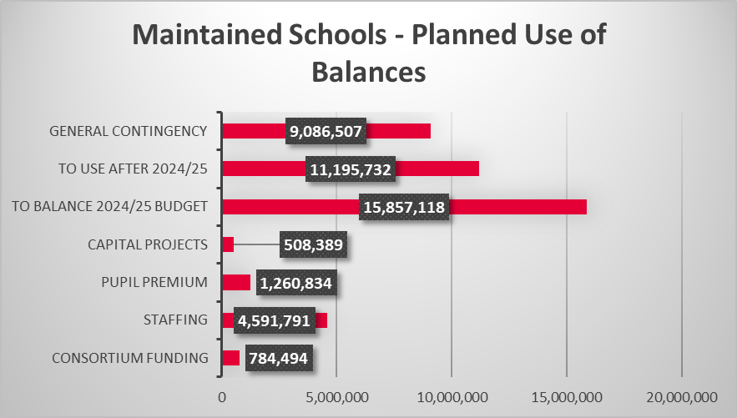

4.11 In comparison to previous years the main three categories are balancing the budget, to use in a future year and general contingency. The planned use of balances for each maintained school are shown in Annex B.

4.12 Table 7 shows the movement in balances for academies between 2021/22 and 2022/23. The balances for each academy or Trust are shown in Annex C.

|  |  |  |  |  |
| --- | --- | --- | --- | --- |
| Phase | 2021/22  £000 | 2022/23  £000 | Change  £000 | Change  % |
| Primary | 52,251 | 50,347 | (1,904) | (3.6) |
| Secondary | 68,430 | 73,980 | 5,550 | 8.1 |
| All-Through | 1,673 | 1,958 | 285 | 17.0 |
| PRU | 4,463 | 4,971 | 507 | 11.4 |
| Special | 9,048 | 9,289 | 241 | 2.7 |
| Total | **135,866** | **140,545** | **4,679** | **3.4** |

4.13 Balances for academies have increased by **£4.7 million**.

4.14 Table 8 for academies shows the number of schools by phase that had an in-year surplus or an in-year deficit.

|  |  |  |  |  |  |
| --- | --- | --- | --- | --- | --- |
| Phase | No. of Schools with in-year Surplus | £000 | No. of Schools with in-year Deficit | £000 | No. of Schools with no Change |
| Primary | 80 | 9,212 | 109 | (11,115) | 39 |
| Secondary | 30 | 14,155 | 28 | (8,606) | 17 |
| All-Through | 0 | 1,958 | 2 | (1,673) | 0 |
| PRU | 3 | 584 | 0 | (77) | 0 |
| Special | 3 | 609 | 8 | (369) | 5 |
| Total | **116** | **26,518** | **146** | **(21,840)** | **61** |

4.15 Table 9 shows for academies the number of schools in surplus and deficit. For the schools in surplus, it is also shown the number of schools above the DfE thresholds.

|  |  |  |  |  |
| --- | --- | --- | --- | --- |
| Phase | Surplus | No change / Pooled | Deficit | Surplus above DfE Threshold |
| Primary | 149 | 63 | 16 | 120 |
| Secondary | 51 | 22 | 2 | 46 |
| All-Through | 0 | 2 | 0 | 0 |
| Special | 10 | 5 | 0 | 7 |
| PRU | 3 | 0 | 0 | 3 |
| Total | **213** | **92** | **18** | **176** |

4.16 Table 9 shows there are 18 academies in deficit which is no change to the previous years. The pooling of balances has increased from 62 schools last year to 89 schools. The other 3 schools report their balance and there was no change to the previous year.

4.17 Chart 2 shows the movement in school balances over the last 5 years.

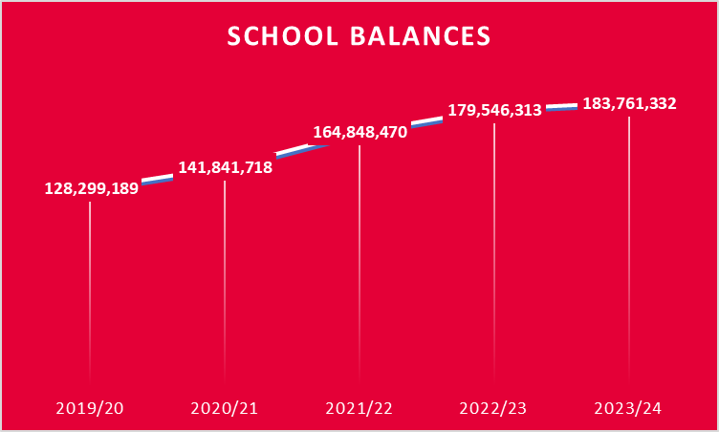

4.18 It can be seen in Chart 2 that since 2019/20 balances have increased by **£55.5 million** (43.2%).

**5. Review of School Balances**

5.1 The Finance Review Group has undertaken the review of School Balances on behalf of Schools Forum. Table 10 shows the schools that were contacted in October 2023

|  |  |  |  |  |
| --- | --- | --- | --- | --- |
| Primary | All-Through | Secondary | Special | PRU |
| Colne Engaine | Beaulieu Park | Colchester Royal Grammar | The Pioneer | NE Essex Co-op |
| Crays Hill P |  | Manningtree High |  | Mid Essex Co-op |
| Flitch Green |  |  |  |  |
| Gt. Chesterford |  |  |  |  |
| Hutton All Saints |  |  |  |  |
| Kirby P |  |  |  |  |
| Lyons Hall |  |  |  |  |
| Messing P |  |  |  |  |
| Monkwick Inf |  |  |  |  |
| Moulsham Inf |  |  |  |  |
| Noak Bridge |  |  |  |  |
| Perryfields Jnr |  |  |  |  |
| Rochford P |  |  |  |  |
| Rolph P |  |  |  |  |
| South Benfleet P |  |  |  |  |
| St Andrew’s Gt Yeldham |  |  |  |  |
| St James P |  |  |  |  |
| Shenfield St Mary |  |  |  |  |
| St Osyth P |  |  |  |  |
| St Thomas More’s RC P |  |  |  |  |
| Stisted Primary |  |  |  |  |
| Tolleshunt D’Arcy |  |  |  |  |
| Waterman P |  |  |  |  |
| The Wickford CE P |  |  |  |  |

5.2 Responses were received from 21 schools (65.6%) and were split between schools saying their balances have reduced to less than 30% giving the reasons why or detailing the reason for the high balance.

5.3 Where schools still have balances of 30% or more the reasons for holding high balances include funding held for property repairs, fluctuating pupil numbers, funding held to afford pay rises or trust policy to hold at least one month’s funding.

5.4 It was agreed the Authority should review the evidence and determine how the review is to progress.

5.5 The Authority expected that academy balances would reduce for the year ending 31st August 2023, following the reduction in maintained school balances at 31st March 2023. A number of schools have stated that their balances have decreased to less than 30% due to the teacher’s pay award not being fully funded, high energy prices and repairs to school buildings.

5.6 It was therefore decided to wait for an update on academy balances before proceeding with the next steps.

5.7 In November 2023 the Education & Skills Funding Agency updated their guidance on Academy Trust Reserves. Whilst Trusts are free to decide the level of reserves that they hold, it is claimed 90% of Trusts hold reserves of at least 5%. Where Trusts hold one month’s salary costs to protect cashflow this is estimated to be around 6% - 8% of income.

5.8 The ESFA define high level of reserves being 20% or higher of total income received.

5.9 Table 11 shows a breakdown of balances as a percentage of revenue funding.

|  |  |  |  |  |  |  |
| --- | --- | --- | --- | --- | --- | --- |
|  | Nursery | Primary | Secondary | All-Through | Special | PRU |
| 60% and above | 0 | 1 | 2 | 0 | 2 | 2 |
| Between 50% & 59.9% | 0 | 2 | 0 | 0 | 0 | 1 |
| Between 40% & 49.9% | 0 | 8 | 0 | 0 | 2 | 1 |
| Between 30% & 39.9% | 0 | 32 | 4 | 0 | 1 | 0 |
| Between 20% & 29.9% | 1 | 103 | 14 | 0 | 4 | 1 |
| Between 8.1% & 19.9% | 0 | 124 |  | 0 | 3 | 1 |
| Between 5.1% & 19.9% |  |  | 31 | 0 |  |  |
| Between 0% & DfE limit | 1 | 90 | 6 | 0 | 4 | 0 |
| Deficit | 0 | 29 | 2 | 0 | 1 | 0 |

5.10 There are 58 schools that have balances of 30% or higher of their revenue funding, which is a decrease of 12 schools from 2022/23.

5.11 Table 12 shows there are 20 schools that have balances of 30% or higher over the last consecutive 5 financial years and these schools will be included in the ongoing balances review.

|  |  |  |  |  |
| --- | --- | --- | --- | --- |
| Primary | All-Through | Secondary | Special | PRU |
| Crays Hill P |  | Colchester Royal Grammar |  | NE Essex Co-operative Academy |
| Flitch Green |  | Manningtree High |  | Mid Essex Co-operative Academy |
| Hutton All Saints |  | Stewards School |  |  |
| Latchingdon P |  |  |  |  |
| Lyons Hall |  |  |  |  |
| Messing P |  |  |  |  |
| Noak Bridge |  |  |  |  |
| Perryfields Jnr |  |  |  |  |
| Rochford P |  |  |  |  |
| South Benfleet P |  |  |  |  |
| St Andrew’s Gt Yeldham |  |  |  |  |
| Shenfield St Mary |  |  |  |  |
| St Osyth P |  |  |  |  |
| St Thomas More’s RC P |  |  |  |  |
| The Wickford CE P |  |  |  |  |

5.12 The Authority will consider the way forward for the balances review in light of the responses received so far and will take proposals to the next Finance Review Group meeting.

**6. Other Resource Implications**

**7. Consultation with stakeholders**

**8. Background / Supporting papers.**

8.1 Annex A – Maintained School Balances 2023/24

8.2 Annex B – Maintained Schools Planned Use of Balances

8.3 Annex C – Academy Balances 2022/23

|  |  |
| --- | --- |
| Schools Forum | **Agenda Item 13** |
| Date: 10 July 2024 |  |

**REPORT TITLE: CONSTITUTION and MEMBERSHIP OF SCHOOLS FORUM**

Report by Yannick Stupples-Whyley

Contact details: Telephone (03330 138464); e-mail: yannick.stupples-whyley@essex.gov.uk

**1. Purpose of report**

* 1. To consider the current membership of the Schools Forum in the light of the continuing transfer of maintained schools to the Academy sector and the change in pupil numbers.

**2. Recommendations**

2.1 To note that no changes are required to the Constitution of Schools Forum.

###### 3. Relevant Schools Forum Power and Responsibility

3.1 Table 1 shows the relevant responsibilities that Forum has in relation to the Schools Forum, which are taken from the Education and Skills Funding Agency’s **Schools forum powers and responsibilities** published in September 2018.

|  |  |  |
| --- | --- | --- |
| Local Authority | Schools Forum | DfE |
| Membership: length of office – Decides | None – but good practice to get Forum’s view | None |
| Voting Procedures – None | Determines | None |
| Chair of Schools Forum – facilitates | Elects | None |

###### 4. Background

4.1 Schools Forum approved a mix of both in-person and remote meetings at the May 2021 meeting following the change to the Schools Forum Regulations allowing the use of remote meetings on a permanent basis.

4.2 At the meeting of 17 May 2023 Schools Forum approved to move the in-person meeting from January to May on a permanent basis. Should an in-person meeting be cancelled the Authority will where applicable change the next remote meeting to an in-person meeting. The usual pattern of meetings is shown below:

* May – in person
* July – remote
* September – in person
* November – remote
* January – remote

4.3 All sub-group meetings will be held remotely.

4.4 Table 2 shows the agreed structure Forum approved in December 2020:

|  |  |  |  |
| --- | --- | --- | --- |
|  | Maintained Schools | Academies | Total |
| Primary | 5 | 5 | 10 |
| Secondary | 1 | 6 | 7 |
| Special | 1 | 1 | 2 |
| PRUs | 1 | 1 | 2 |
| Nursery | 1 | - | 1 |
| Non School Members |  |  | 6 |
| Total | **9** | **13** | **28** |

4.5 Table 3 shows the ratio of pupils between primary and secondary schools as at the January Census 2024.

|  |  |  |
| --- | --- | --- |
|  | Pupils | Ratio |
| Primary | 119,426 | 1.46 |
| Secondary | 81,848 | 1.00 |

4.6 The ratio between primary and secondary pupils is 1.46:1 which requires no change to the number of primary and secondary representatives.

4.7 Table 4 shows a breakdown of pupils for primary and secondary between maintained schools and academies as at the January Census 2024.

|  |  |  |  |
| --- | --- | --- | --- |
|  | No. of Schools | Pupils | % Split |
| Primary  Maintained  Academies  Total Primary | 204  241  **445** | 52,438  66,988  **119,426** | 43.9%  56.1%  **100.0%** |
| Secondary  Maintained  Academies  Total Secondary | 4  75  **79** | 3,822  78,026  **81,848** | 4.7%  95.3%  **100.0%** |

4.8 The split of primary pupils between maintained schools and academies requires 4 maintained members and 6 academy members.

4.9 Forum agreed at their meeting on 29 November 2023 to cease the position of the next maintained member to come to their end of term and at that date elect a new academy member.

4.10 A full list of members is shown in Annex A

4.11 Table 5 shows the members who within the next twelve months will reach the end of their current term of office.

|  |  |
| --- | --- |
| Name | Last Meeting |
| Luke Bulpett | 10th July 2024 |
| Debs Watson | 27th November 2024 |
| Lyn Wright | 27th November 2024 |
| Ruth Sturdy | 27th November 2024 |
| Jo Santinelli | 27th November 2024 |

4.12 Details of attendance are shown at Annex B for Schools Forum, the SEN Sub-Group, the Finance Review Group and the Early Years Sub-Group.

**5. Financial Implications**

5.1 There are no financial implications.

**6. Other Resource Implications**

**School Forum Members (July 2024)**

**Maintained Schools:**

**Primary School Headteachers**

|  |  |  |
| --- | --- | --- |
| **Name** | **School** | **Term of Membership** |
| Sue Bardetti | Holland Haven Primary School | November 2021 to November 2025 |
| Luke Bulpett | Brightside Primary School | July 2020 to July 2024 |
| Jinnie Nichols | St Giles’ & St Andrew’s CE Primary Schools | September 2021 to September 2025 |

**Primary School Governors**

|  |  |  |
| --- | --- | --- |
| **Name** | **School** | **Term of Membership** |
| Nigel Hill | John Bunyan Primary | November 2022 to November 2026 |
| Claire Styles | Trinity Road Primary | September 2021 to September 2025 |

**Secondary School Governors**

|  |  |  |
| --- | --- | --- |
| **Name** | **School** | **Term of Membership** |
| Sean Moriarty | St Benedict’s Catholic College | November 2022 to November 2026 |

**Special School Headteachers**

|  |  |  |
| --- | --- | --- |
| **Name** | **School** | **Term of Membership** |
| Simon Wall | Lexden Springs | May 2023 to May 2027 |

**Pupil Referral Units**

|  |  |  |
| --- | --- | --- |
| **Name** | **School** | **Term of Membership** |
| Jo Barak | CSS South | September 2021 to September 2025 |

**Maintained Nursery Schools**

|  |  |  |
| --- | --- | --- |
| **Name** | **School** | **Term of Membership** |
| Debs Watson | Tanglewood Nursery School | November 2020 to November 2024 |

**Academies / Free Schools:**

**Primary**

|  |  |  |
| --- | --- | --- |
| **Name** | **School / MAT** | **Term of Membership** |
| Robin Taverner | St Mary’s Primary, Woodham | July 2022 to July 2026 |
| Rod Lane | Lakelands Primary School | January 2023 to January 2027 |
| Harriet Phelps-Knights | Janet Duke Primary School | May 2022 to May 2026 |
| Liz Gelston | Hatfield Heath Primary | July 2024 to July 2028 |
| John Hunter | Felmore Primary | September 2023 to September 2027 |

**Secondary**

|  |  |  |
| --- | --- | --- |
| **Name** | **School / MAT** | **Term of Membership** |
| Ruth Bird (Chair) | The Chelmsford Learning Partnership | January 2023 to January 2027 |
| Dan Leonard | West Hatch High School | May 2023 to May 2027 |
| Stuart Roberts | Shenfield High School | July 2022 to July 2026 |
| James Saunders | Honywood School | November 2022 to November 2026 |
| Lyn Wright | Sigma Trust | November 2020 to November 2024 |
| Jody Gee | Anglo European School | November 2022 to November 2026 |

**Special**

|  |  |  |
| --- | --- | --- |
| **Name** | **School / MAT** | **Term of Membership** |
| Ruth Sturdy | SEAX Trust | November 2020 to November 2024 |

**Pupil Referral Units**

|  |  |  |
| --- | --- | --- |
| **Name** | **School / MAT** | **Term of Membership** |
| Philomena Cozens | Keys Co-operative Academy Trust | July 2023 to July 2027 |

**Non-School Members**

|  |  |  |
| --- | --- | --- |
| **Name** | **Representation** | **Term of Membership** |
| Jeff Fair (Vice-Chair) | Teaching Unions Rep | January 2022 to January 2026 |
| Scott Bowak | 16-19 teaching institutions | January 2023 to January 2027 |
| Charlotte Little | Anglican Church Rep | May 2023 to May 2027 |
| Jo Santinelli | Roman Catholic Church Rep | November 2020 to November 2024 |
| Chanel Lassman | PVI | May 2022 to May 2026 |
| Marilyn Smith | Support Staff Unions Rep | September 2021 to September 2025 |

**Annex B**

**School Forum Attendance**

|  |  |  |  |  |  |  |
| --- | --- | --- | --- | --- | --- | --- |
|  | **12th July 2023** | **27th Sept 2023** | **29th Nov 2023** | **10th Jan 2024** | **% Attendance** | **% Attendance incl. Sub** |
| Ruth Bird (Chair) | Yes | Yes | Yes | Yes | 100 | 100 |
| Jeff Fair (Vice – Chair) | Yes | Yes | Yes | Yes | 100 | 100 |
| Sue Bardetti | Yes | Yes | Yes | Yes | 100 | 100 |
| Luke Bulpett | Sub | No | Yes | Yes | 50 | 75 |
| Jinnie Nichols | Yes | Sub | Yes | Yes | 75 | 100 |
| Nigel Hill | Yes | Yes | Yes | Yes | 100 | 100 |
| Claire Styles | Yes | Yes | Yes | Yes | 100 | 100 |
| Sean Moriarty | Yes | Yes | Yes | Yes | 100 | 100 |
| Simon Wall | Yes | Sub | Yes | Yes | 75 | 100 |
| Jo Barak | Yes | Yes | Yes | Yes | 100 | 100 |
| Debs Watson | Sub | Yes | No | Sub | 25 | 75 |
| Harriet Phelps-Knights | Yes | Yes | Yes | Yes | 100 | 100 |
| Richard Potter | Yes | Yes |  |  | 100 | 100 |
| John Hunter | Yes | Yes | Yes | Yes | 100 | 100 |
| Rod Lane | Yes | Yes | Yes | Yes | 100 | 100 |
| Robin Taverner | Yes | Yes | Yes | Yes | 100 | 100 |
| Lyn Wright | Yes | Yes | Yes | Yes | 100 | 100 |
| Dan Leonard | Yes | No | Sub | Yes | 50 | 75 |
| Ruth Sturdy | Yes | Yes | Yes | Yes | 100 | 100 |
| Jody Gee | Yes | Yes | Yes | Yes | 100 | 100 |
| James Saunders | Yes | Sub | Yes | Yes | 75 | 100 |
| Stuart Roberts | Yes | Yes | Yes | Yes | 100 | 100 |
| Philomena Cozens | Yes | No | Yes | Yes | 75 | 75 |
| Chanel Lassman | Yes | No | No | Yes | 50 | 50 |
| Marilyn Smith | Yes | Yes | Yes | Yes | 100 | 100 |
| Charlotte Little | No | Yes | Yes | Yes | 75 | 75 |
| Jo Santinelli | Yes | Yes | No | Yes | 75 | 75 |
| Scott Bowak | No | Yes | Yes | Yes | 75 | 75 |

**High Needs Review Group Attendance**

|  |  |  |  |  |  |
| --- | --- | --- | --- | --- | --- |
|  | **20th June**  **2023** | **13th Sept**  **2023** | **26th Feb**  **2024** | **17th June 2024** | **% Attendance** |
| Jeff Fair (Chair) | Yes | Yes | Yes | Yes | 100 |
| Rod Lane | Yes | Yes | Yes | Yes | 100 |
| Sue Bardetti | Yes | Yes | Yes | Yes | 100 |
| Luke Bulpett | Yes | Yes | Yes | Yes | 100 |
| Harriet Phelps-Knights | No | Yes | Yes | Yes | 75 |
| John Hunter | Yes | Yes | Yes | Yes | 100 |
| Claire Styles |  |  | Yes | Yes | 100 |
| Pam Langmead | Yes | No | Yes | Yes | 75 |
| Ruth Bird | Yes | Yes | Yes | Yes | 100 |
| Carole Herman | Yes | Yes | Yes | Yes | 100 |
| Ruth Sturdy | Yes | Yes | Yes | Yes | 100 |
| Simon Wall | Yes | No | No | No | 25 |
| Emily Welton | Yes | No | Yes | Yes | 75 |
| Philomena Cozens | Yes | Yes | Yes | Yes | 100 |
| Jo Barak | Yes | Yes | Yes | Yes | 100 |
| Scott Bowak / Amanda Thurston | Yes | Yes | Yes | No | 75 |

**Finance Review Group Attendance**

|  |  |  |  |  |  |
| --- | --- | --- | --- | --- | --- |
|  | **20th June 2023** | **13th Sept 2023** | **13th Nov 2023** | **17th June 2024** | **% Attendance** |
| Jeff Fair (Chair) | Yes | Yes | Yes | Yes | 100 |
| Rod Lane | Yes | Yes | No | Yes | 75 |
| Sue Bardetti | Yes | Yes | Yes | Yes | 100 |
| Harriet Phelps-Knights | No | Yes | Yes | No | 50 |
| John Hunter | Yes | Yes | Yes | Yes | 100 |
| Nigel Hill | Yes | Yes | Yes | Yes | 100 |
| Pam Langmead | Yes | No | Yes | No | 50 |
| Ruth Bird | Yes | Yes | Yes | Yes | 100 |
| Sean Moriarty | Yes | Yes | Yes | Yes | 100 |
| Carole Herman | Yes | No | Yes | Yes | 75 |
| Jo Barak |  |  | Yes | Yes | 100 |

**Early Years Sub-Group Attendance**

|  |  |  |  |  |  |
| --- | --- | --- | --- | --- | --- |
|  | **15th June 2023** | **21st Sept 2023** | **7th Dec 2023** | **13th June 2024** | **% Attendance** |
| Chanel Lassman (Chair) | Yes | Yes | Yes | Yes | 100 |
| Rod Lane | Yes | Yes | No | Yes | 75 |
| Samantha Cottrill | Yes | Yes | No | No | 50 |
| Maggie Catmull | Yes | Yes | Yes | No | 75 |
| Helen Taylor (Vice-Chair) | Yes | No | Yes | No | 50 |
| Annalei Smith | Yes | Yes | Yes | Yes | 100 |
| Lisa Rozee | Yes | Yes | Yes | Yes | 100 |
| Linda Reynolds | No | Yes | Yes | Yes | 75 |
| Helen Hill | Yes | No | No | No | 25 |
| Kelly Stallwood | No | Yes | No | No | 25 |
| Zoe Orr | Yes | No | No | No | 25 |
| Tina Carnegie- Dielhenn | Yes | No | No | No | 25 |
| Ferliene Willis | No | Yes | Yes | No | 50 |
| Catherine Hamilton | Yes | Yes | No | Yes | 75 |
| Claire Owers | No | Yes | Yes | Yes | 75 |
| Sharlin Paul | Yes | Yes | No | No | 50 |
| Michelle Wisbey | Yes | No | No | Yes | 50 |
| Vicki Wellen | No | Yes | No | No | 25 |
| Dawn Saunders | Yes | No | Yes | Yes | 75 |
| Michelle Boreham | No | No | Yes | No | 25 |
| Claire Macklin | Yes | No | Yes | No | 50 |
| Dawn Saunders | No | Yes | No | No | 25 |
| Gaynor Baker | Yes | Yes | Yes | No | 75 |
| Angie Owen | Yes | No | Yes | Yes | 75 |
| Ruth Edwards | Yes | No | No | Yes | 50 |
|  | **15th June 2023** | **21st Sept 2023** | **7th Dec 2023** | **13th June 2024** | **% Attendance** |
| Rhianna Dyson | Yes | Yes | No | No | 50 |
| Sian Turner | No | Yes | No | No | 25 |
| Angie Craig | No | Yes | Yes | No | 50 |
| Anthonia Fasae | No | No | Yes | No | 25 |
| Terri Ewer | No | No | Yes | Yes | 50 |
| Sarah Drummond | No | No | Yes | No | 25 |
| Jackie Pobjoy | No | No | Yes | No | 25 |

|  |  |
| --- | --- |
| Schools Forum | **Agenda Item 14** |
| Date: 10 July 2024 |  |

**REPORT TITLE: Forward Plan**

Report by Yannick Stupples-Whyley

Contact details: Telephone (03330 138464); e-mail: [yannick.stupples-whyley@essex.gov.uk](mailto:yannick.stupples-whyley@essex.gov.uk)

**1. Purpose of report**

1.1 To bring the Schools Forum Forward Plan and confirm the dates of future meetings.

**2. Recommendations**

2.1That the Forum notes the dates of future meetings.

2.2 That additional items as proposed by Schools Forum are included in the Forward Plan

###### 3. Background

3.1Following a review of School Forum Agendas a Forward Plan has been created. The items included are as follows:

|  |
| --- |
| **Regular and Administrative items** |
| Apologies |
| Any other business and feedback from schools through Associations |
| Feedback from Schools Forum representatives on other bodies |
| Minutes from previous meetings |
| Forward Plan and dates of next meetings |
| Sub Group updates (HNRG, Early Years, FRG) |

|  |  |
| --- | --- |
| **Date of Schools Forum** | **Agenda Items** |
| Wednesday 25th September 2024 | Half Year Budget & Education Functions Update 2024/25 (I) |
| (In-Person – Hamptons Sports and Leisure, Chelmsford) | Scheme for Financing Schools (D) |
|  | High Needs Funding 2025/26 (D/I) |
|  | School Funding 2025/26 including school funding consultation (D) |
|  | Impact of Early Intervention Strategies (I) |
|  | School Meals Advisory Service Update (I) |
|  | Inclusion Framework (I) |
|  | De-Delegation 2025/26 (D) |
|  | Falling Rolls Fund (D) |
|  |  |
| Wednesday 27th November 2024 | Early Years and Childcare Update (I) |
| (Microsoft Teams) | School Funding Consultation Final Proposal (D) |
|  | Scheme for Financing Schools (D/I) |
|  | Constitution and Membership of Schools Forum (D / I) |
|  | School Balances Review (D/I) |
|  | Inclusion Framework (I) |
|  | Falling Rolls Fund (D) |
|  |  |
| Wednesday 15th January 2025 | DSG Budget 2025/26 (D) |
| (Microsoft Teams) | Third Quarter Budget Update 2024/25 (I) |
|  | School Balances Review (D/I) |
|  | Impact of SEND Early Intervention Strategies |
|  |  |
| Wednesday 21st May 2025 | Falling Rolls Fund (D) |
| (In-Person tbc) | Schools Budget & Education Functions Draft Outturn Report 2022/23 (I) |
|  | Constitution and Membership of Schools Forum (D /I) |
|  | School and Academy Balances (I) |
|  | Early Years and Childcare Update (I) |
|  |  |
| Wednesday 9th July 2025 | Falling Rolls Fund (D/I) |
| (Microsoft Teams) | Schools Budget and Education Functions Q1 Update 2024/25, including High Needs Block Update (I) |
|  | Impact of SEND Early Intervention Strategies (I) |

1. St Mary’s Primary was issued a loan in 2022/23, that will be repaid by 2025/26.
2. Tollesbury Primary was issued a loan in 2023/24, that will be repaid by 2027/28.
3. AET has 12 Essex Academies but due to the Trust’s Finance Agreement the balances for special schools must be declared. Annex C shows the balances for Columbus School and The Pioneer School